Astronomy K-1

Kit #60 - #61

Black Line
Masters

Revised June 2002 Teacher Modified Version

Provided By the OCM BOCES Science Center

Patterns of Motion:
What is the pattern of the “swing” motion?

What is the pattern of motion of the top?
Daily Pattern of Motion: Does your School Bus have a daily route?
Dot to Dot Activities
•12
•111
•10
•9
•8
•7
•6
•5
•4
•3
•2
•1
•1
•2
•3
•4
•5
•6
•15
•16
•14
•13
•10
•11
•12
•8
•7
•9
Object Patterns: Outline each of the shape patterns. What is your favorite shape pattern? Color it.

Star Pattern Sheet

•7
•6
•5
•4
•3
•2
•1
•1
•2
•3
•4
•5
•6
•7

Bears in the Sky

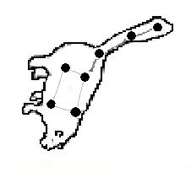

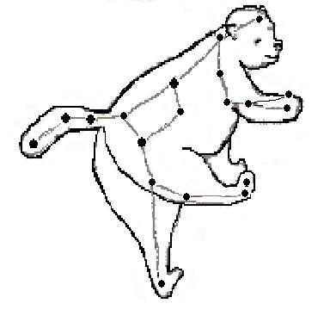

Dipper Finder 1

The Dipper Finder will show you the correct position of the Big Dipper at any hour for any month throughout out the year.

- Cut out the circle and rectangle.
- Place the circle on top of the rectangle and fasten with brad through the North Star (Polaris).
- Set the month to the correct time and then go outside and find the Big Dipper by facing North and holding the Dipper Finder over head.

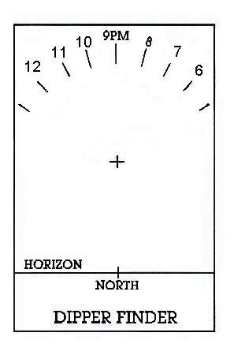

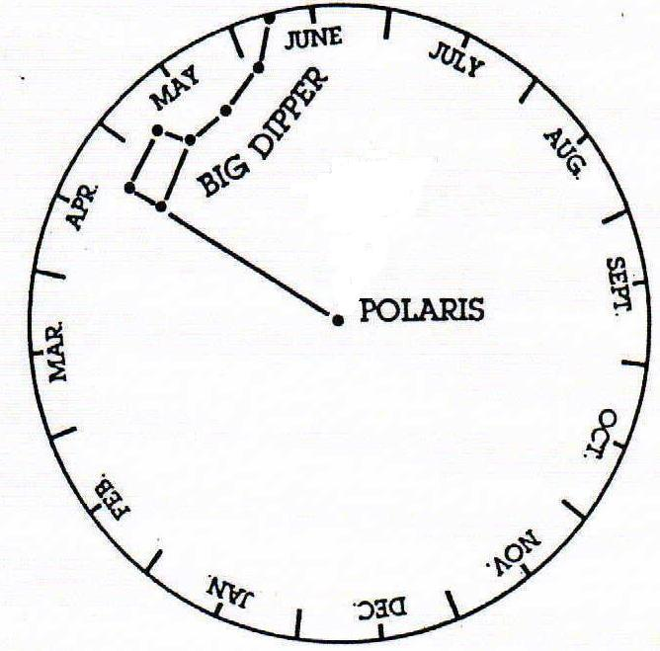
(North Star)

Dipper Finder 2

The Dipper Finder will show you the correct position of the Big Dipper and Little Dipper at any hour for any month throughout out the year.

- Cut out the circle and rectangle.

- Place the circle on top of the rectangle and fasten with a brad through the North Star (Polaris).

- Set the month to the correct time and then go outside and find the Big Dipper by facing North and holding the Dipper Finder over head.

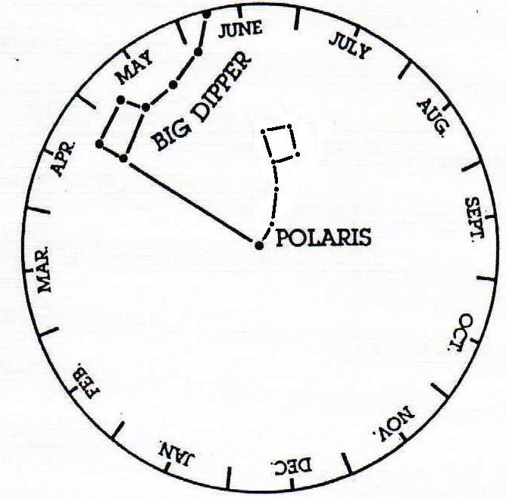
Little Dipper
(North Star)

