Student Journal

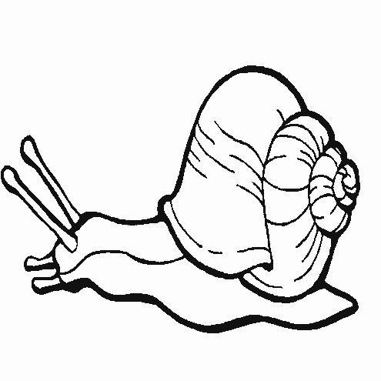

Characteristics of Animals

Name

_____________________________________

Teacher Edit Version May 2012
Activity 1 Name _______________________

What animal would you like to be for one day?
Draw a picture of the animal in the box.

Draw a picture of what this animal would eat.

Activity 1 Name _____________________

Living or Non-Living?

Directions: Circle the pictures of living things.

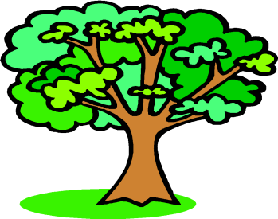

Activity 2 Name ____________________
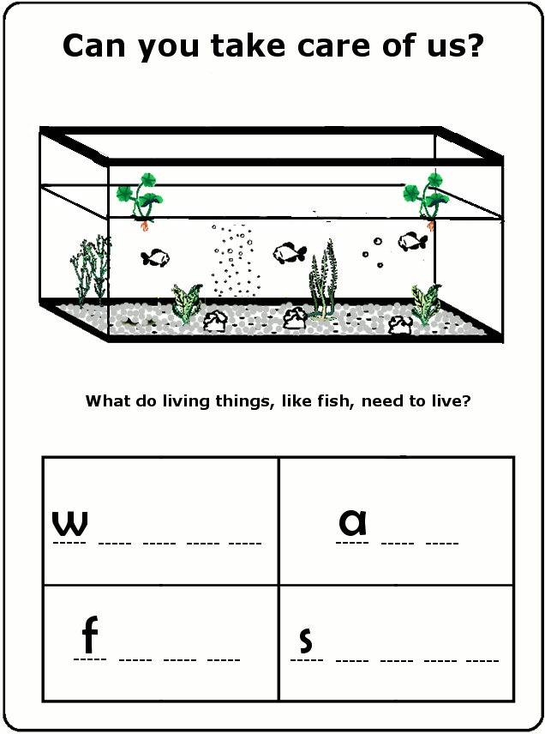
Activity 2 Name ____________________

Draw an aquarium that shows what fish need to live. Tell about your picture.

Write four words that tell what a fish needs to live.


1.

2.

3.

4.

1 Name ____________________
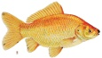

If a fish has the characteristic, draw a smiley face in the circle.
One has been done for you.

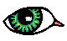
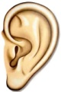
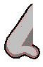
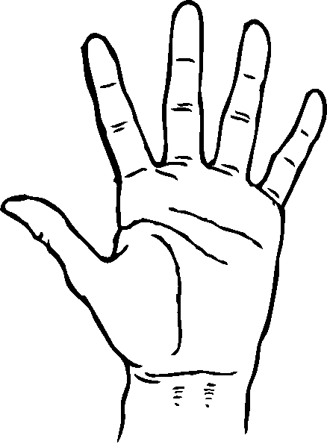


move
see
smell
touch
eat
hear

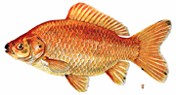

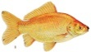
2 Name ______________________
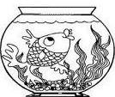
Observations of a Goldfish



- Goldfish are
- Goldfish look
- Goldfish have
- Goldfish need
- Goldfish move using
- Goldfish live in

3 Name ______________________

Draw a fish:

Tell how a part of the fish helps it to live.

4 Name ____________________
How are fish the same?
Directions: Draw a line from the fish to the picture of the fish characteristic.
eyes

a tail fin

scales

top fin

mouth

shape

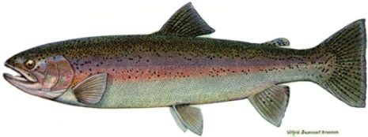
Rainbow trout
Goldfish

Circle a common fish characteristic on each fish that is NOT on the list.
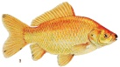
5 Name _______________________
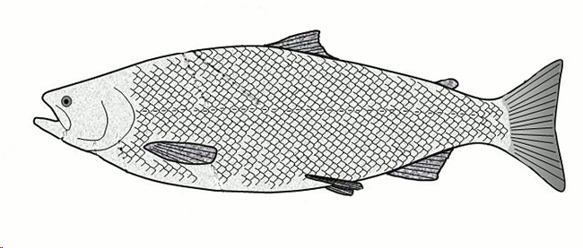
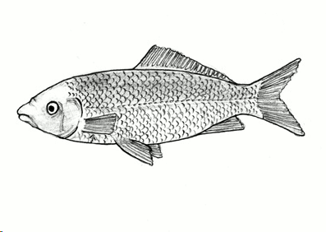
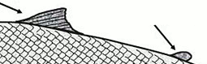
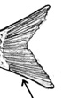
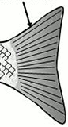
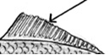
How are fish different?
or
or
or
Directions: Draw a line from the fish to the picture of the fish characteristic.

Goldfish
Rainbow trout


Do fish have a sense of smell?
6 Name ______________________
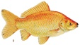
How am I like a fish?

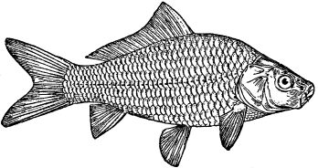
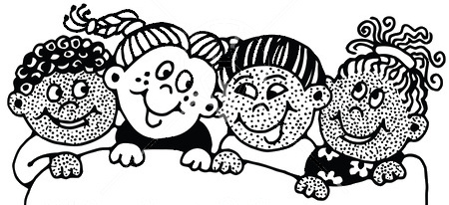

What do fish do? | Do I do that? | Are we the same?
1 Name _______________________
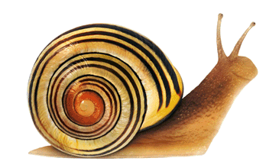
If a snail has the characteristic, draw a smiley face in the circle.
move
see
smell
touch
eat
hear

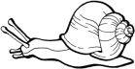

2 Name _______________________
Observations of a Snail

- Snails are
- Snails look
- Snails have
- Snails need
- Snails move using a
- Some snails live in

3 Name _____________________

Draw a snail:

Tell how a part of the snail helps it to live.
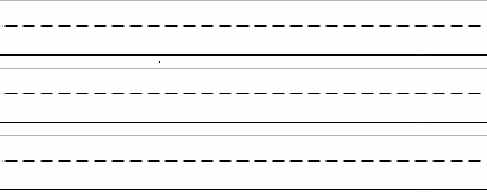
4 Name ______________________
How am I like a snail?
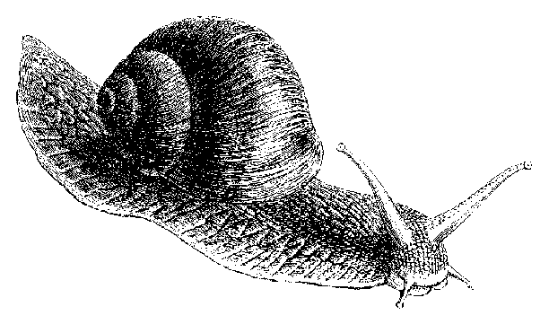
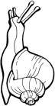

What do snails do? | Do I do that? | Are we the same?

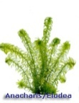
1 Name _____________________

Why are plants in the aquarium?

Draw a picture of the aquarium.
Draw a fish and a plant.

How do the plants help the fish?
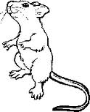
1 Name______________________

1.

2.3.

4.
Can you take care of me?

What are four things that gerbils need to live?

2 Name_______________________
If a gerbil has the characteristic, draw a smiley face in the circle.
move
see
smell
touch
eat
hear

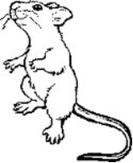

3 Name_______________________

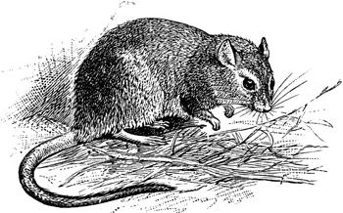
Observations of a Gerbil

- Gerbils are
- Gerbils look
- Gerbils have
- Gerbils need
- Gerbils move using
- Gerbils live on

4 Name_______________________

Draw a gerbil:

Tell how a part of the gerbil helps it to live.
5 Name______________________
How am I like a gerbil?

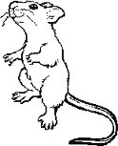

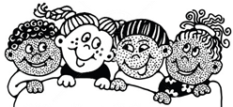

What do gerbils do?  What are gerbils like? | Do I do that?  Am I like that? | Are we the same?
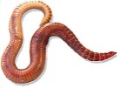
1 Name_______________________
If a worm has the characteristic, draw a smiley face in the circle.
move
see
smell
touch
eat
hear

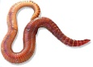
2 Name______________________
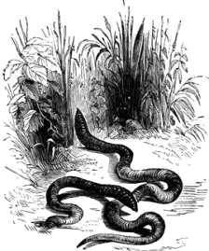
Observations of a Worm

- Worms are
- Worms look
- Worms have
- Worms need
- Worms move using their
- Worms live in

3 Name______________________

Draw a worm:

Tell how a part of the worm helps it to live.
4 Name______________________

How am I like a worm?
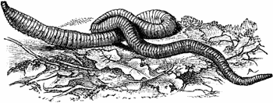
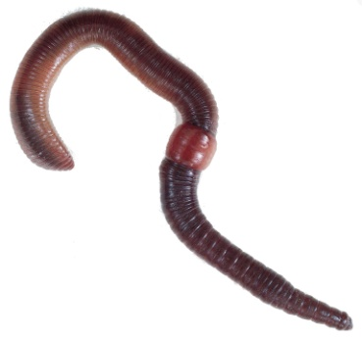
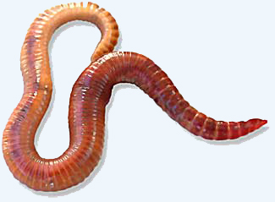

What do worms do? | Do I do that? | Are we the same?

Activity 10 Name______________________

Draw a line from the characteristic type to the squirrel body part.
see
hear
smell
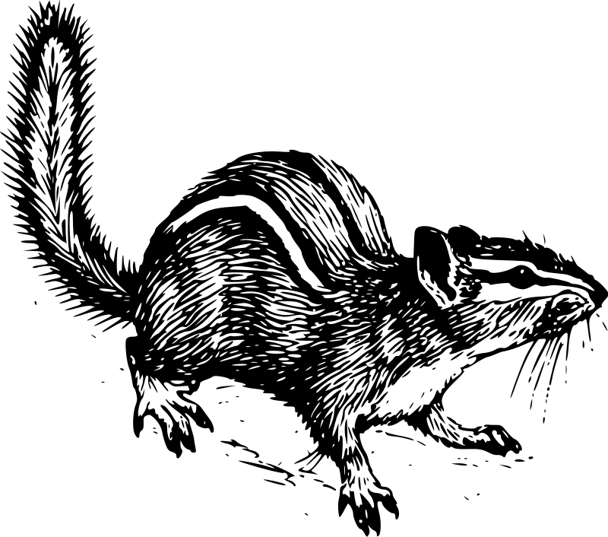

touch
move
eat/drink

Color brown the part of the squirrel that keeps it warm.

Which of these does the squirrel need to live? Circle any.
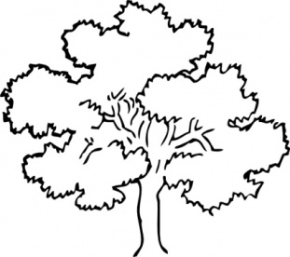
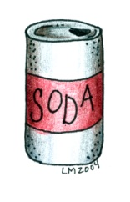
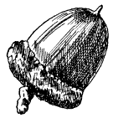
Activity 10 Name______________________
Match the Animals by their Characteristics
Match the animal on the left with the one with the closest characteristics on the right.
Draw a line between them. One will be left over.
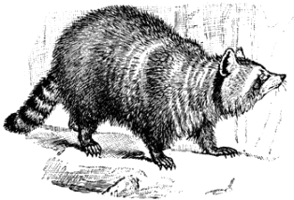
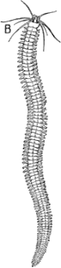
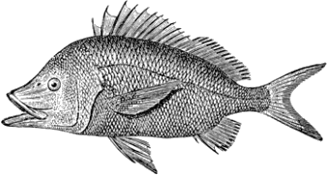
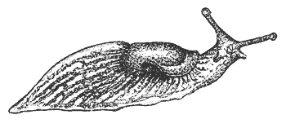
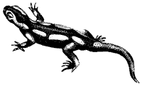
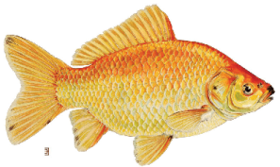
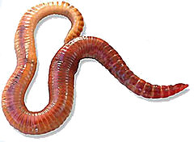
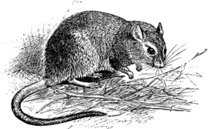

Activity 11 Name_______________________

Cut out the animal picture and paste it in the box with the matching skull.

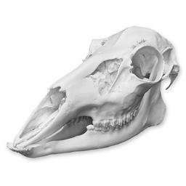 | 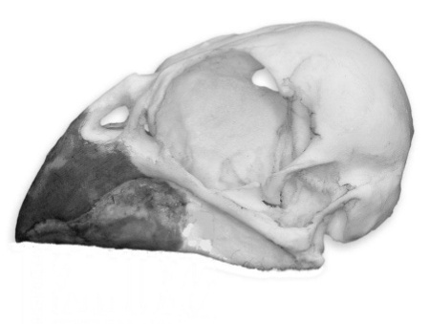
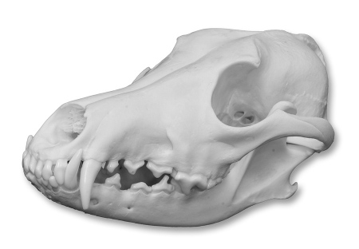 | 