Evaluating ESL Teachers & Teachers of ELLs

Ask about Students:
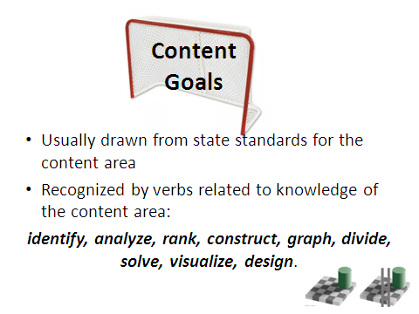
“What are the language acquisition stages of your English Language Learners? How is this lesson tailored to their levels?”

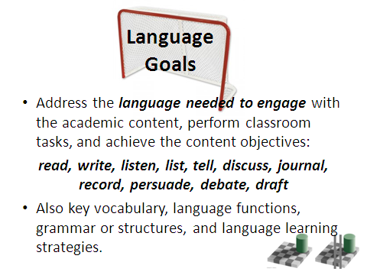
Ask about Curriculum:
“What are the lesson’s content objectives and language objectives? How did you determine these objectives?”

Ask about Instruction:
“What are your instructional strategies specific to ELLs? How will you check ELL student comprehension and learning?”

For more resources:
Mid-State RBERN
http://rbern.ocmboces.org/
(315)433-2664

