New York State Student Learning Objective: Science 6th Grade
All SLOs MUST include the following basic components:
Population | These are the students assigned to the course section(s) in this SLO - all students who are assigned to the course section(s) must be included in the SLO. (Full class rosters of all students must be provided for all included course sections.)  Three sections of 6th grade science, heterogeneously grouped, 75 students
Learning Content | What is being taught over the instructional period covered? Common Core/National/State standards? Will this goal apply to all standards applicable to a course or just to specific priority standards?  Students will be able to explain, analyze, and interpret scientific processes and phenomena related to the physical setting and environmental science.
Interval of Instructional Time | What is the instructional period covered (if not a year, rationale for semester/quarter/etc.)?  2012-2013 school year
Evidence | What specific assessment(s) will be used to measure this goal? The assessment must align to the learning content of the course.  Baseline assessment: Given a set of graphs, charts, and tables containing scientific observations, data, and information, students will answer 10 multiple choice questions pertaining to the scientific method, inferences, and predictions. Students will complete two short answer responses related to a written explanation of a scientific experiment (total points possible is 14 pts.)  Summative assessment: Students will complete 20 questions (15 multiple choice, 5 short answers) specific to Earth’s four spheres. Students will answer four skill based questions pertaining to graphed data and written explanations (total possible is 25 pts.)
Baseline | What is the starting level of students’ knowledge of the learning content at the beginning of the instructional period?  points # of students Points # of students  14 0 7 5  13 0 6 5  12 3 5 5  11 12 4 0  10 15 3 0  9 15 2 0  8 5 1 0
Target(s) | What is the expected outcome (target) of students’ level of knowledge of the learning content at the end of the instructional period?  Seventy-five percent of all students will score twenty or more points
HEDI Scoring | How will evaluators determine what range of student performance “meets” the goal (effective) versus “well-below” (ineffective), “below” (developing), and “well-above” (highly effective)?  The targets below are based on the baseline and the district history.
 | HIGHLY EFFECTIVE |  |  | EFFECTIVE |  |  |  |  |  |  |  |  | DEVELOPING |  |  |  |  |  | INEFFECTIVE
 | 20 | 19 | 18 | 17 | 16 | 15 | 14 | 13 | 12 | 11 | 10 | 9 | 8 | 7 | 6 | 5 | 4 | 3 | 2 | 1 | 0
 | 99-  100% | 95-  98% | 90-  94% | 87-  89% | 83-  86% | 80-  82% | 76-  79% | 73-  75% | 71-  73% | 69-  70% | 67-  68% | 65-  66% | 63-  64% | 61-  62% | 59-  60% | 57-  58% | 55-  56% | 53-  54% | 51-  52% | 49-  50% | <48%
Rationale | Describe the reasoning behind the choices regarding learning content, evidence, and target and how they will be used together to prepare students for future growth and development in subsequent grades/courses, as well as college and career readiness.  The Learning Content is based on the Intermediate Level Science Core Curriculum. The baseline evidence will provide teachers with a basis of students’ abilities to explain, analyze, and interpret scientific processes and phenomena. The summative assessment will combine the students’ abilities to explain, analyze and interpret scientific processes and phenomena specific to the atmosphere, hydrosphere, biosphere, and lithosphere.

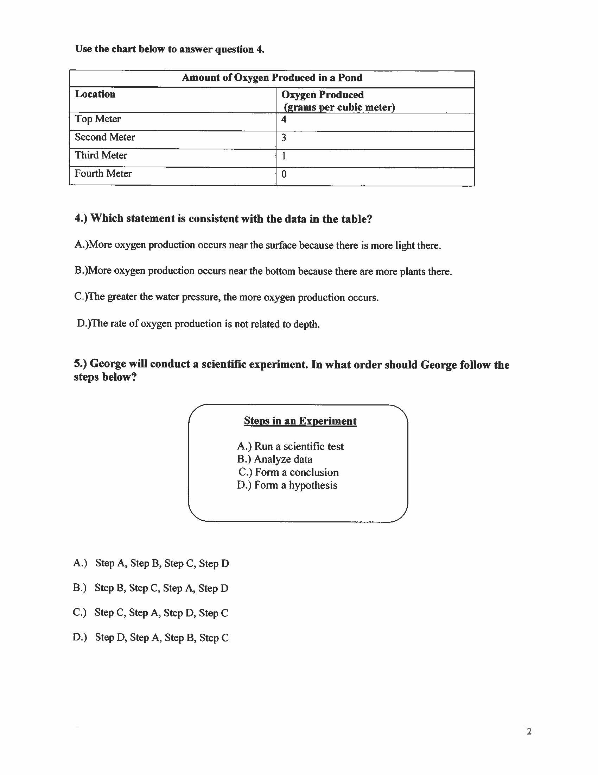

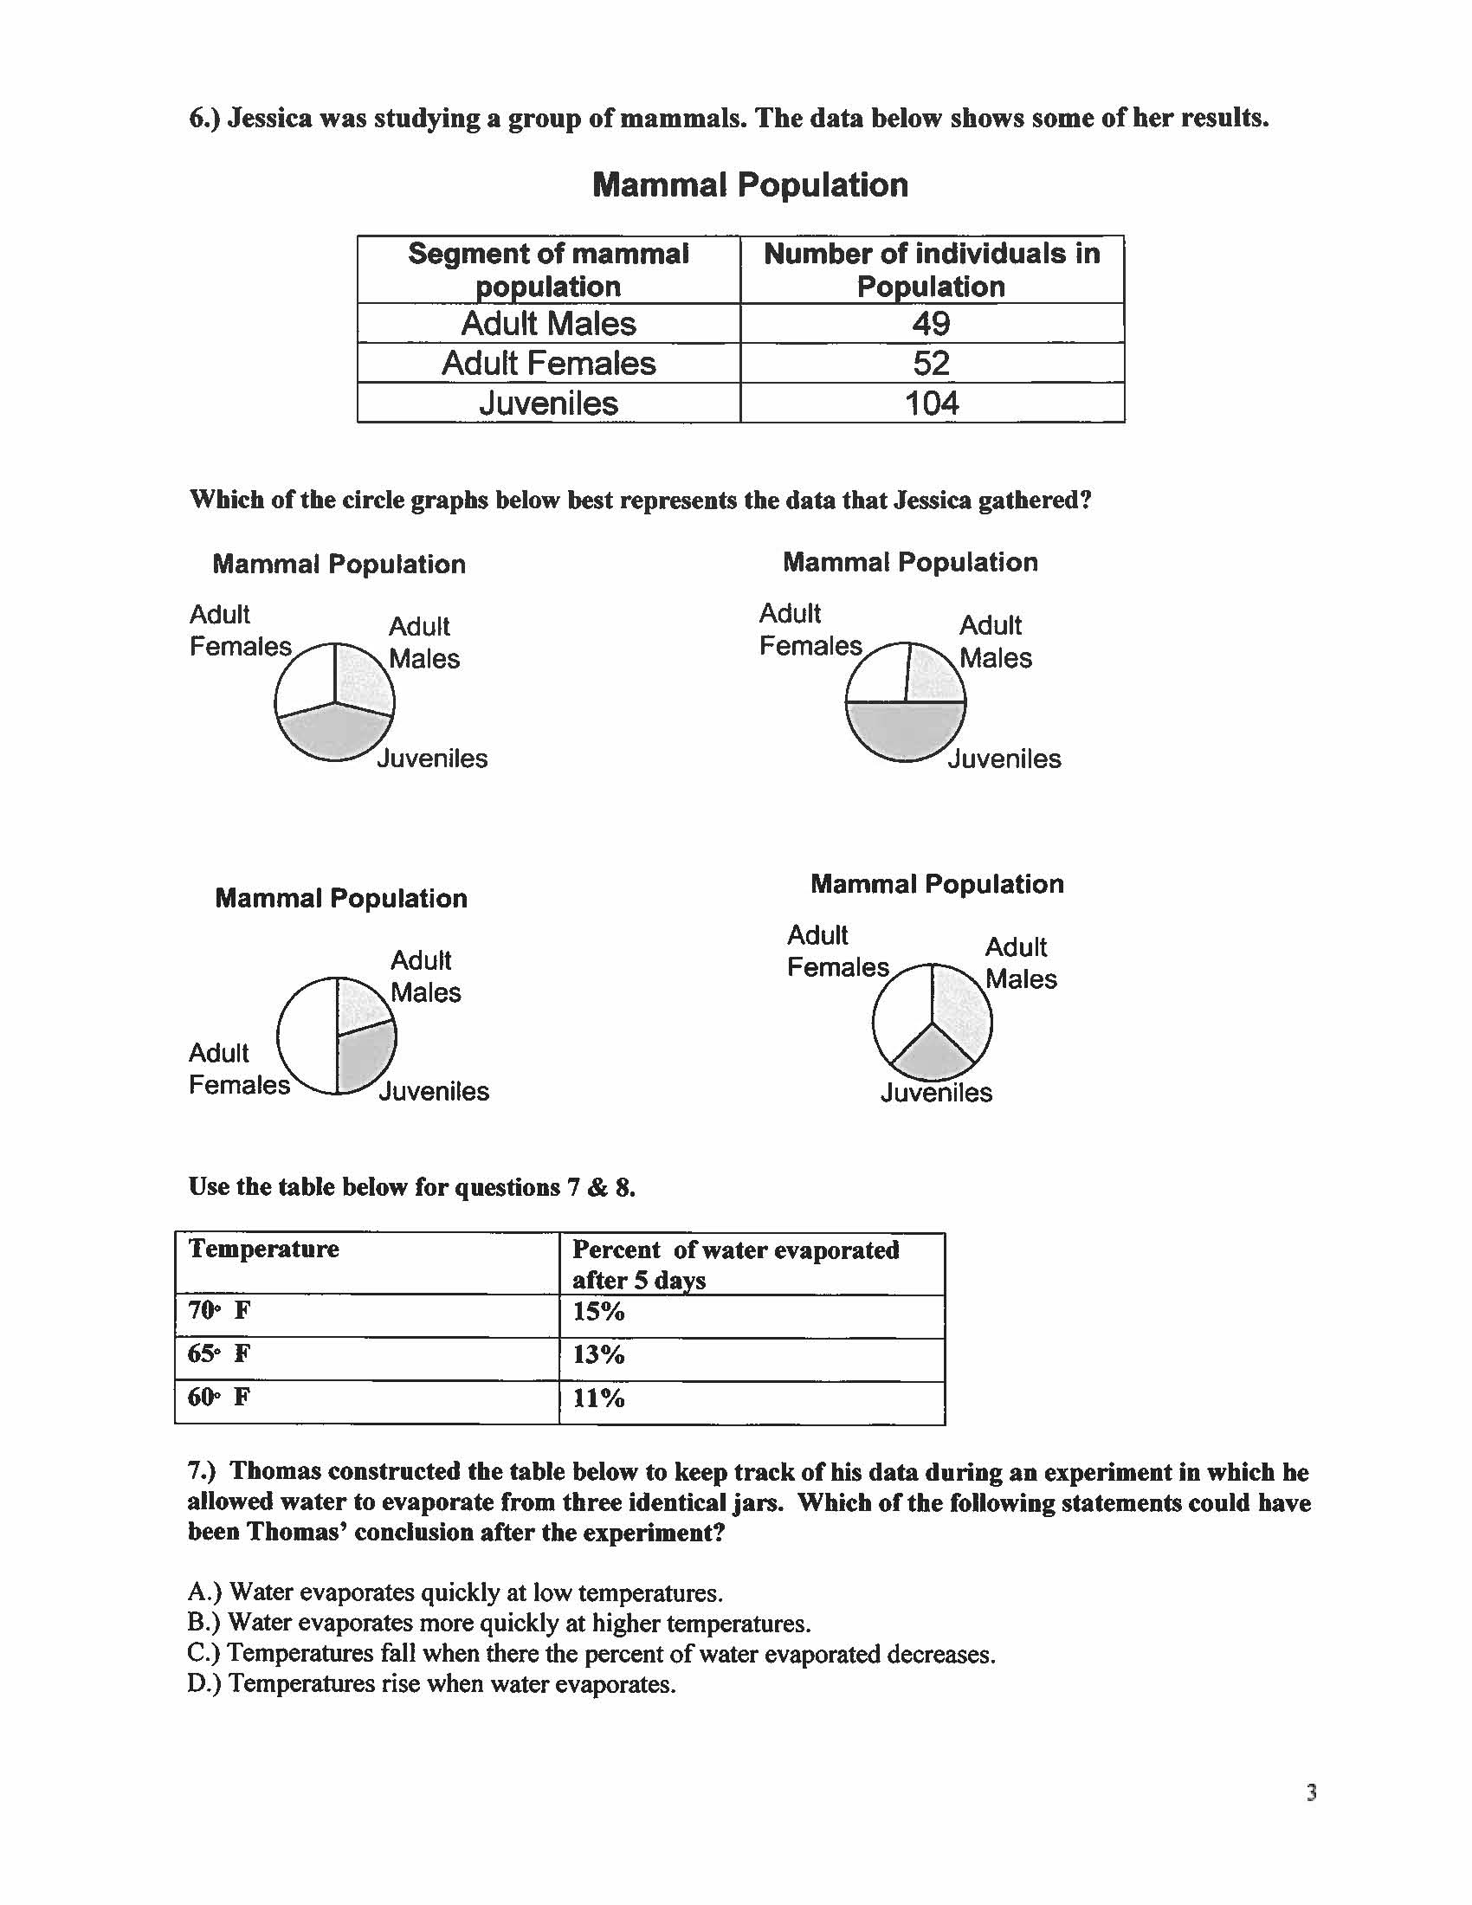

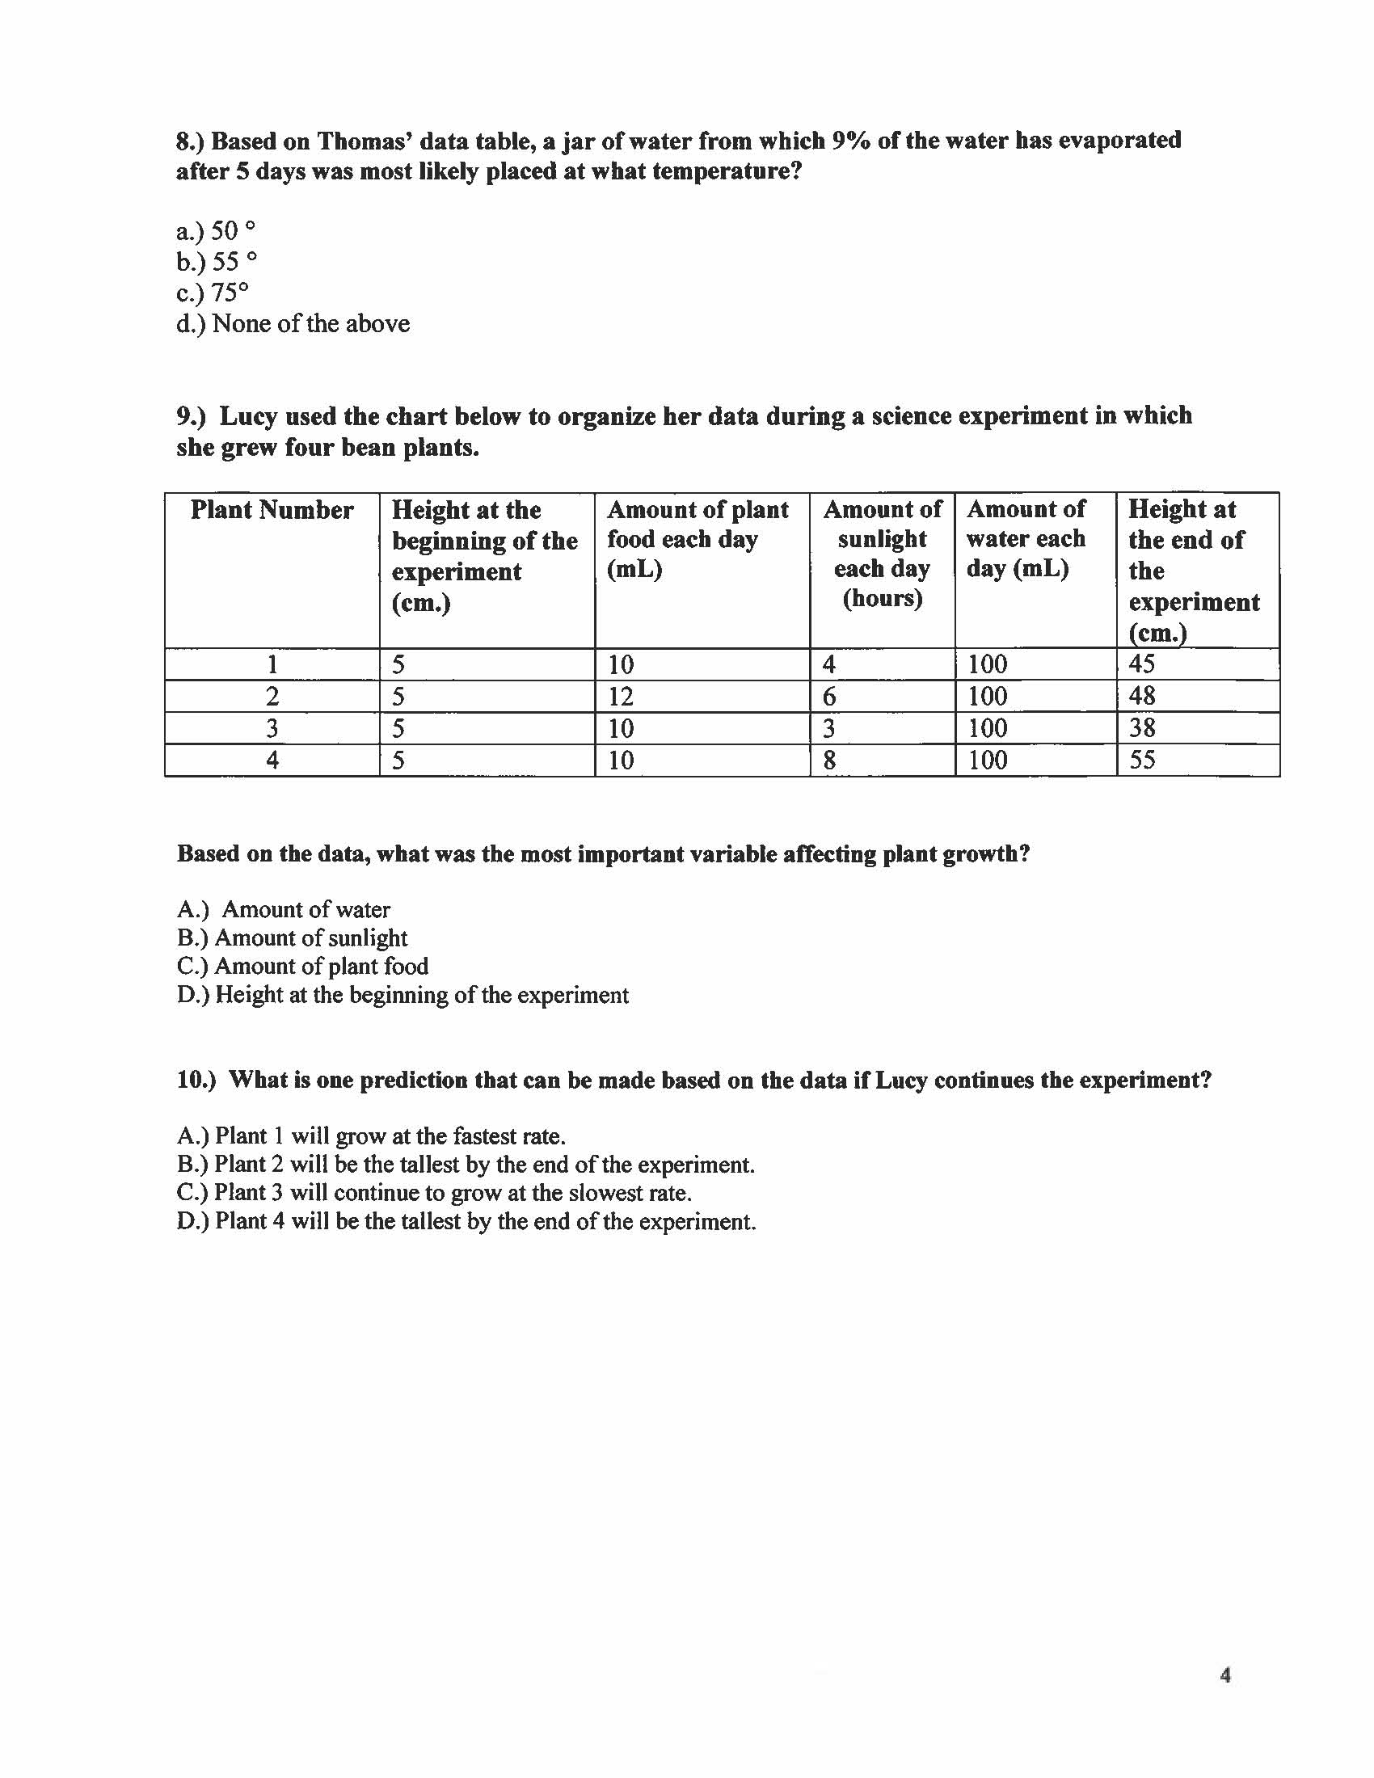

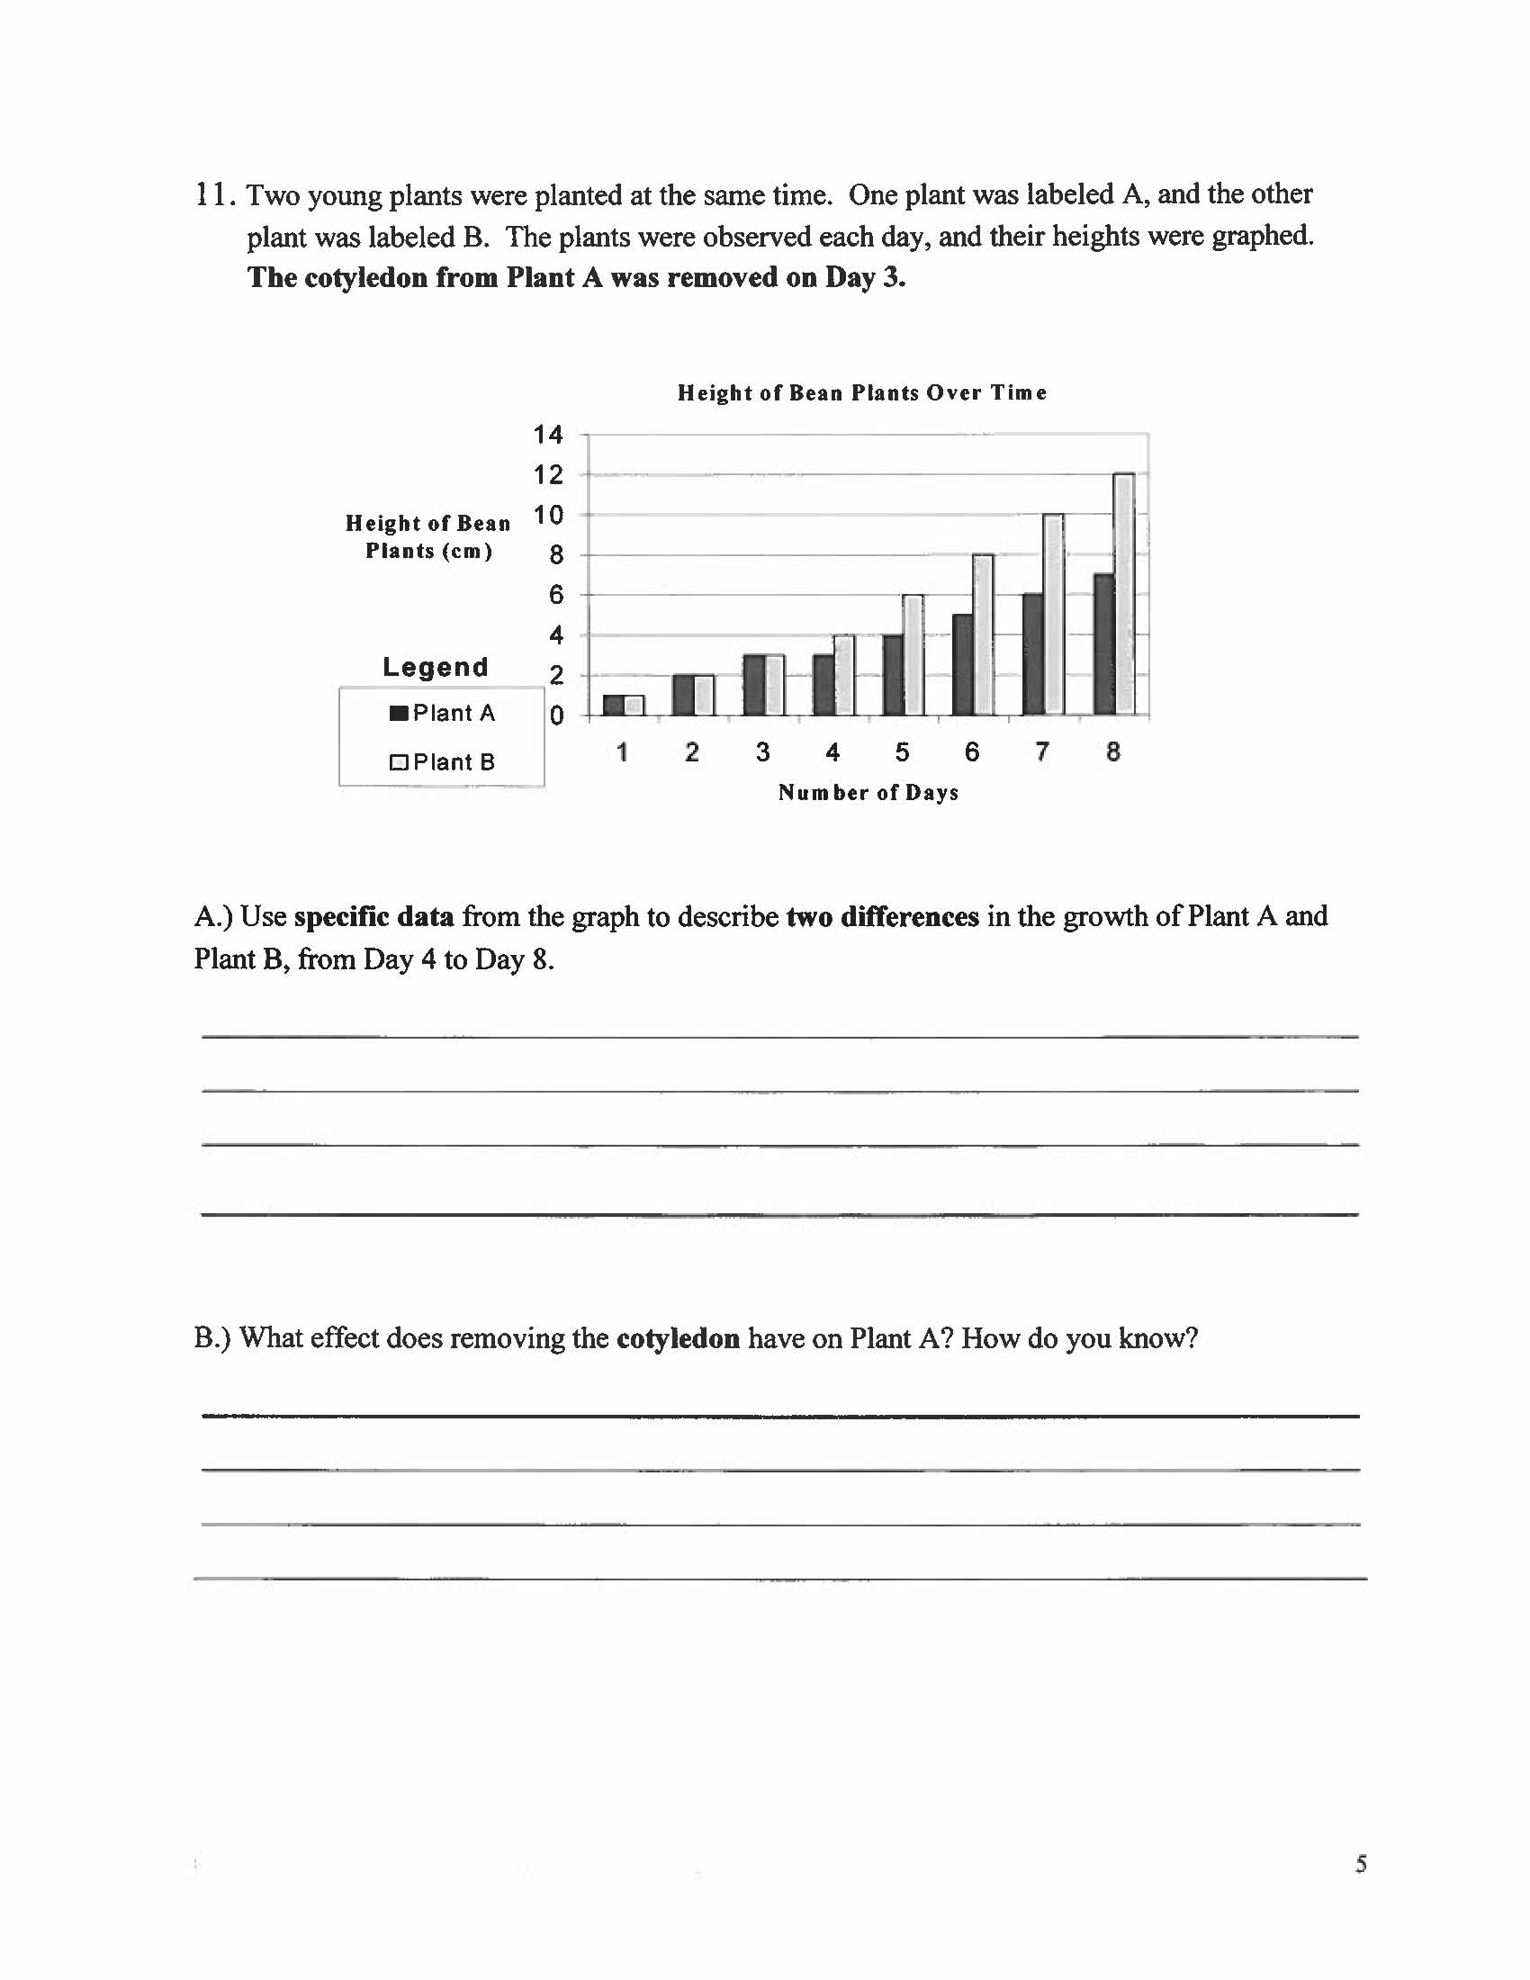

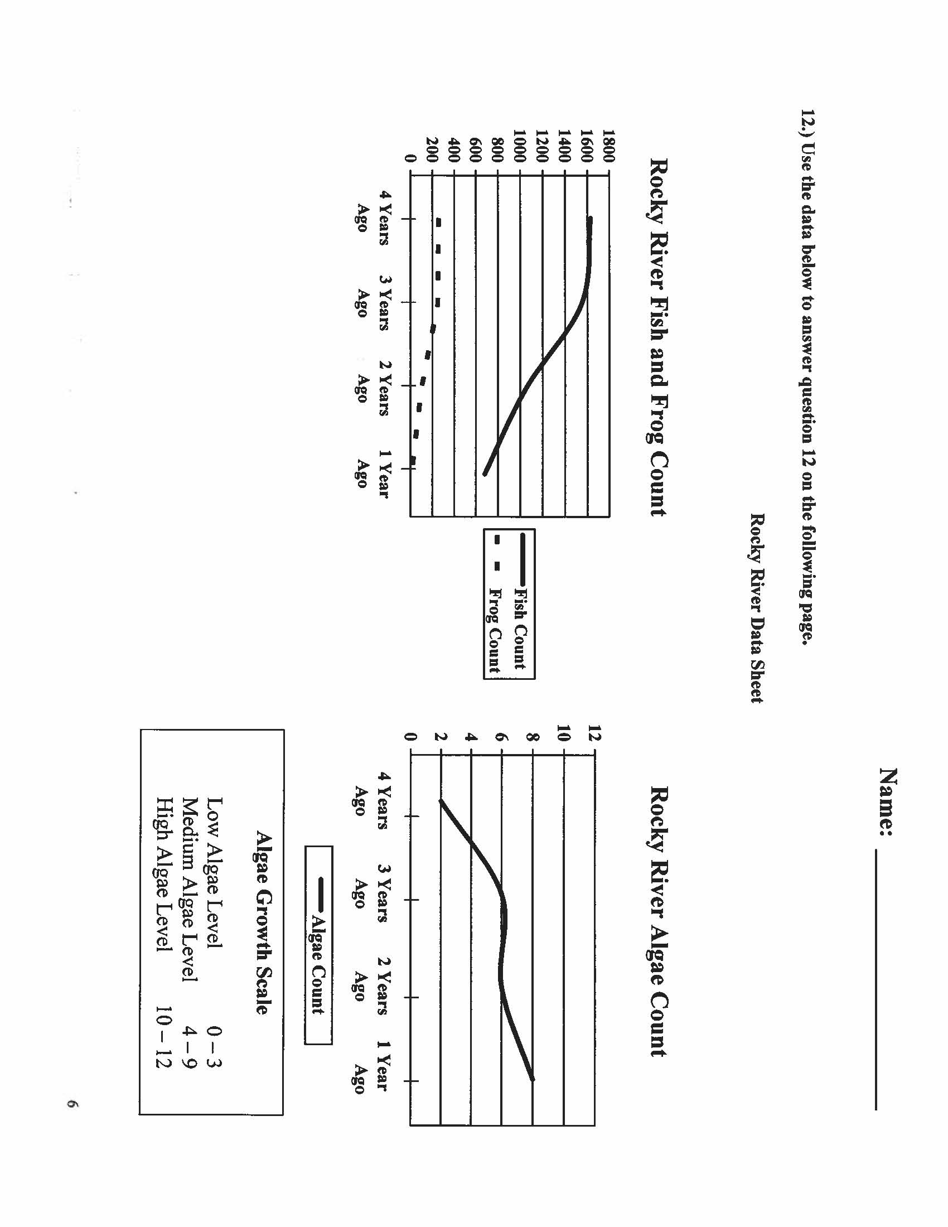

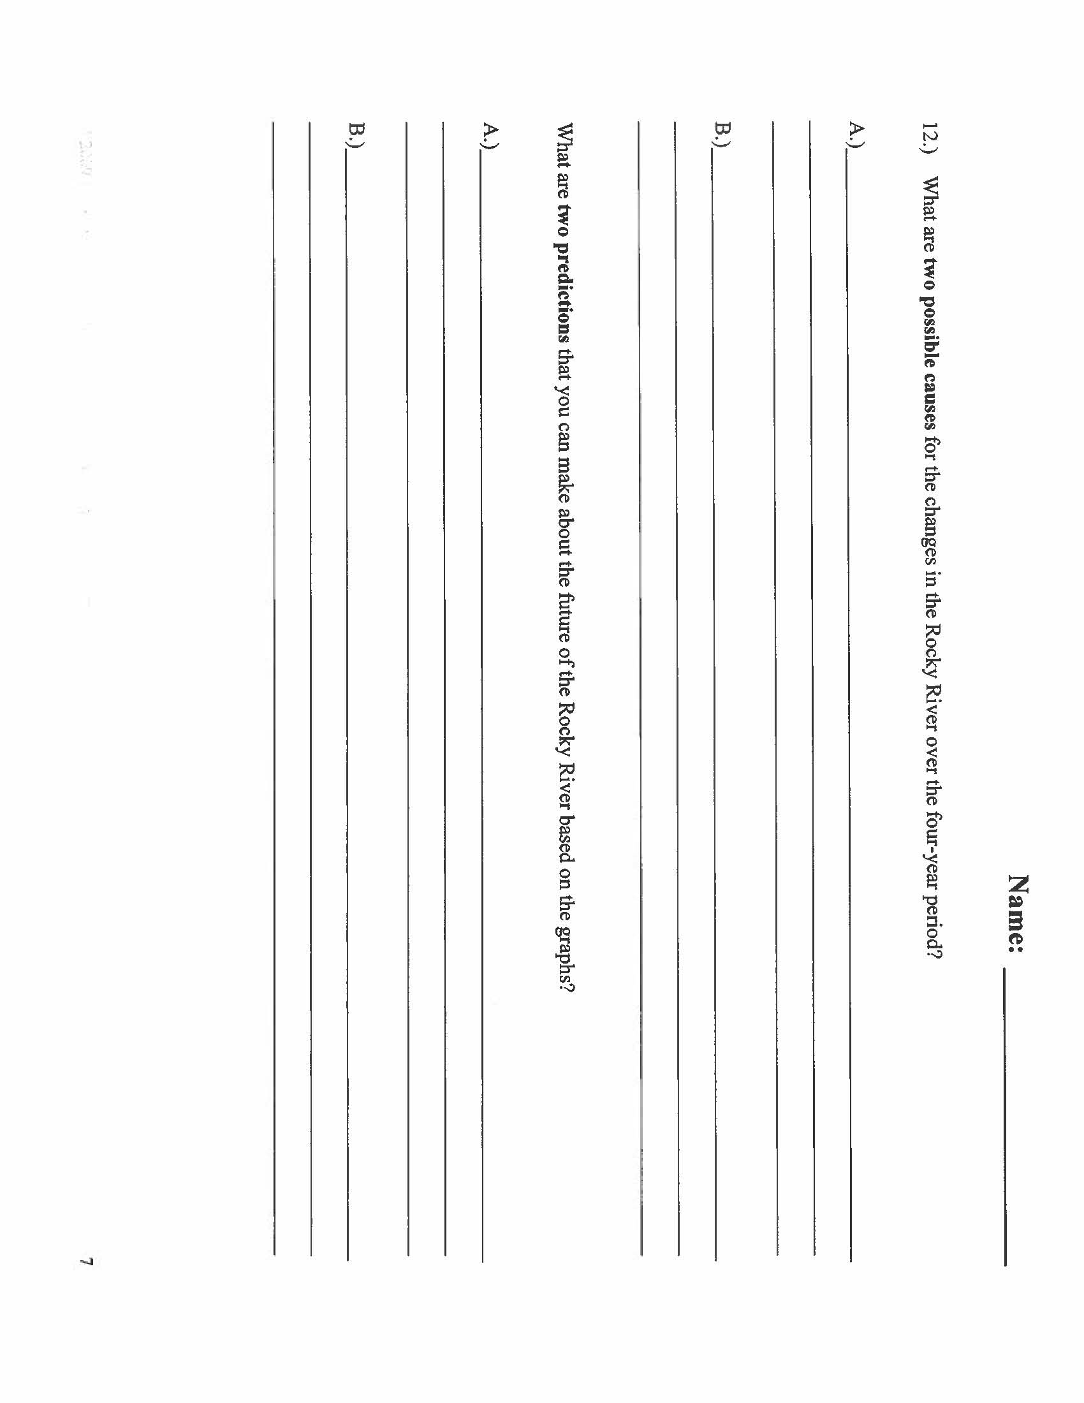
Name: _____________________________ Class: _____________
6th Grade Science Summative Assessment 2012-2013

Directions: For questions 1 - 5, circle the letter of the correct answer.

1 | 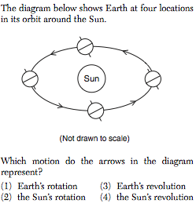
2 | 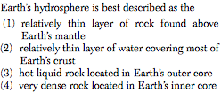
3 | 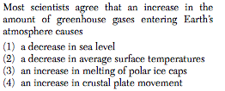
4 | 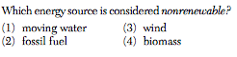
5 | 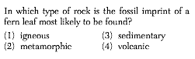
6 | 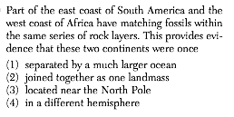
7 | 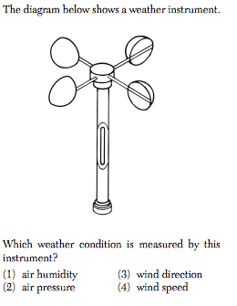
8 | 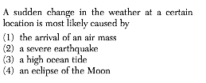
9 | 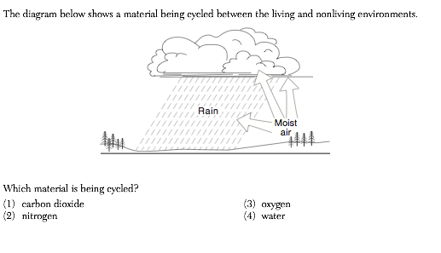
10 | 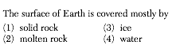
11 | 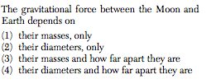
12 | 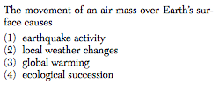
13 | 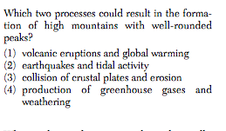
14 | 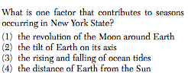
15 | 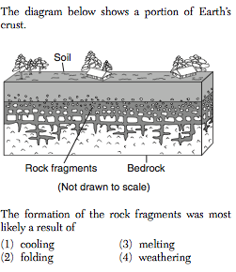

16.

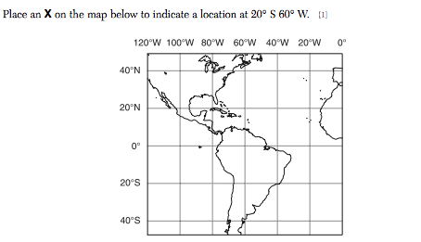

17.

This diagram shows a boundary between crustal plates. The arrows show the direction of plate movement.

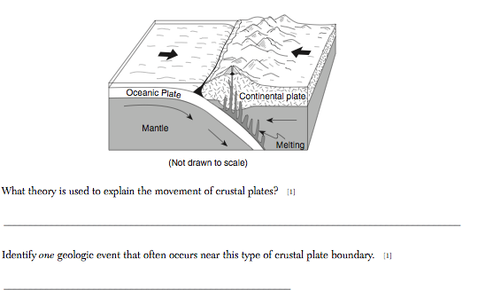

18. Base your answer to the questions on the diagram below and your knowledge of science. The diagram shows the rock cycle in Earth’s crust.

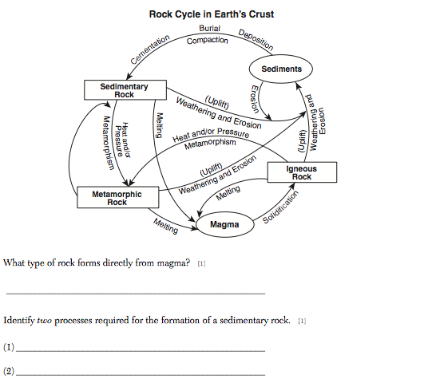

19.

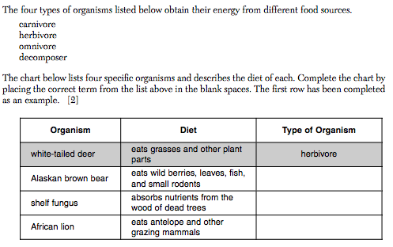

20. Base your answers on the map below and your knowledge of science. The map shows the seven continents and several lithospheric plates. The dark lines between the plates represent the boundaries that separate them. Three of the plates are labeled.

