**New York State Student Learning Objective: Studio in Art 9th Grade**

|  |  |  |  |  |  |  |  |  |  |  |  |  |  |  |  |  |  |  |  |  |  |
| --- | --- | --- | --- | --- | --- | --- | --- | --- | --- | --- | --- | --- | --- | --- | --- | --- | --- | --- | --- | --- | --- |
| *All SLOs MUST include the following basic components:* | | | | | | | | | | | | | | | | | | | | | |
| **Population** | *These are the students assigned to the course section(s) in this SLO - all students who are assigned to the course section(s) must be included in the SLO. (Full class rosters of all students must be provided for all included course sections.)*  Three classes of ninth grade students of a wide range of artistic and academic abilities as determined by the total enrollment on a specific district-determined date. (80 students) Please refer to the attached class rosters for specific notes on individual students. | | | | | | | | | | | | | | | | | | | | |
| **Learning Content** | *What is being taught over the instructional period covered? Common Core/National/State standards? Will this goal apply to all standards applicable to a course or just to specific priority standards?*  Evaluation will be based on three standards from the New York State Learning Standards for Visual Arts: *Creating*, *Knowing and Using Art Materials and Resources*, and *Responding to and Analyzing Works of Art*. These standards will be focused on during the interval of instruction. | | | | | | | | | | | | | | | | | | | | |
| **Interval of Instructional Time** | *What is the instructional period covered (if not a year, rationale for semester/quarter/etc)?*  The instructional period will begin at the start of the school year in September and conclude in the middle of May when the final project and evaluation begins. Classes are on a block schedule and will meet every other day for approximately 74 minutes per class. | | | | | | | | | | | | | | | | | | | | |
| **Evidence** | *What specific assessment(s) will be used to measure this goal? The assessment must align to the learning content of the course.*  Baseline: Many, but not all, ninth grade students will be coming from eighth grade with 10 weeks of Art experience either from three different middle schools in this district or another school district (New York State or another). As a result, students will be given a district-developed pre-assessment to determine their abilities within the New York State Visual Arts Standards. A district-developed pre-assessment administered at the beginning of the school year. (See attached)  Summative: A district-developed summative assessment administered over several days beginning in mid-May. (See attached) | | | | | | | | | | | | | | | | | | | | |
| **Baseline** | *What is the starting level of students’ knowledge of the learning content at the beginning of the instructional period?*  One the baseline assessment, 50% scored at the *Developing* level of accomplishment on the pre-assessment rubric; 25% *Proficient*; 25% *Exemplary*.  The rubric is based on *Exemplary* (4), *Proficient* (3*), Developing* (2), and *Emerging* (1) levels of accomplishment. | | | | | | | | | | | | | | | | | | | | |
| **Target(s)** | *What is the expected outcome (target) of students’ level of knowledge of the learning content at the end of the instructional period?*  It is expected that by the end of the course, at least 80% of students will have demonstrated growth and development as measured by the district-developed summative assessment by scoring in at least in the *Proficient* range according to the rubric. The summative assessment will be given mid May. (The *Proficient* level is similar to the *Effective* level on the HEDI scoring guide.) | | | | | | | | | | | | | | | | | | | | |
| **HEDI Scoring** | *How will evaluators determine what range of student performance “meets” the goal (effective) versus “well-below” (ineffective), “below” (developing), and “well-above” (highly effective)?*  The scoring targets were based on the baseline data as well as the historical data for the course and district. | | | | | | | | | | | | | | | | | | | | |
| **HIGHLY EFFECTIVE** | | | **EFFECTIVE** | | | | | | | | | **DEVELOPING** | | | | | | **INEFFECTIVE** | | |
| 20 | 19 | 18 | 17 | 16 | 15 | 14 | **13** | 12 | 11 | 10 | 9 | 8 | 7 | 6 | 5 | 4 | 3 | 2 | 1 | 0 |
| 97-100 | 94-96 | 90-93 | 87-89 | 85-86 | 83-84 | 81-82 | 77-80 | 75-76 | 73-74 | 71-72 | 69-70 | 67-68 | 65-66 | 63-64 | 61-62 | 59-60 | 57-58 | 40-56 | 2-39 | 0 |
| **Rationale** | *Describe the reasoning behind the choices regarding learning content, evidence, and target and how they will be used together to prepare students for future growth and development in subsequent grades/courses, as well as college and career readiness.*  The learning content is based on three of the four New York State Learning Standards fort the Arts: *Creating*, *Knowing and Using Arts Materials and Resources*, and *Responding to and Analyzing Works of Art.* The baseline and summative assessments will consist of three parts to reflect these learning standards:   * A still life drawing, * A visual journal entry (or Artist Trading Card, or 4”x4”) using mixed media, * A written response to a piece of artwork.   These three parts will be scored using a common rubric based on four levels of accomplishment with certain criteria: *Exemplary* (4 points), *Proficient* (3 points)*, Developing* (2 points), and *Emerging* (1 point). At the conclusion of this course, it is expected that most students, at least 80%, will have demonstrated these three learning standards at a *Proficient* level. Once the ability to work at the *Proficient* level is achieved, the student will be prepared to be successful in the advanced level art courses during their high school career. | | | | | | | | | | | | | | | | | | | | |

**Pre/Post Drawing Assignment: The All White Still Life**

**Objective:** Given a still life containing white objects with ellipses (ex: bottles), straight edges (ex: boxes), as well as organic objects (ex: flowers), students will demonstrate their ability to draw from observation using a view finder to accurately represent those shapes with proper proportion and scale, using the Rule of Thirds to locate their focal point and their ability to create values to represent the illusion of three dimensions on a two dimensional surface. (Note: This assignment will determine student growth and development with NYS Standard 1: Creating Art.)

**Criteria:** **Level of Performance:** *Exemplary 4, Proficient 3, Developing 2, Emerging 1*

***Composition:***

* Use of view finder
* Foreground, middle ground, background
* Development of focal point
* Use of Rule of Thirds

***Accuracy of Shapes:***

* Proportion
* Scale
* Placement/location
* Detail

***Values:***

* Wide range of values
* Value placement accurately rendered
* Value placement
* Rendering reflects observation and impact of a light source
  + Core value
  + Cast shadow
  + High lights

__________________________________________________________________

Total Score:___________

Student score is determined by their level of achievement with criteria and is given a score based on 1-4, Emerging to Exemplary.

**Pre/Post Art Production Assignment: The Artist Trading Card**

**Objective:** Given a variety of materials, students will demonstrate their knowledge of composition, the Art Elements and Principles of Design and their ability to manipulate different materials to create an Artist Trading Card that engages the viewer with an interesting composition. (Note: This assignment will determine student growth and development with NYS Standard 2: Knowing and Using Art Materials and Resources.)

**Criteria:** **Level of Performance:** *Exemplary 4, Proficient 3, Developing 2, Emerging 1*

***Composition:***

* Foreground, middle ground, background
* Development of focal point
* Use of Rule of Thirds

***Development of a Theme:***

* Contains a theme
* Evidence of research

***Use of materials:***

* Selective choice and application of materials
* Care for quality craftsmanship is evident
* Uses a variety of materials, technique and processes

***Art Elements and Principles of Design:***

* Evidence of Art Elements knowledge is visible
* Evidence of Principles of Design knowledge is visible

__________________________________________________________________

Total Score:___________

Student score is determined by their level of achievement with criteria and is given a score based on 1-4, Emerging to Exemplary.

**Pre/Post Responding to and Analyzing Works of Art: The Visual Writing Prompt**

**Objective:** Given a specific piece of art, students will demonstrate their ability to reflect, interpret and evaluate works of art using the language of art criticism. (Note: This assignment will determine student growth and development with NYS Standard 3: Responding to and Analyzing works of art.)

**Teacher:** show the following on the board to the class:

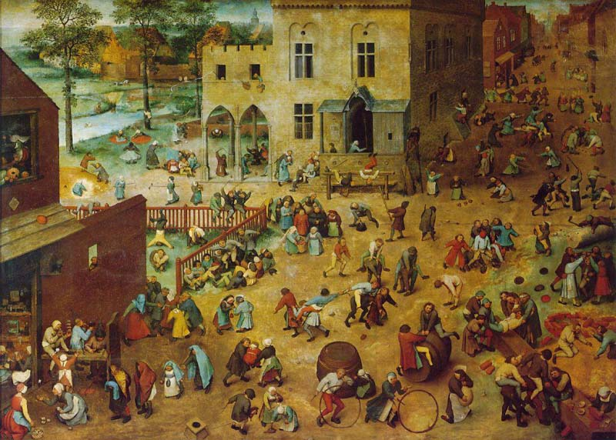 Pieter Bruegel, the Elder (1525 – 1569), *Kinderspiele Children’s Games*. (<http://www.gardenofpraise.com/art28.htm>)

**Students:** Refer to Bruegel’s image and on a separate sheet of lined paper, use complete and reflective sentences to answer the following:

1. Copy the descriptive information about this artwork.
2. List everything you observe in the artwork. Describe all the objects in detail, including location within the format.
3. Describe how the artist uses the Art Elements in this piece.
4. Describe how the artist uses the Principles of Design in this piece.
5. What clues exist in this piece that tells you answers to the Who/What/Why/When questions?
6. What do you think is happening in this piece? What is the artist communicating?
7. What do you think the next piece of artwork by the same artist might look like?
8. How relevant is this piece to your life in the 21st century?

**Criteria:** **Level of Performance:** *Exemplary 4, Proficient 3, Developing 2, Emerging 1*

***Vocabulary:***

* Art terms used accurately
* Knowledge of Art Elements
* Knowledge of Principles of Design

***Description:***

* Many details are identified

***Understanding and Communicating:***

* Understanding of time and place
* Understanding of culture
* Identify differences
* Identify similarities

__________________________________________________________________

Total Score:___________

Student score is determined by their level of achievement with criteria and is given a score based on 1-4, Emerging to Exemplary.