WinCapWeb Employee Self-Service Instructions

Welcome to WinCapWeb. To access your account, login with the following web address:

https://wincapweb.com

You can access this web address from the OCM BOCES website under “OCM BOCES Only”, “WinCapWeb”, “Login to WinCapWeb”.

Your Username is your BOCES email address. Note you only need to enter the first part of your email address before the “@” sign.

The Password is the one that you created during the initial registration. For security reasons, choose NO when the programs asks if you want to remember your password.

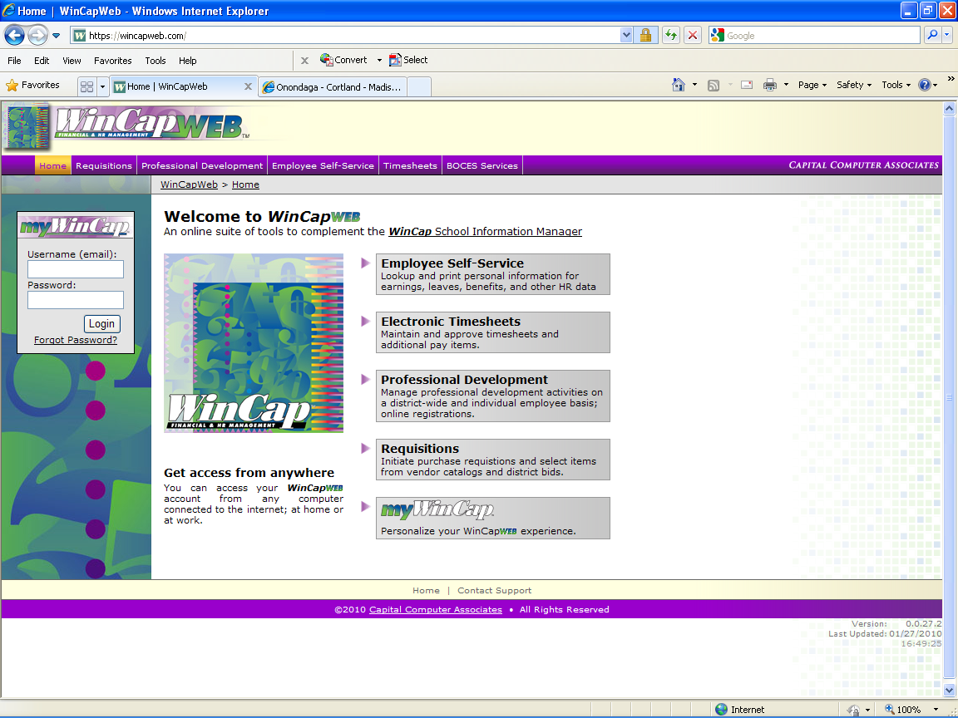

After logging in, you will automatically be brought to the Employee Self-Service page where you can look at your employee demographics, review attendance activity and balances, submit on-line leave requests, and review paychecks and YTD payroll information.

The following screen will appear after you log on.

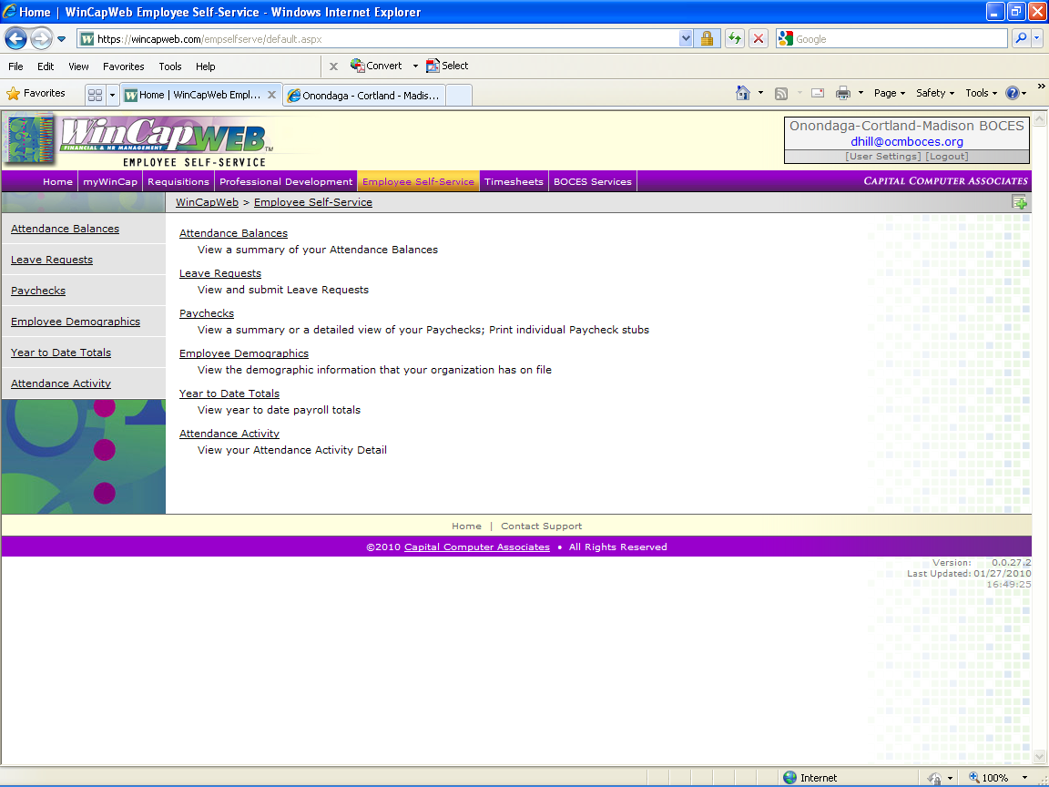

Employee Demographics

Employee Demographics is the data that is stored in the Human Resource system. You should review the Employee Demographics page to ensure that the information that BOCES has on file for you is accurate. If a change is necessary, you should fill out a Personnel Change Form (see link attached) or contact the BOCES Personnel Department for assistance.

Personnel Change Form
http://www.ocmboces.org/OCM/administration/person/PDFforms/pchangefill.pdf

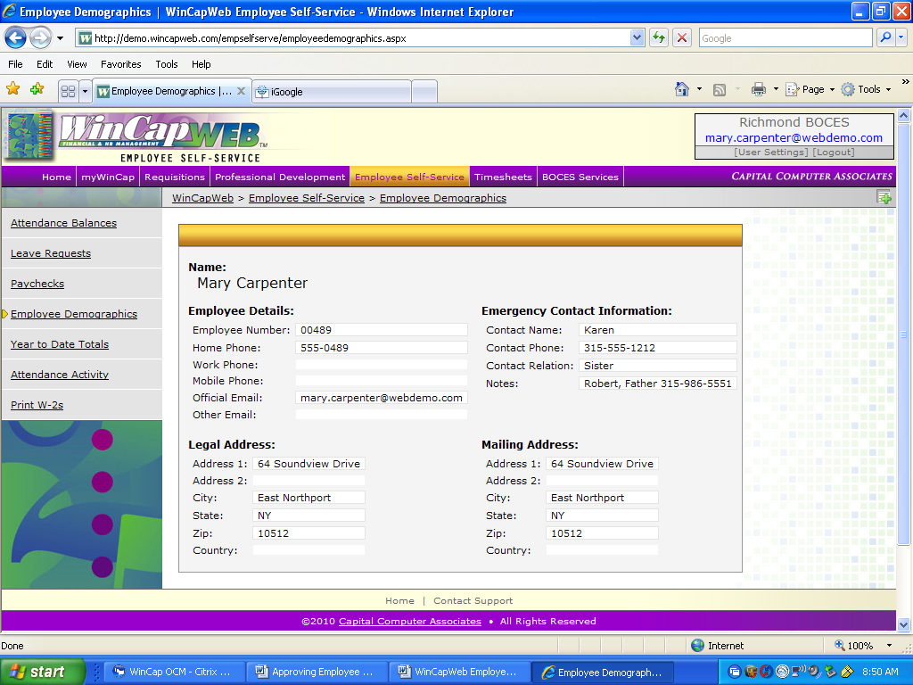

Paychecks

By clicking on “Paychecks”, you will be able to view all of your paychecks on the web, from July 1st, 2004 to the present.

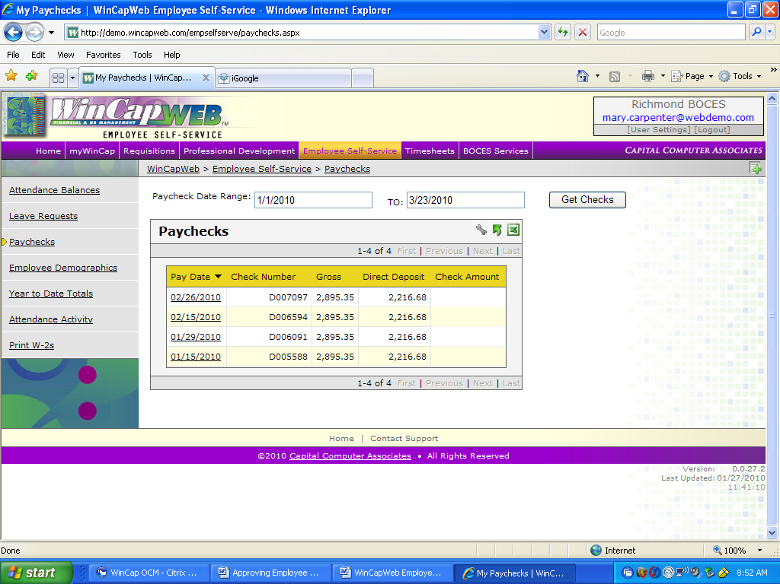

Use the “Paycheck Date Range” to select paycheck dates and then click “Get Checks”. Once your checks are displayed, you can click on an individual check to see the detail of that selected check.

Whenever paycheck display is accessed, it will default to today’s date and the prior month as the range where checks are displayed.

Paychecks (con’t)

After clicking on an individual check, your paycheck will look like the screen below.

To Print your Paycheck – click “Print as PDF”

To return back to the paycheck selection screen, select “<<Back to Paychecks”

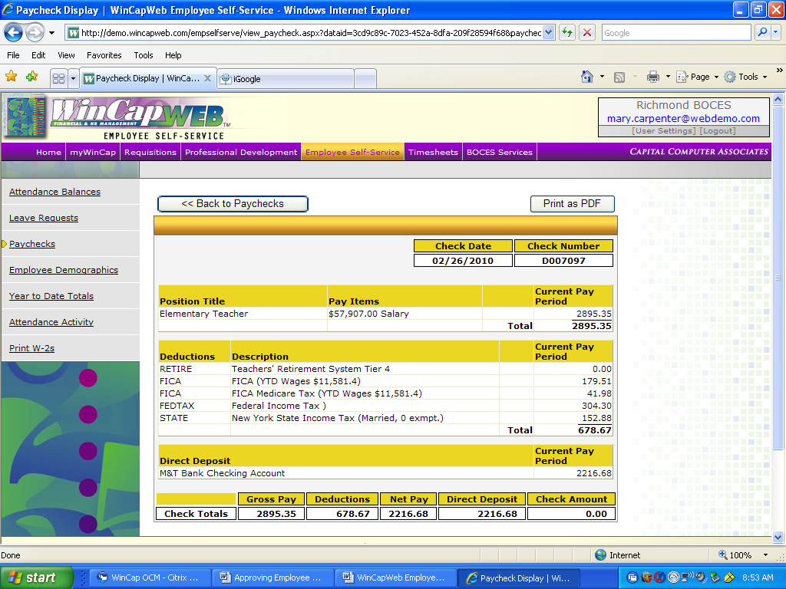

Note
In the “Paychecks” display, only the current pay period information appears on each paycheck.
To review year-to-date information for salary and deductions, you will need to go to the
“Year to Date Totals” section of the web.

Year to Date Totals

The year to date totals can be sorted by Fiscal Year to Date (July – June), Calendar Year to Date (Jan – Dec), Quarterly, or Monthly. Choose the type of information you want to view from the “drop down” box and select “Get Totals”.

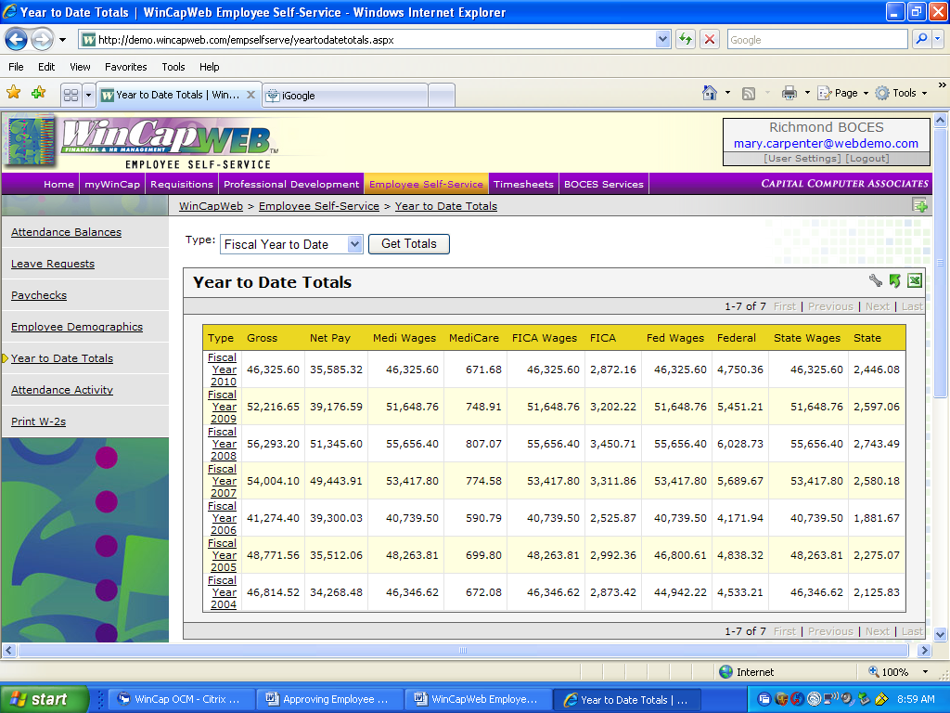

To view year to date detail information, click on the particular “Fiscal Year” (Calendar Year, Quarter or Month) you want to review in the “Year to Date Totals” area. Next scroll down to the “Year to Date Detail” section and more detailed information will appear based on how you sorted the data.

This is the detailed information that appears when you scroll down the page after clicking on “Year/Qtr/Mth” in the “Year to Date Totals” area.

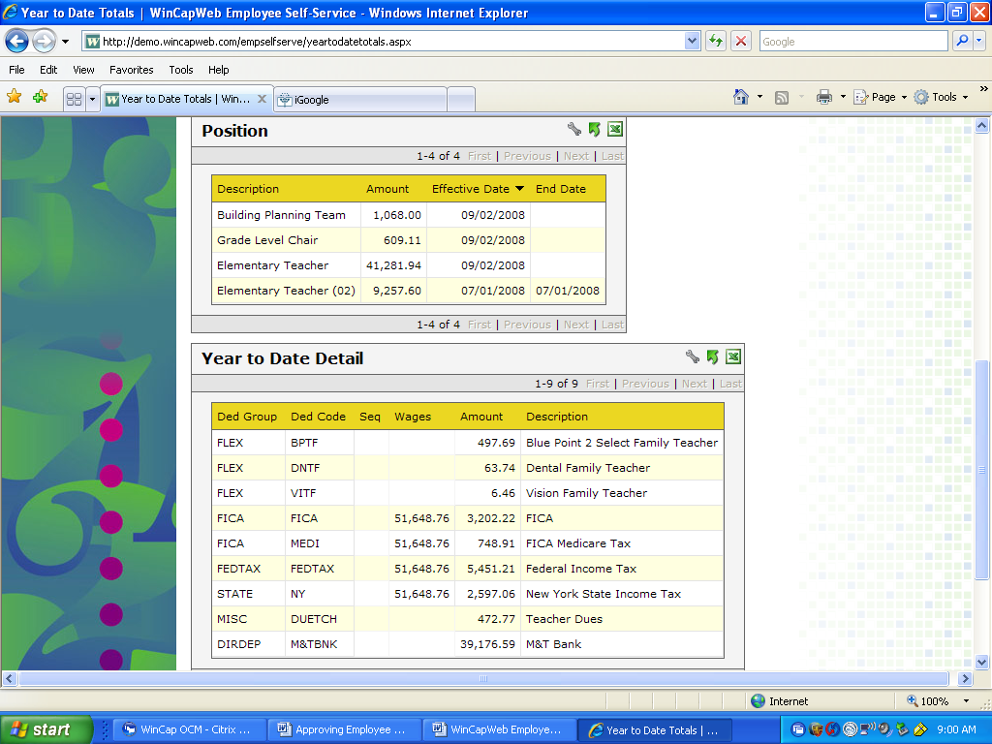

Attendance Balances

This section gives you a summary of your attendance balances by attendance code.

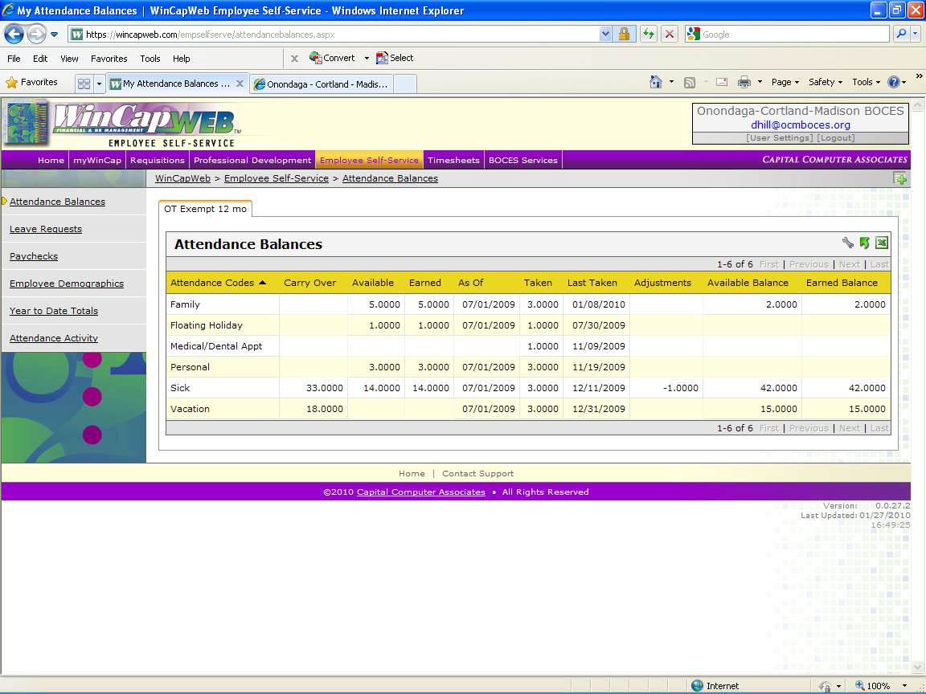

An explanation of the descriptions of column headers for “Attendance Balances” are as follows:
Carryover - Balance carried over from prior year
Available - Total new time that will be earned this year by year end
Earned - New time that has been earned this year to date
Adjustment - Manual adjustments/corrections posted to date
Available Balance - Total time available for use by year-end (reflects taken time but not requested time)
Earned Balance - Time carried over from prior year + current year earned
Requested - Time for leave requests not yet confirmed as taken

Attendance Activity

The Attendance Activity section will give you detailed information regarding your attendance transactions.

Use the “Activity Date Range” to select the time period that you need to see. Then click “Get Attendance”

Use to scroll bars to move up and down and left and right through the screen. You can also use the “wrench” to customize this page to show only those columns that are important to you. See the “Customizing Your View” section at the end of this document for information on this feature.

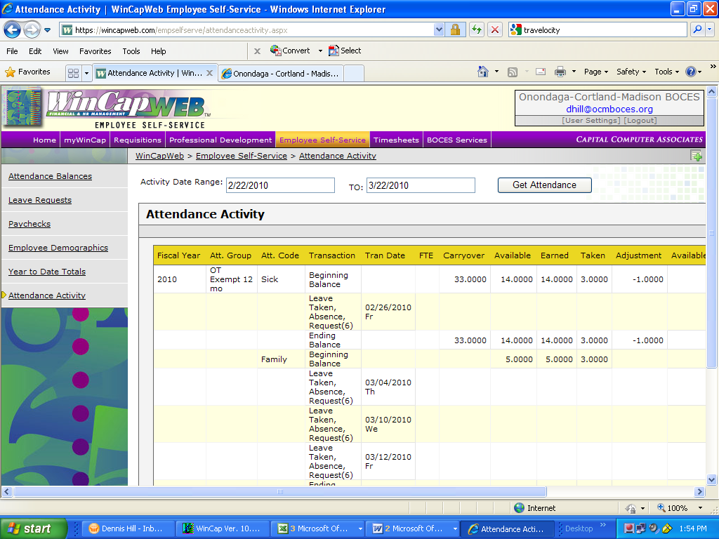

Leave Requests

This is the area where you will enter your requested leave days.

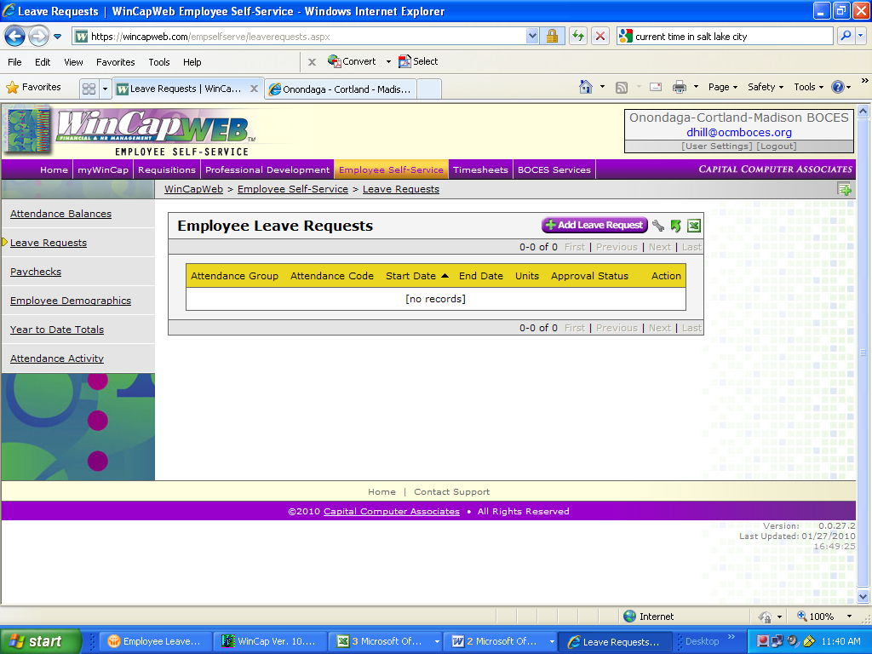

“Click” on “+ Add Leave Request” to request a leave day.

The Leave Request Form will open up.

The instructions for the Leave Requests are located at the top of the page. Follow these instructions when entering your requested day. Please remember to only enter a 1 or .5 in the “Units” box. This box represents whether you will be taking a full day or a half day on each of the days requested in this leave request transaction. It does not represent the total number of days you are taking off.

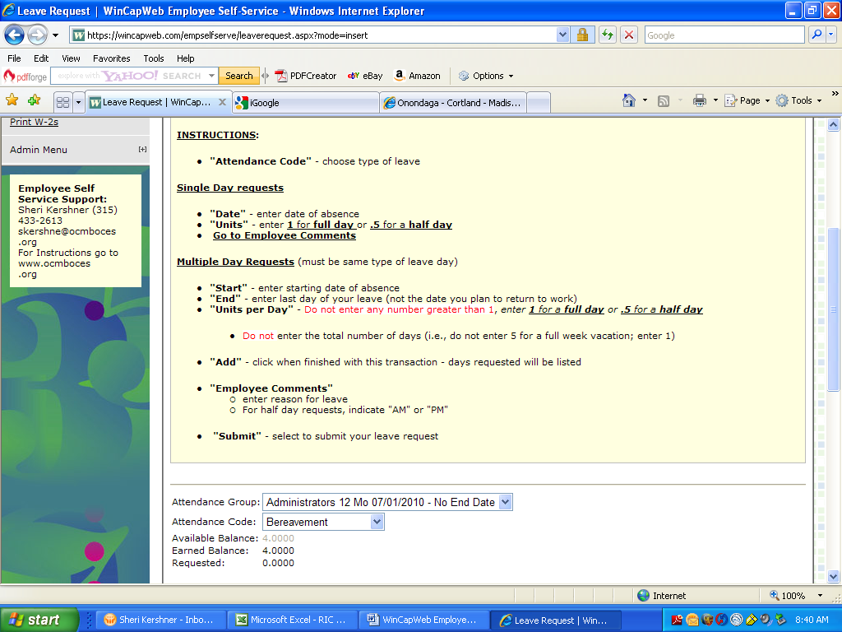
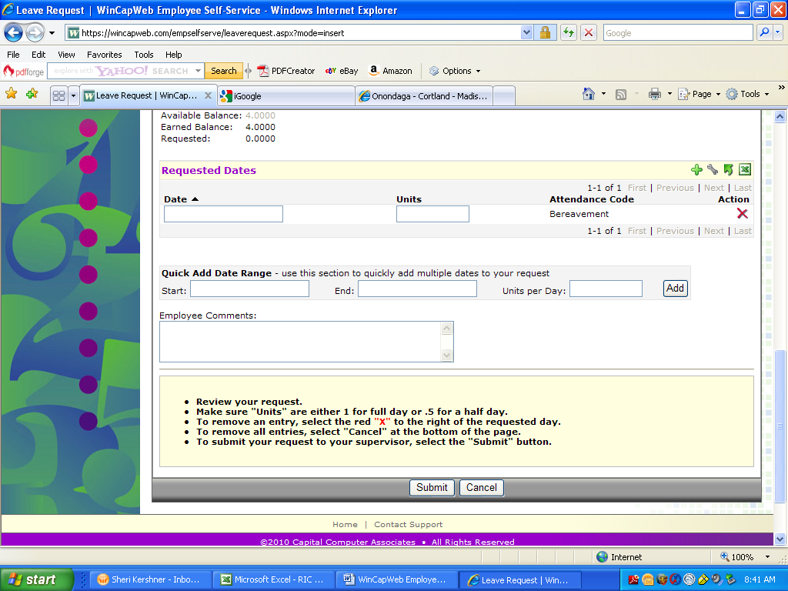

Follow the instructions at the bottom of the form, to review and submit your request.

Customizing Your View

Throughout the Employee Self Service area, you are able to customize the way information is viewed on the screen by clicking the “wrench” located in the upper right hand corner of the grid.

Whenever you select this wrench option, a “Table Display Settings” will appear (see below). You can then choose which columns you want to see and the order in which they will be displayed. Choose OK when you are all set.

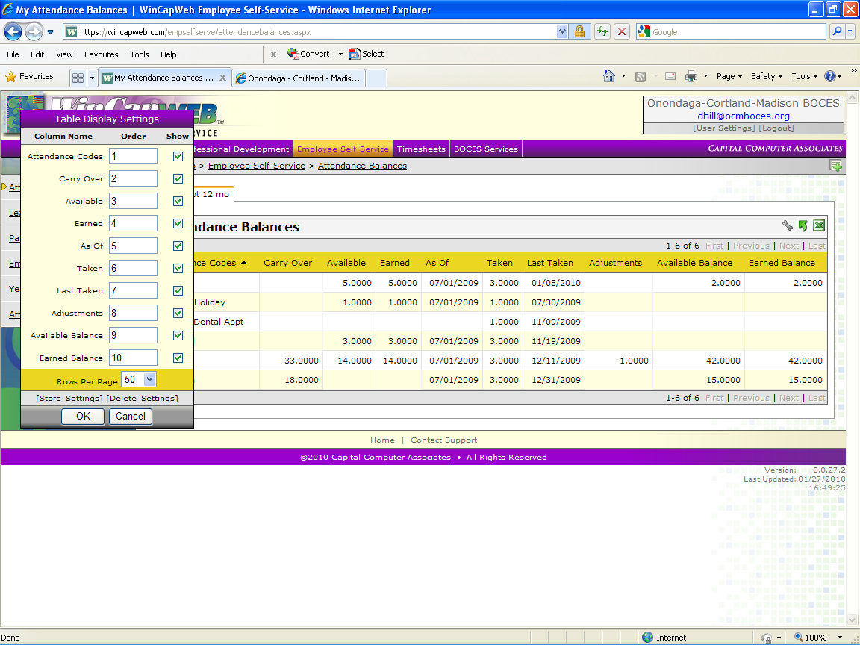

For WinCapWeb questions, please contact one of the three people listed below:

Sheri Kershner Tammy Jones Dennis Hill
(315) 433-2613 (315) 433-2632 (315) 433-2626
skershne@ocmboces.org tjones@ocmboces.org dhill@ocmboces.org

