WinCapWeb Employee Leave Approval Instructions

From this point further you should approve your requests only on WinCapWeb and not in WinCap. Once you approve or disapprove the request, the employee will automatically receive an email stating that the request has been approved or disapproved.

Go to www.wincapweb.com
Sign in with your username and password (Note: for your username, you only need to enter the first part of your email address prior to the “@” sign. ex – skershner)
Highlight the “Employee Self-Service” menu tab on the purple tool bar and go to “Admin Menu” and then “My Leave Request Approvals”

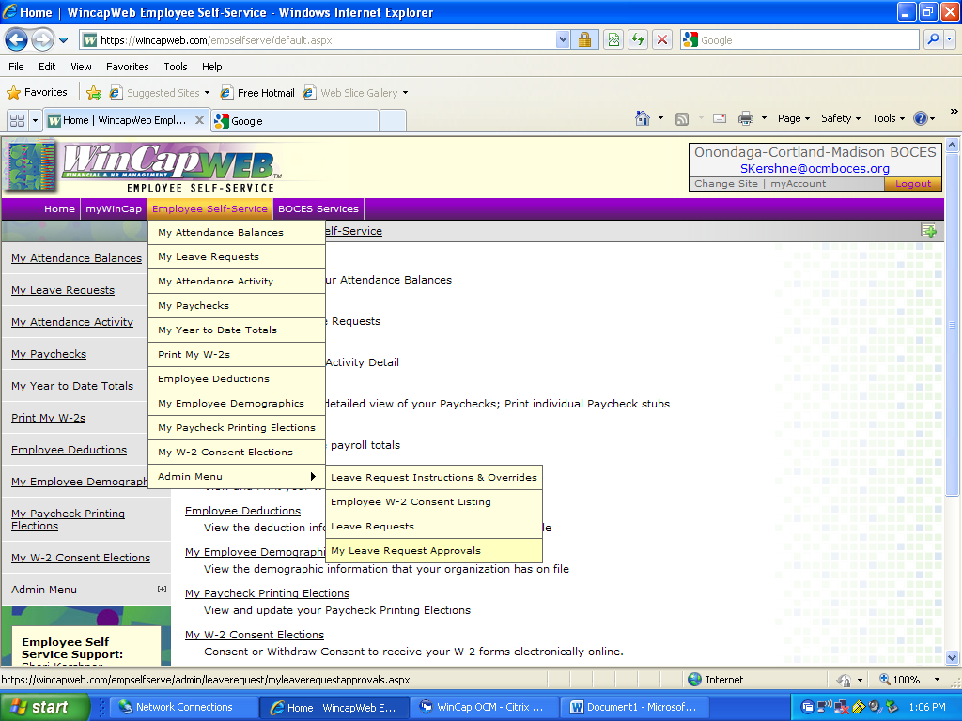
If there are any leave requests waiting for your approval they will appear in the “My Leave Request Approvals” box.

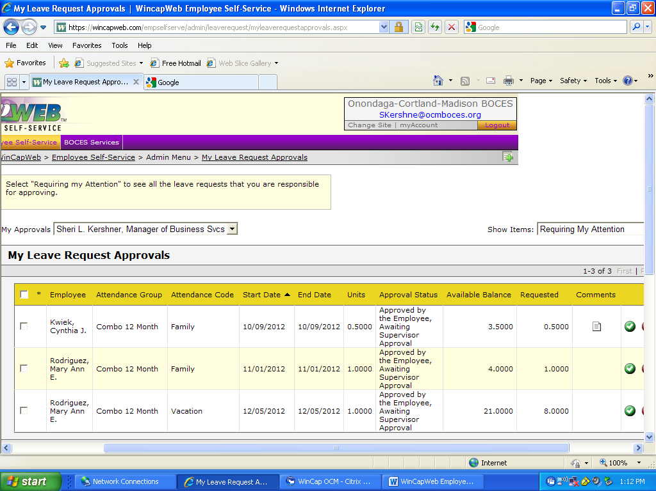

Review each leave request transaction to determine whether you want to approve, disapprove or put on hold.

IMPORTANT: Before you approve the request, make sure that the employee has enough days available. To do this you should compare the “Available Balance” column with the “Requested” column. If the “Requested” column is greater than the “Available Balance” column, you should not approve the request, unless the day is a “Medical/Dental” or “Family Excess” day. “Medical/Dental” or “Family Excess” leave request days come from the employees “Sick” balances. As a result, the employees are not assigned an available balance for these types of days and the “Available Balance” column will be zero. Please note that you must make sure the employee has enough sick time to cover these requests however. If you have an employee you are concerned about, please contact Sheri Kershner to assist you in looking up the sick days available in WinCap. Also, employees are limited to “5” “Family Excess” days, so make sure the requested “Family Excess” days do not exceed this limit.
If you have any questions on the number of days available to your employees, please consult their union contracts or speak with the Tammy Jones in the Personnel Department.

If there are any comments in the “Comments” column, you can click on the piece of paper icon and the comment will appear. In this example, the comment indicated that the half day was for the “pm”.

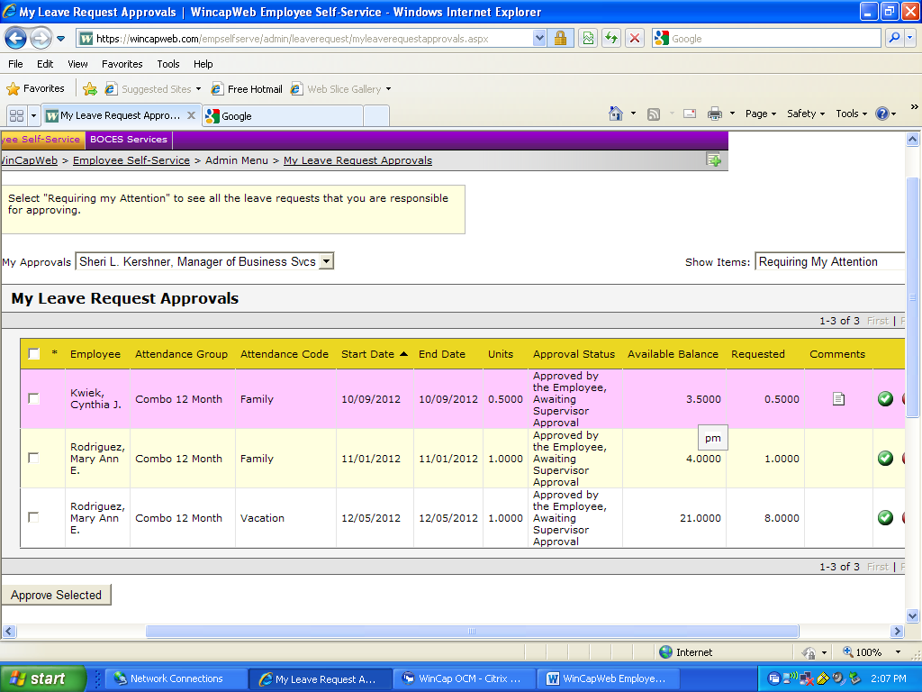

To Approve A Leave Request

There are two ways to Approve a leave request. The easiest way is to click on the box to the left of the request. If you have more than one request, click on all the ones you want to approve.

Once all the transactions are checked that you want to approve, hit the “Approve Selected” box at the bottom of the screen. Please note that you must review each transaction to determine that there are days available prior to selecting the box to approve.

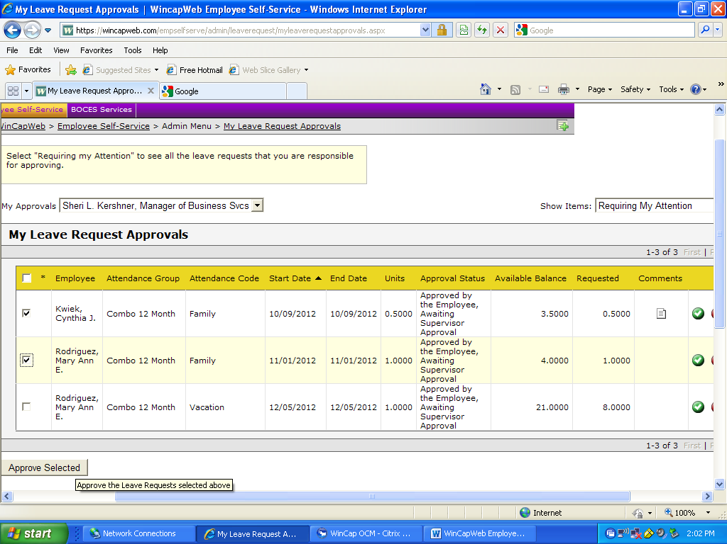

After you approve the requests, you will get a confirmation that the requests were approved. You will also notice that the transactions you approved are no longer in your “My Leave Request Approvals” box.

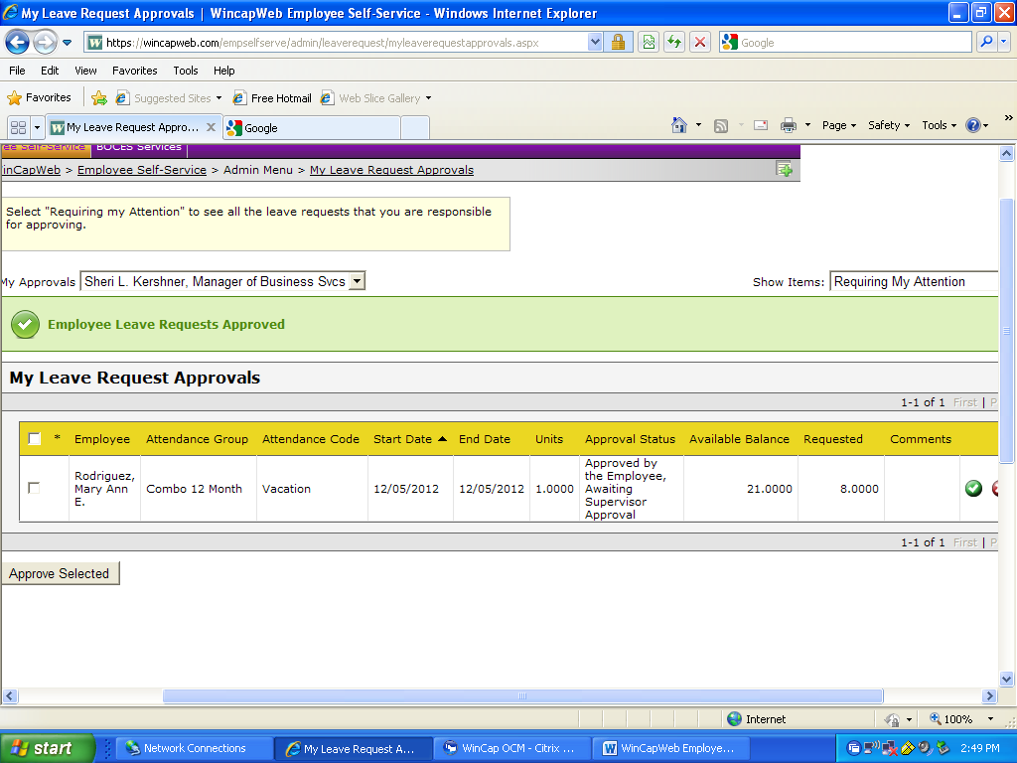

To approve the transaction individually, click on the green circle icon with a check mark in it in the “Action” column all the way to the right of the screen.

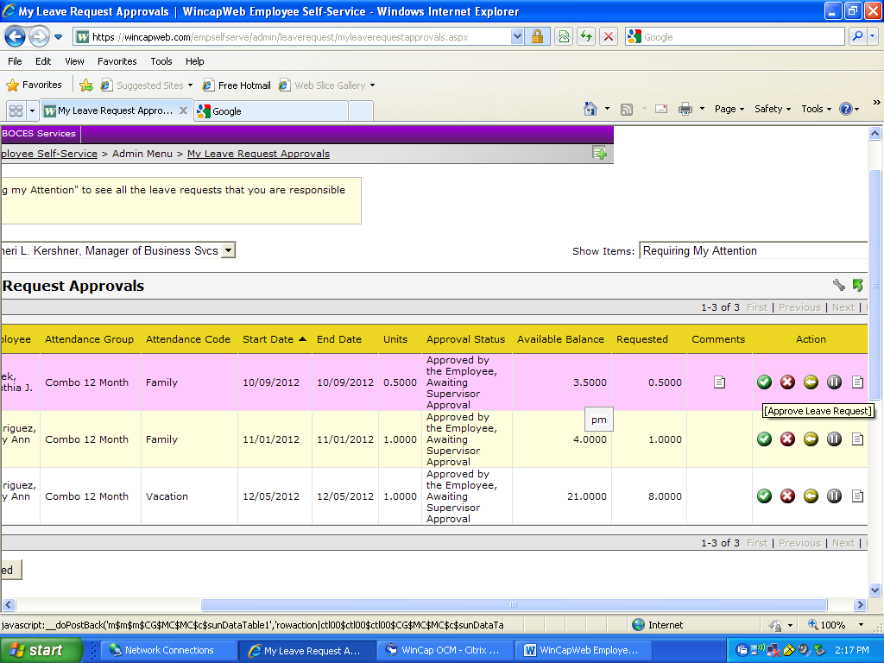

A box will open up below. Review the transaction and then hit “OK” to approve.

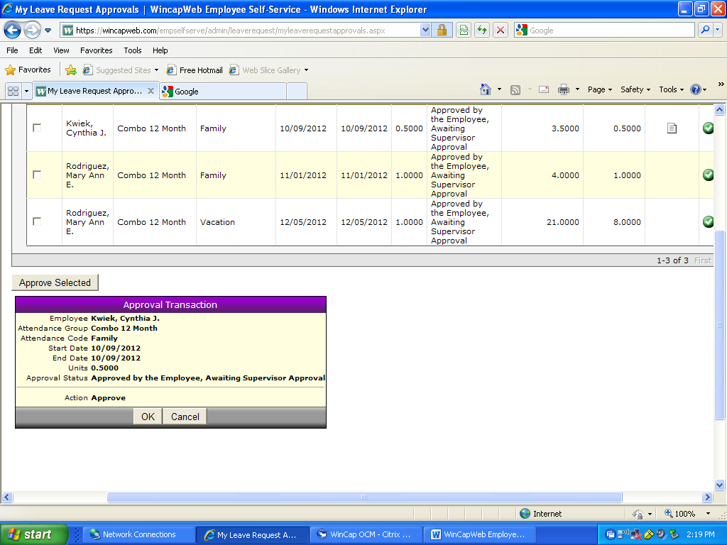

To Disapprove a Request

Click on the red circle icon with an X in it, in the “Action” column.

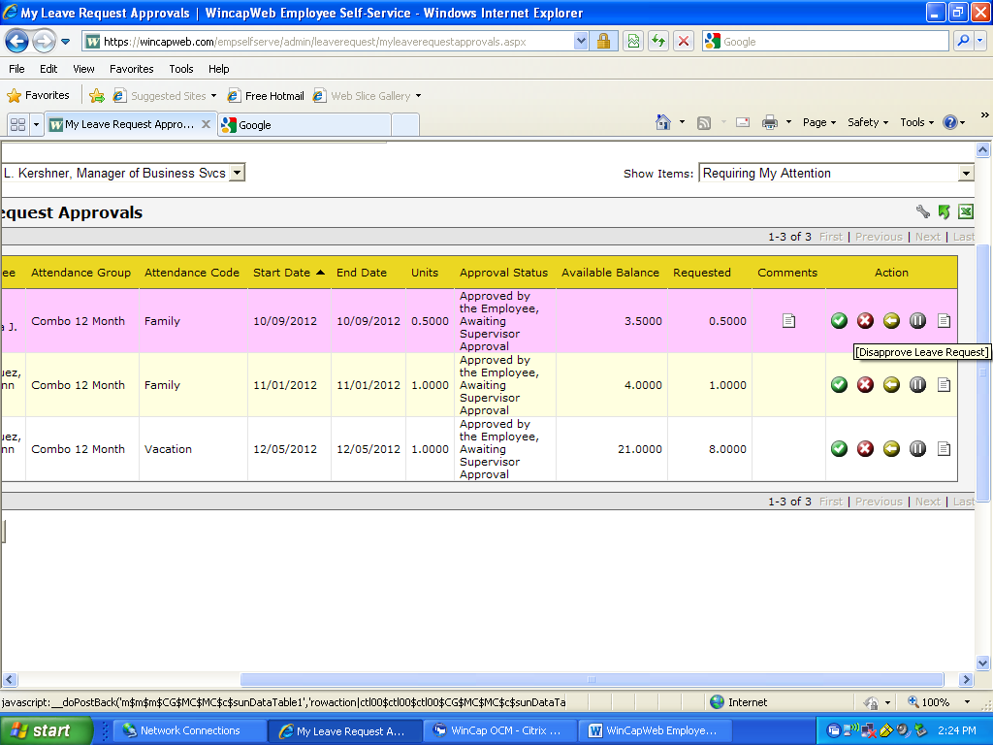

Clicking on this icon will bring up a box at the bottom of the screen asking you for a comment as to why you are disapproving the request.
Type in the comment and then hit “OK” to disapprove the request.

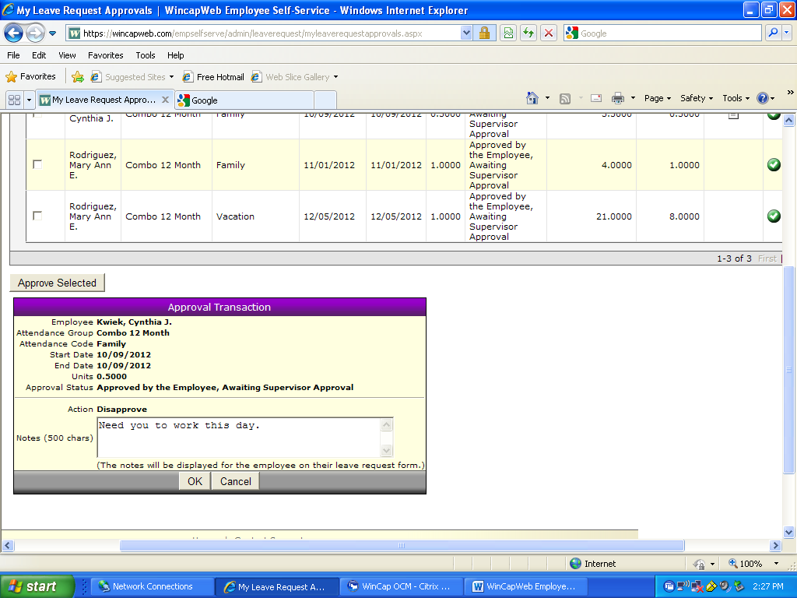

Other Options

Under the “Action” column there are some other options you can use.

The yellow icon with the left arrow in it, will allow you to refer the request back to the employee. This will put the request back at the employee’s level. The only thing that the employee can do with it at this time is to cancel or change the units. They will not be able to change the type of day.
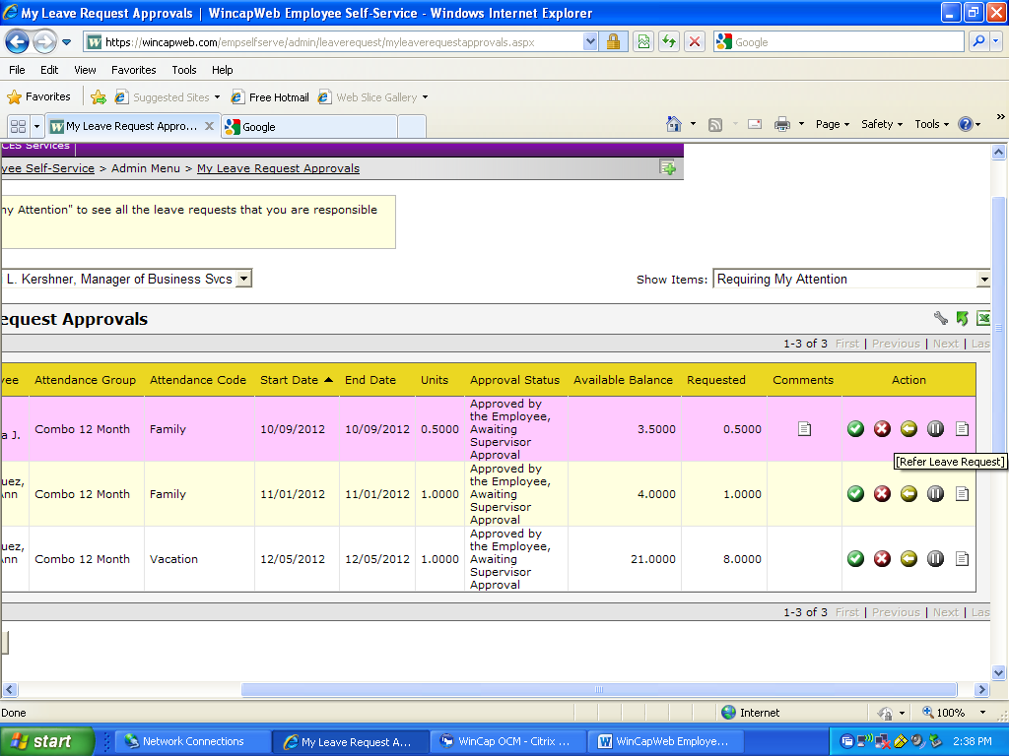

The grey icon with the pause symbol in it, allows you to put the request on hold. If you select this, you will no longer see the request in your listing to approve that automatically comes up when you go to “My Leave Request Approvals”. To view the request again at a later date, you would need to hit the “On Hold” drop down menu option in the “Show Items” box on the top right of the screen.
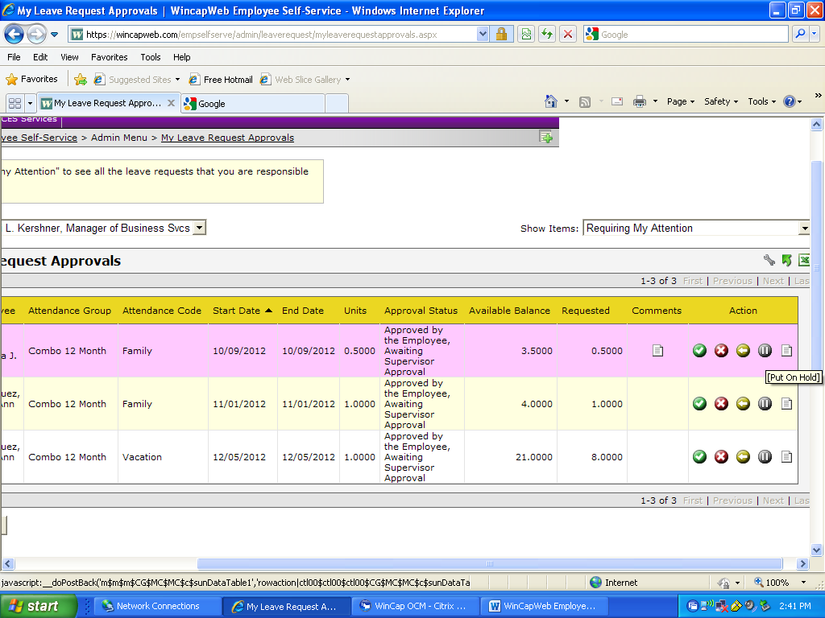
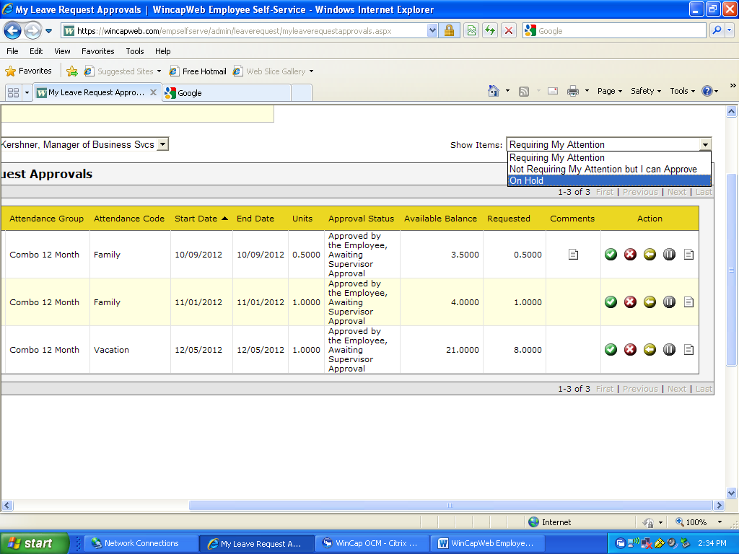

The piece of paper icon in the “Action” column, will allow you to view the employee leave form that the employee filled out electronically.

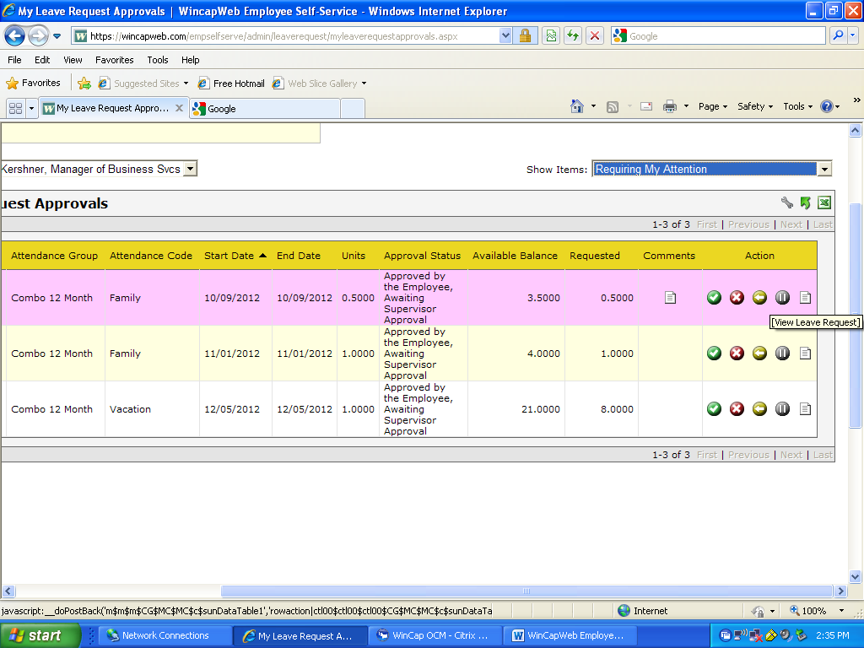

To Find a Request that You Have Already Approved

Once you approve a request, it automatically disappears from your “My Leave Request Approvals” box. Also once you have approved the request, the employee can no longer cancel or change the units requested. If an employee comes to you after you have already approved the request and asks you to delete the request, you will need to do the following.

Go to the top purple tool bar and highlight the “Employee Self-Service” menu tab and go to “Admin Menu” and then “Leave Requests”.

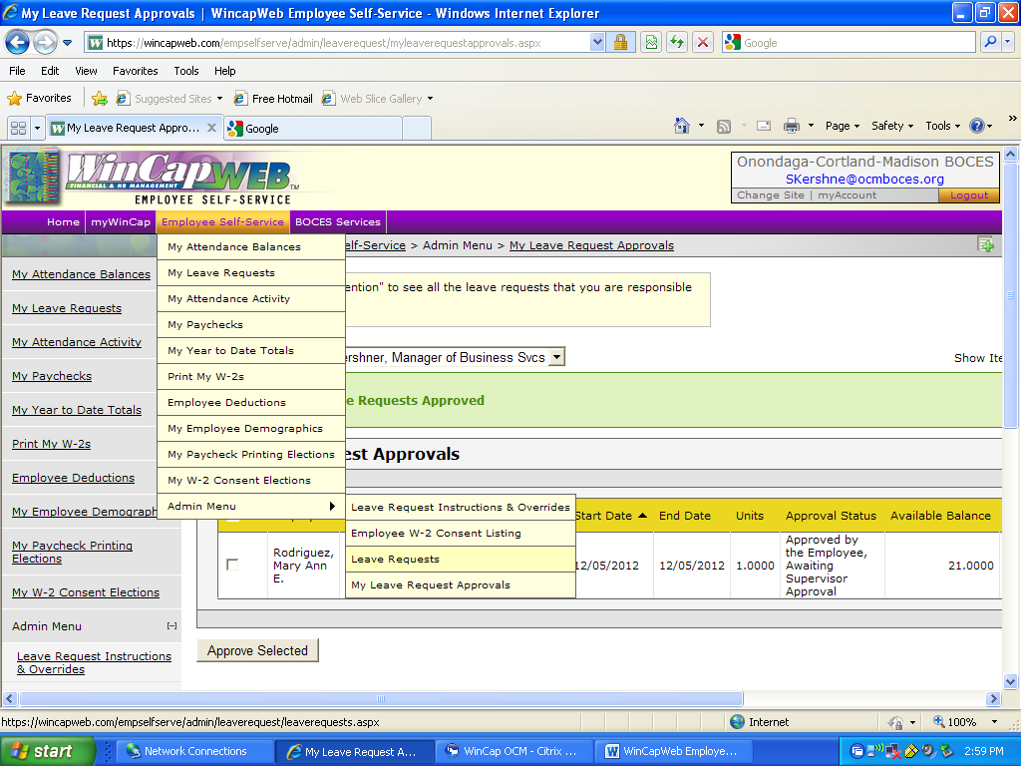

This will bring you to a list of your employee leave requests. Anything that has not been posted yet will have pencil icon or a red X icon next to it. These are the only transactions that you can do anything with. If a transaction needs to be changed that has already been posted, you will need to contact Tammy Jones in the Personnel Department.

If the transaction has not been posted yet, you can edit the units per day by selecting on the pencil icon. This will bring you back to the employee leave request where you can make your change.
You can remove the request by clicking on the red X icon. This will bring you back to the employee leave request for you to enter a reason why you are removing the request.
To make it easier to find the transaction, you can sort the list by clicking on any of the column headings. If you do not, they will appear in the order that they were entered on the web.

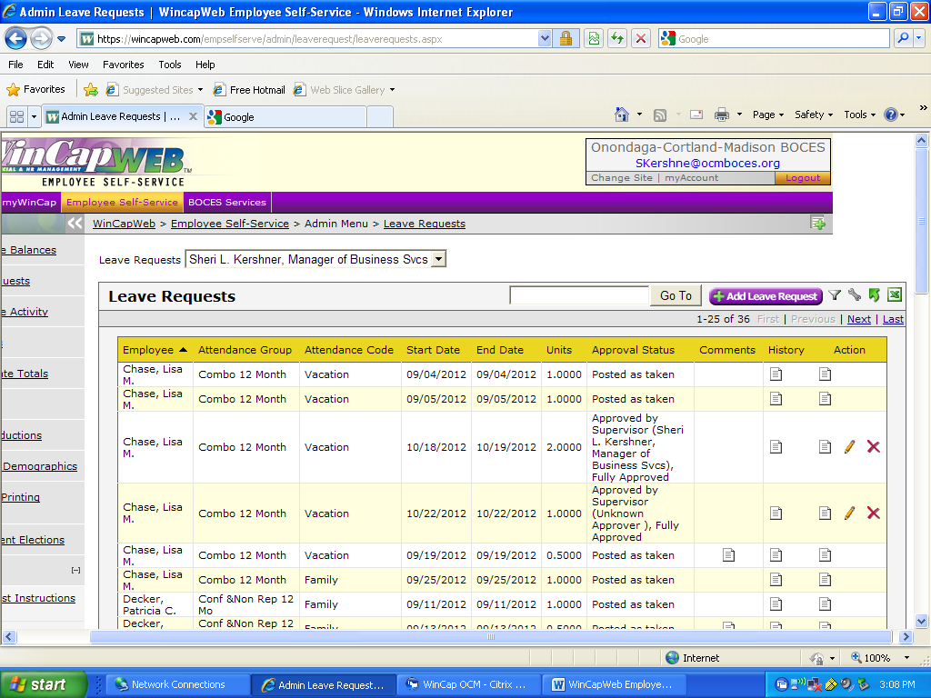

Any questions, please contact Sheri Kershner at (315) 433-2613 or skershne@ocmboces.org.

