WinCapWEB Employee Self Service

You have been invited to create a WinCapWEB account with OCM BOCES. Once the account is created (by selecting the link in the invitation email and following the account creation steps) you will have access to the Employee Self Service module. WinCapWEB is accessible through any internet browser, at home or at work by going to www.WinCapWeb.com and using the username (email) and password you established. This is a portal where you can access your attendance balances and activity, initiate leave requests, demographic and deduction changes as well as print paycheck stubs and W-2s. Below you will find instructions on printing your paychecks and reviewing your year-to-date payroll information.
My Paychecks
Any paycheck stub you have received through WinCap may be obtained under the paychecks section of Employee Self Service.
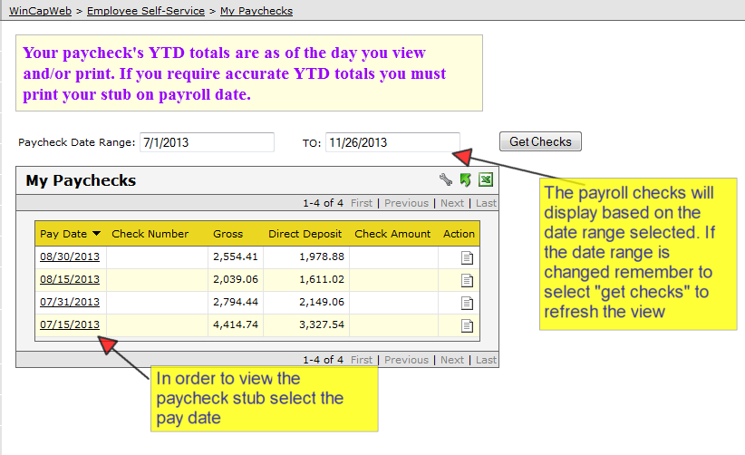

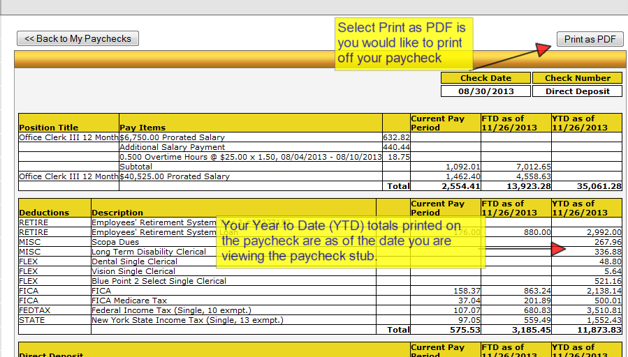

Note
When you click on the Print as PDF button, you will have the option to save your PDF to your computer or thumb drive instead of printing.

Important
Your Year to Date (YTD) totals will reflect the most current information in the payroll system. Therefore, if you print a paycheck from 6 months ago, the YTD information will reflect your latest paycheck, not the one you are printing. In order to retain the YTD information, you will need to print or save the paystub after each payroll.

If you have any questions, please contact payroll at (315) 433-2667 or (315) 433-2626.

My Year to Date Totals
The My Year to Date totals section allows you to obtain position and deduction data for particular fiscal and/or calendar year as well as quarter or month.
