WinCapWeb Instructions
How to Enter a Day Off

- Go to www.wincapweb.com
- Log on - (username is BOCES email address)
- Go to “Leave Requests”
- Click on

To take one day off:

- Choose the “Attendance Code”
- Enter the “Date”
- Enter the “Units” (1 or .5)
- For ½ day (.5), indicate AM/PM in employee comment section
- Click on “Submit” at the bottom of the form. (Note–you do not need to hit “Add”)

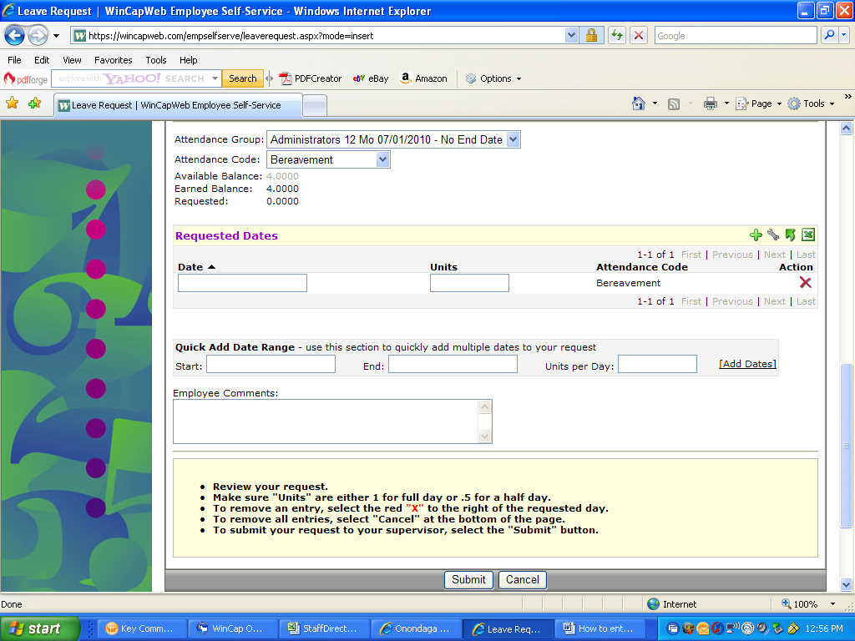

To take consecutive days off: (Note – must be the same type of day)

- Choose the “Attendance Code”
- Enter the “Start” and “End” dates in the Quick Add Date Range area
- Enter the “Units per Day” (1 or .5)
- For ½ day (.5), indicate AM/PM in employee comment section
- Select “Add Dates”
- Wait for summary of days to appear above the date range

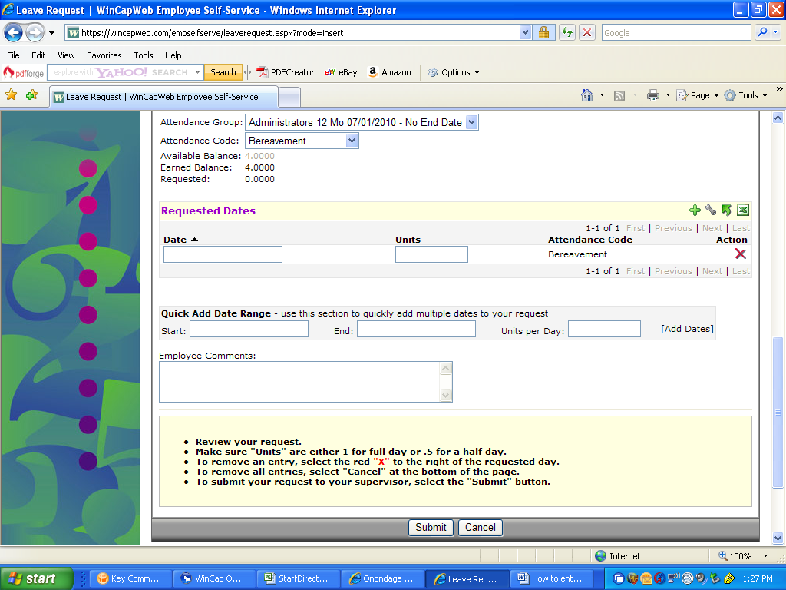
0.5 or 1.0

- After dates appear and days look appropriate, click on “Submit” at the bottom of the form

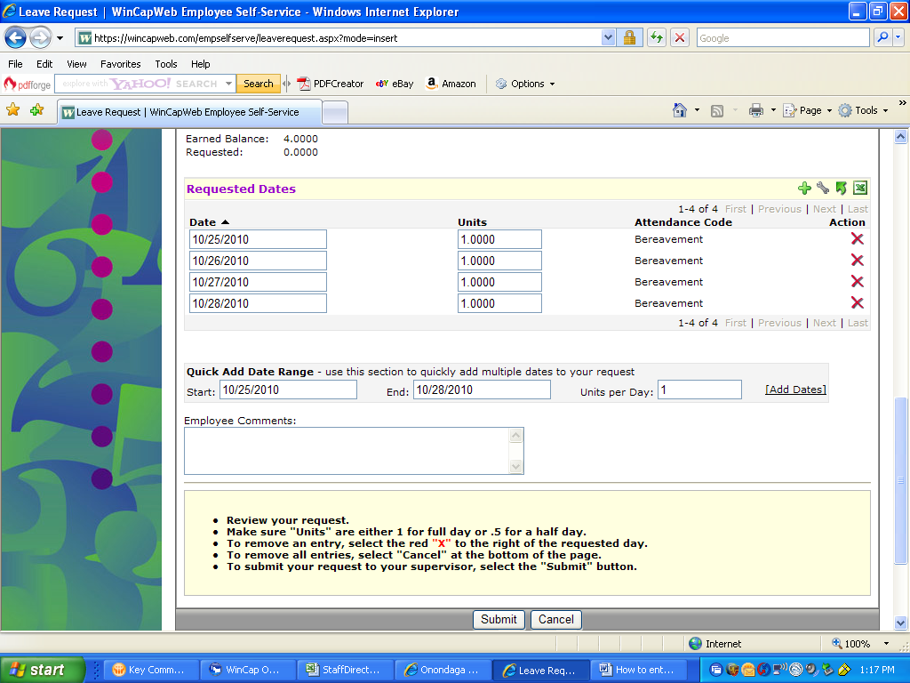

If you have any questions or issues, please call Tammy Jones at (315) 433-2632, Sheri Kershner at (315) 433-2613 or Dennis Hill at (315) 433-2626.

