Payroll Budget Status Report

Go to Reports, Payroll, Payroll Accounting Reports, Payroll/Employee Budgetary Status Report
(To make it easier to get to the report, set up a shortcut icon “PBR”. You may already have this on the right side of your screen. If you need assistance on setting up this icon, contact Sheri Kershner at (315) 433-2613 or skershne@ocmboces.org)

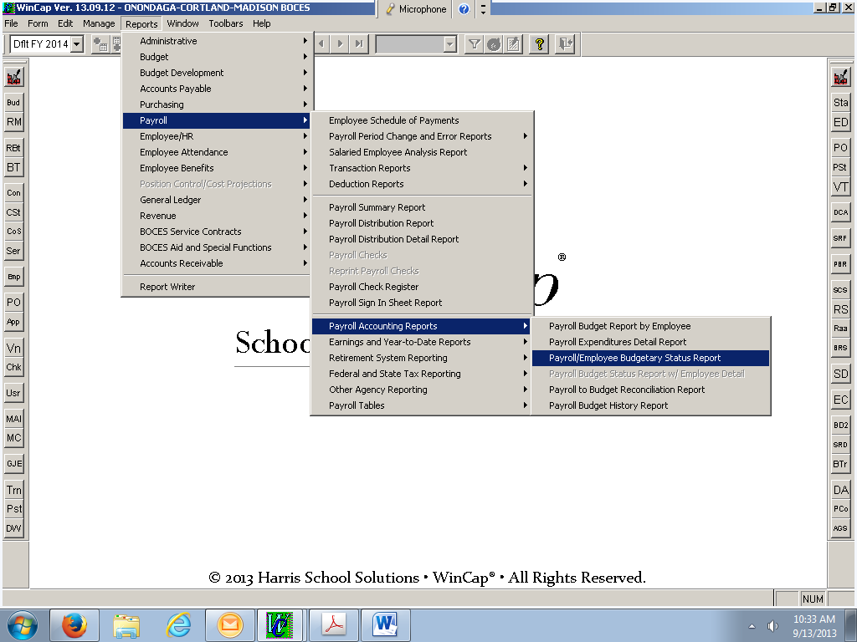

At the header screen choose to sort by “Budget Code”. You are welcome to narrow your search down further by selecting other options on this screen, such as “Division”, “Supervisor”, “Budget Code”, etc.

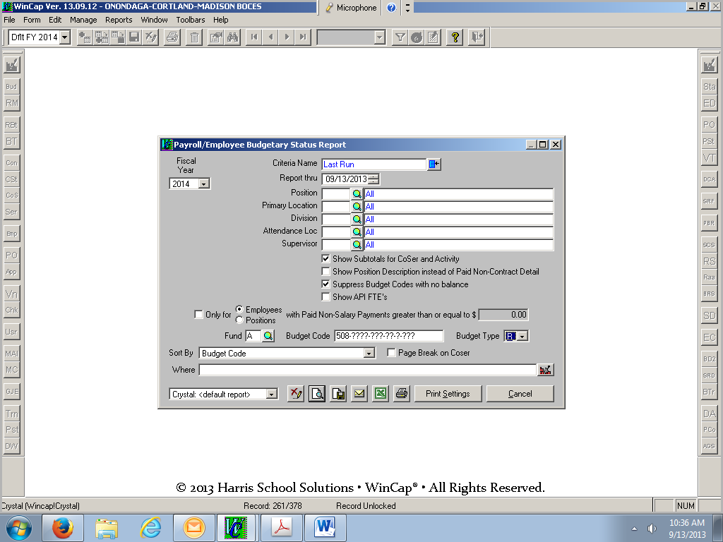

To view the report on the screen, hit the print preview icon at the bottom of the screen (piece of paper icon with a magnify glass on it). To print the report, select the printer icon.

