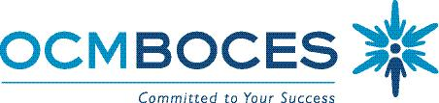

Special Education Council

Meeting Schedule 2018-2019

9:00 -11:00 A.M.
Date of Meeting | Location of Meeting
September 13, 2018 | Cayuga Conference Room:  Main Campus - OCM BOCES  110 Elwood Davis Dr.  Liverpool, NY 13088
October 25, 2018 | Owasco Conference Room, Main Campus
November 15, 2018 | Onondaga Room, 200 Elwood Davis Road  200
December 13, 2018 | Cayuga Conference Room
January 10, 2019 | Cayuga Conference Room
March 14, 2019 | Cayuga Conference Room
April 11, 2019 | Cayuga Conference Room
May 9, 2019 | Cayuga Conference Room
June 6, 2018 | Cayuga Conference Room

8/27/18 BC

All Meetings will be held the 2nd Thursday of the month except for November which is the third Thursday of the month at 200 Elwood Davis Road, next to Main Campus.

There is no meeting in February.

