**C:\Users\lcarter\AppData\Local\Microsoft\Windows\Temporary Internet Files\Content.IE5\0LPEJVHJ\MC900297565[1].wmf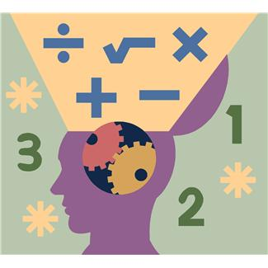7-12 Math Committee Minutes**

**October 30, 2014**

**Welcome New Members!**

**Math Task**

* Thank you Jason!
* Task:

“How old are your daughters?” Fred asked one day.

“The product of their ages is 36” replied his friend George.

“You are not giving me enough information” protested Fred.

“The sum of their ages is the age of your oldest son,” said George.

“That narrows it down some, but I stil need more information,” replied Fred.

“Fine then…I can tell you that my oldest daughter, who is at leasta year older than the other two, is a fine piano player.”

“Ahhh! Now I know how old your daughters are!” What are the ages of George’s daughters and how did Fred know?

**Reviewed Purpose & Goals of Committee**

* Develop a common understanding of Common Core shifts, mathematical practices and standards as a committee
* Determine current state of students’ math skills and current practices in math classrooms across BOCES
* Develop a plan for professional development for math teachers across BOCES
* Research and recommend resources / textbooks should be purchased to support instruction aligned to Common Core
* Research math intervention programs and determine if intervention programs should be purchased
* Develop meaningful ways to incorporate literacy into the math classroom

**Norms**

* Discussed and established norms for our work together
* See PowerPoint for established norms

**Review of Mathematical shifts and practices**

* Reviewed shifts and practices
* Activity – putting various I can statements

**Data Dive**

* Reviewed Regents and 3-8 data and discussed strengths and areas of focus

**Math Rounds**

* Discussed the purpose and focus of math rounds

**Getting to the 7-12 Math Committee website:**

Go to website, under OCM BOCES ONLY, Instruction, 7-12 Math Committee (left top)