**C:\Users\lcarter\AppData\Local\Microsoft\Windows\Temporary Internet Files\Content.IE5\0LPEJVHJ\MC900297565[1].wmf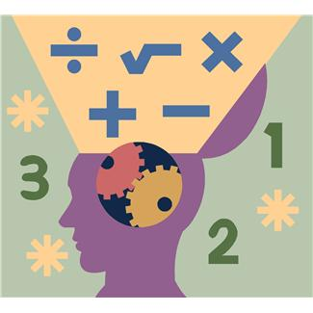7-12 Math Committee Minutes**

**October 2, 2013**

**Welcome New Members!**

**Math Task**

* Thank you Taylor!
* Task:

Laila tells Julius to pick a number between one and ten. “Add three to your number and multiply the sum by five”, she tells him. Next she says, “Now take that number and subtract seven from it and tell me the new number”. “Twenty-three” Julius exclaims.

Write an expression that records the operations that Julius used.

What was Julius’ original number?

In the next round Laila is supposed to pick a number between 1 and 10 and follow the same instructions. She gives her final result as 108. Julius immediately replies, “Hey, you cheated!” What might he mean?

**Reviewed Purpose & Goals of Committee**

* Develop a common understanding of Common Core shifts, mathematical practices and standards as a committee
* Determine current state of students’ math skills and current practices in math classrooms across BOCES
* Develop a plan for professional development for math teachers across BOCES
* Research and recommend resources / textbooks should be purchased to support instruction aligned to Common Core
* Research math intervention programs and determine if intervention programs should be purchased
* Develop meaningful ways to incorporate literacy into the math classroom

**Article Discussion**

* Reading in the Mathematics Classroom

*What does this mean for my students?*

* Students need to be taught the same mathematical language (plugging things in instead of substituting)
* Teaching students the process and thinking; how to persist
* Need to learn the application of practices

*What does this mean for me as a math teacher?*

* We need to be cognizant of how we present problems
* Mathematical reading: We need to read through problems and dissect with students (guided practice)
* Need to be intentional in teaching mathematical language
* Need to shift from being a questioner vs. a decider
* Need to teach how to analyze the structure of a textbook
* Cross curricular opportunities

**Update on Pilot of Math 180**

* Corey Dobbins shared the structure of Math 180 and how it has been going as well as some of the challenges

**Update on Math Navigator**

* Kaley Laine shared the structure of Math Navigator and how it has been going we well as some of the challenges.

**Presentation from National Math Conference**

* Turnkey presentation of Peg Smith’s Task, Tools, and Talk: A Framework for Enacting Mathematical Practices workshop

**Conference Information**

[www.amtnys.org](http://www.amtnys.org)

Calculator training – October 18th