**C:\Users\lcarter\AppData\Local\Microsoft\Windows\Temporary Internet Files\Content.IE5\0LPEJVHJ\MC900297565[1].wmf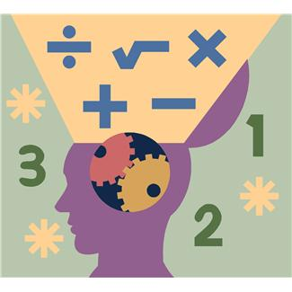7-12 Math Committee Minutes**

**February 12, 2014**

**Math Task**

* Thank you Kris!
* Task:

Using QR Codes to solve equations

**Reviewed Purpose & Goals of Committee**

* Develop a common understanding of Common Core shifts, mathematical practices and standards as a committee
* Determine current state of students’ math skills and current practices in math classrooms across BOCES
* Develop a plan for professional development for math teachers across BOCES
* Research and recommend resources / textbooks should be purchased to support instruction aligned to Common Core
* Research math intervention programs and determine if intervention programs should be purchased
* Develop meaningful ways to incorporate literacy into the math classroom

**Celebrations!**

* Celebrations in a shoe aligned to the mathematical practices

**Sharing Student Work Using January Literacy Strategy**

* Thank you for bringing student work to share!
* Please keep using the strategies

**Review, Exploration, and Discussion of Instructional Resources for grades 7 & 8**

* Gretchen led the team through a textbook alignment activity. All of the groups chose the ‘pink’ textbook.

**What Does the Data Tell Us about Math 180?**

* We have seen some growth! So far, the growth of the 58 students enrolled has been 168 quantiles on average. The 7th graders have grown 100 quantiles and 8th graders have grown 179 quantiles.
* There is an upcoming full day of training scheduled.
* We will look more data after the training.
* There has been discussion about comparing the STAR data and the SMI data – the measures are different though.
* We still need to determine how to proceed for students who are performing below the ‘entry’ point for Math 180

**Progress Update on Math Navigator**

* Students are growing!
* Teachers report that the levels of complexity vary depending upon the module; kids who are in class consistently are established with the routine. Some students are experiencing difficulty with the level of the materials. Modules have a grade level with aligned (some say 8, others 8+). Teachers reported that the 8+ materials are more challenging. Overall, things are going smoother now that the first module is complete.

**Next meeting: March 12 ~ 8:30 am– 11am at Henry Campus**