Terrestrial
Ecosystems

Kit #75

Blackline Masters

Revised February 2012 Adaptable Teacher Edit copy

Ecosystems Research Project
Introduction
There are different places where different kinds of plants and animals live. Some places are hot, dry places while others places are cool, shady places. Different kinds of plants and animals live in these different environments although some plants and animals live in a variety of environments. You may have seen trees, insects and mammals near your home. You may have also seen grass, flowers, birds and worms. All these things get what they need to live from their environment, or everything around them. In an environment the living and nonliving things that affect each other to form an ecosystem.

The Question
What are the characteristics of some different ecosystems?
OR
What are the different environments around the world and what lives there?

The Learning Task
Your TASK will be to explore ecosystems through surfing the web. You will complete many tasks in order to further your knowledge of a specific ecosystem. You will compile your completed tasks into a classroom presentation. The tasks will be to:

    - List characteristics of the environment of the ecosystem (think atmosphere, hydrosphere, geology, energy: try to list one for each of these).

    - Create an animal and plant list for the ecosystem (major plant and animal populations).

    - Select one plant and one animal to study: create a labeled drawing, list interesting facts about the organism’s life activities in the environment, etc.

    - Construct a food chain, food web and energy pyramid

    - Identify environmental impact issues

    - Venn diagram comparison to another student’s ecosystem

    - Write a letter (email)

    - Written narrative or technical presentation

    - Diorama

    - Oral presentation and presentation of diorama

Ecosystems Research Project, pg. 2
Background: Something for Everyone
You and your classmates will explore the many different ecosystems found all over the world. You will be learning about the environment and the animals and plants which inhabit each ecosystem. Your job is to help your classmates to learn about a specific ecosystem by sharing your research with them. The first step or “Phase 1” is to decide which ecosystem you are going to study and to start your research.
Phase 1: Land Ecosystems
Using the internet or library resources explore different land ecosystems or biomes. Talk to your teacher about the land ecosystem you find most interesting. With your teacher’s approval complete the following tasks pertaining to the ecosystem.

1. Identify at least 4 characteristics of the ecosystem’s environment.

2. Name at least 4 animals and 3 plant populations found in the ecosystem.

3. Select one plant and one animal to study: create a labeled drawing, give 4 interesting facts about each organism’s life activities in the environment.

4. Narrative: Pretend you are a tour guide working in your chosen ecosystem. Describe the environment to me as if I were a tourist on your bus. Tell me about the scenery, the animals, the plants and any other important information.
Phase 2: Communities

Now that you have a good understanding of the nonliving and living parts of your ecosystem, it is time to look at the major communities of living things in your ecosystem. You will be adding to your list of animal populations additional animals that make up the ecosystem community,

1. Look at your list of 4 animals from Phase 1, step 3. Classify each of these animals as herbivores, carnivores, omnivores, or decomposers. If you do not have an animal for each of these groups for your ecosystem, do research to find additional animals.

2. Construct a food chain diagram for your ecosystem. Tell how an increase in the population of one of the organisms affects the other organisms in the food chain (be specific).

3. Construct a food web for your ecosystem. Explain how a decrease in a population in a food web affects the other populations in the food web community (be specific).

4. Construct an energy pyramid for your ecosystem using one population of organisms for each level. Explain how the shape of the pyramid shows the energy flow in the ecosystem.

Ecosystems Research Project, pg. 3
Phase 3: Ecosystem Impacts
Revisit your resources or find new information on ways in which the ecosystem you are studying is impacted by nature, by the organisms living there or by other forces.
1. Select a population in your ecosystem. Tell how an individual in that population can have a harmful, competitive or beneficial interaction with another organism in the ecosystem.
2. Select a part of your ecosystem environment. Tell how a change in that part will affect a specific population of organisms.
3. Write about a natural change that could occur in the atmosphere, hydrosphere or geology of the area you are studying.

Phase 4: Debating, Discussing and Reaching Consensus
You and your classmates have learned about different ecosystems. Now you will pair with another team or person to compare/contrast two separate ecosystems (please compare with someone doing a different ecosystem) using a Venn diagram. After this discussion, the two of you should work together to write a short paragraph stating how the two ecosystems are alike and how they are different.
Phase 5: Real World Feedback
You have learned a lot about ecosystems. Now is the time to put your learning into a letter you will send out for real world feedback. You will write a letter (an email letter) that contains opinions, information and perspectives that you have gained. Here's the process:
1. Think of something about your ecosystem that you found interesting or about which you would like more information. Compose a question about this interest.
2. Begin your letter with a statement of who you are and why you are writing your message to this particular person or organization.
3. Give background information that shows you understand the topic.
4. State two questions you would like to ask the person about ecosystems. (Yes and no questions or one word answers are not acceptable.)
5. Write your paragraph and have your partner proofread your message.
6. Use correct letter format and make sure you have correctly addressed the email message. Use the link below to make contact. Before you send your message make sure your teacher gets a copy and gives you permission to send the email.

Your Contact is: Ask Earl about Ecosystems (http://kids.yahoo.com/ask_earl)

Ecosystems Research Project, pg. 4

Phase 6: Summative Assessment
Presentation: Create a written report, a technical presentation using audio-visual components, or create an audio recording and a handout with the basic information about your ecosystem. Create a diorama for your ecosystem.
Report Part:
Use the information that you gathered for Phase 1, Phase 2 and Phase 3 to create a written or verbal presentation.
Be sure to include the following:
- Name of the ecosystem (type of ecosystem)
- Characteristics of the 3 major parts of the environment
- Plant populations found there (minimum of 3)
- An example of how a plant is adapted to the ecosystem environment
- Animal populations found there (minimum of 4)
- An examples of how an animal is adapted to the ecosystem environment
- Community: Share how the plant and animal populations interact by using the terms producers, consumers (herbivore, carnivore and omnivore) by doing the following:
  - Draw a food web for your ecosystem
  - Draw a simple food web for your ecosystem
  - Draw an energy pyramid for a food chain in your ecosystem
- Ecosystem Impacts:
  - Tell about one way that living things impact each other in your ecosystem.
  - Tell about one way that the environment impacts a living thing in your ecosystem.
  - BONUS: Tell about one way that people are impacting your ecosystem.

Diorama Part:

Create a diorama that represents the living communities and the environment of your ecosystem. Try to structure your diorama in a way that shows some of the interactions within your ecosystem. Be prepared to explain the parts of your diorama.

Activity 5 - Plants: Leaves Name: ______________________

1. If you were a leaf on a plant what would be your two main jobs? (circle one)

A. be green and move water C. make food and be green

B. make food and move water D. make food and make water

Photosynthesis:

2. What do plants store in food through photosynthesis?

3. What form of energy do leaves take in for photosynthesis?

4. What type of food is produced through photosynthesis?

5. What is the name of the chemical that powers photosynthesis?

6-9. The leaf pictured below has arrows pointing in and out. On each of the arrows write the name of an item that goes into the leaf and out of the leaf.

Activity 6 - Plants: Stems Name: ______________________

1. If you were a stem on a plant what would be your two main jobs? (circle two)
A. grow straight upwards
B. support the plant
C. transport materials
D. make food for the plant

Photosynthesis:
2. Stems help photosynthesis by moving to the leaves.

3. Stems move made by photosynthesis in the leaves to the rest of the plant.

Transport:

4. The process by which stems move water upwards is called .

5-8. Stem Transport: The stem pictured below has arrows pointing up and down. On two of the arrows write the name of the item that goes up the stem. On two of the arrows write the name of the item that goes down the stem.

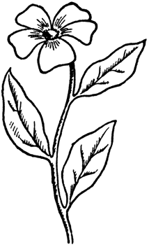
Bonus: What is the name of the tubes that transport material downwards?
Bonus: What is the name of the tubes that transport material upwards?

Activity 7 - Plants: Roots Name: ______________________

1. If you were a plant root what would be your three main jobs? (circle three)
A. grow straight down
B. anchor the plant
C. transport materials downwards
D. make food for the plant
E. transport materials upwards
F. store food for the plant

Photosynthesis:
2. Roots help support photosynthesis by taking in from the soil.

3. Roots help support photosynthesis by the plant so the leaves can reach towards the sunlight.

4. Roots receive food, stored energy, from the leaves and it to be used later by the plant.

5-8. Root Transport: The root pictured below has arrows pointing in and down. On two of the arrows write the name of the item that goes into the root from the soil. On one of the arrows write the name of the item that goes into the root from the stem.
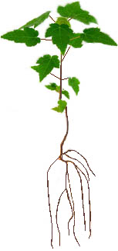
Bonus: What are the names of the tubes that transport material upwards and downwards in a plant?
Bonus: What are the two basic types of roots?

Activity 9: Food Chain ‘Character’ Cards
Graphics from the CPAWS Education website: www.cpawscalgary.org/education

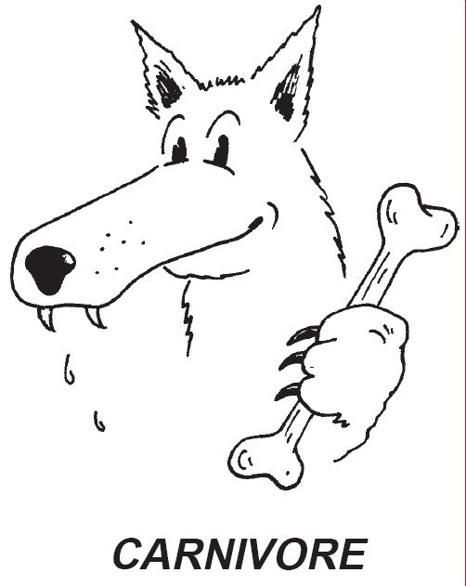
Activity 9: Food Chain ‘Character’ Cards
Graphics from the CPAWS Education website: www.cpawscalgary.org/education
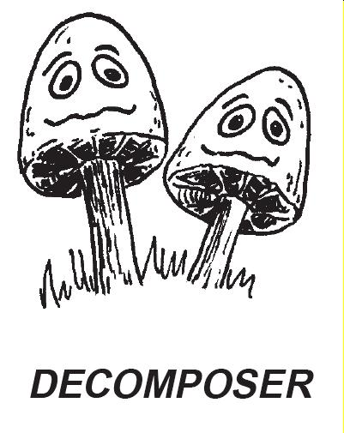

Activity 9: Food Chain ‘Character’ Cards

Graphics from the CPAWS Education website: www.cpawscalgary.org/education
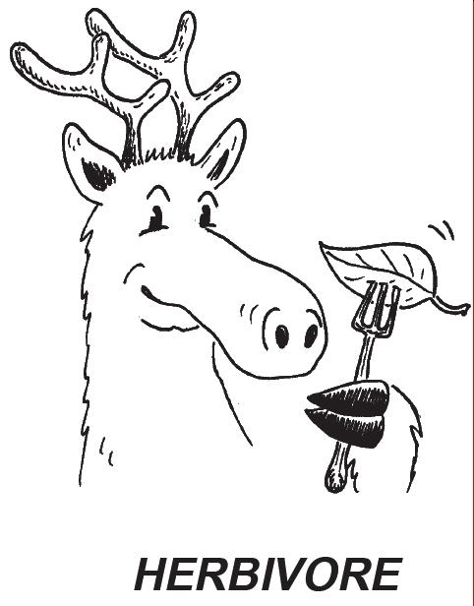

Activity 9: Food Chain ‘Character’ Cards

Graphics from the CPAWS Education website: www.cpawscalgary.org/education
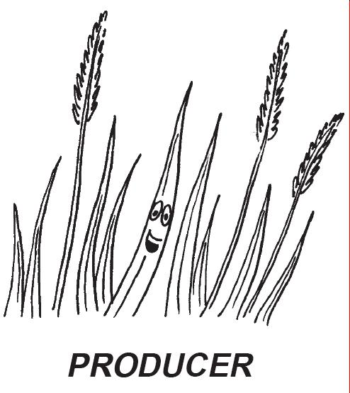

Activity 10: Food Chain Stackers

Activity 10: Food Chain Stackers

Activity 10: Food Chain Stackers

Activity 10: Food Chain Stackers

B | B | B | B
T | T | T | T
D | D | D | D
H | H | H | H
F | F | F | F
Activity 12: “How Many Bears Can Live in This Forest?”

Activity 12: Evaluation

Beavers

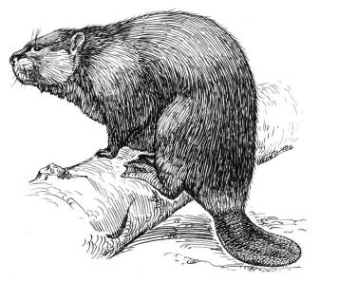
The beaver holds the title for being the largest rodent in North America. The adults can measure 35 to 46 inches long, including their wide and flat tail. They can weigh up to 110 pounds, but usually they weigh in at 45 to 60 pounds. Their tail is unique from other rodents because it is nearly round, covered with leathery scales and has sparse, coarse hair. Beavers use their tail like a boat rudder as they swim. They use it for balance when they're on land gnawing on sticks.

You may not know that beavers also slap their tail on the water as a warning signal that danger is nearby. They have huge back feet with five webbed toes to help them navigate the waters. Their front feet are tiny compared to the back to help them hold sticks for gnawing. They use their front feet to help them carry stones and sticks to construct their dams. Their fur is long and coarse and ranges in color from a light pale yellow to black. You probably know that beavers have large, sharp, front teeth. Did you know that their ears and nostrils are small so they can be closed when the beaver swims underwater?
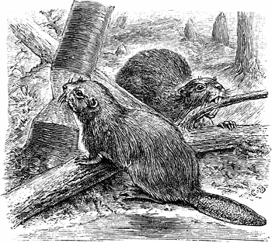
It is common to see bark stripped off of tree trunks near the ground in beaver territory. A beaver's favorite meal is twigs from aspens, poplars, alders and, for a side dish, water grasses, fleshy roots and water lilies. In the fall, beavers cache (store) branches and logs in the water. They store it near a lodge or bank burrow so it is easy to get at in the winter. Beavers will go ashore in the winter as long as they can break through the ice at the pond's edge.
Beavers are really the only local wildlife that will remodel their environment to meet their needs. They dam up small streams to create a pond where they then build a lodge. Around the pond you'll find canals and runways used to transport building materials and food back to the pond. The 15-foot wide, 5 foot high dam is actually built of sticks and mud. The dams create widespread flooding of woodlands and farmland.

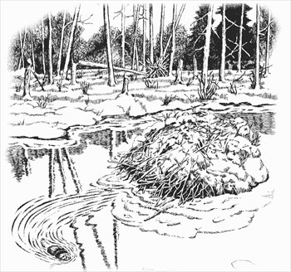
This can benefit other water adapted wildlife species like otter, mink, muskrats, waterfowl and water birds. Ponds provide a good water supply for animals such as deer, bear and grouse. On the other hand, beaver dams flood the habitat of other animals and drown the plants. Over time trees not suited to very wet soil will die off. Dams will block trout from migrating upstream and keep them from reproducing. Dams can plug manmade structures like culverts causing flooding on roads, railroad tracks and farm fields.
After Beavers flood an area they are able to build their safe home – the lodge. Not all Beavers live in lodges, some live in river banks.

Beaver populations haven't always been great in numbers. They were commonly found in New York before European settlement, but by 1900, logging and fur trapping almost caused them to become extinct. Beavers were then protected from trapping. Managed trapping has kept the beaver population steady and at healthy levels.
Beavers have adapted well to the changing landscape and their numbers have increased. Look for beaver lodges and signs of beaver like gnawed trees. Look for their signature tracks and beaver lodges near ponds, along rivers and streams.

Reflecting on the Reading:
How might beavers cause an imbalance in their local environment?
Write a paragraph about how beavers can change the environment and cause an imbalance.
Include how this imbalance affects the beaver, and how it affects other living things.
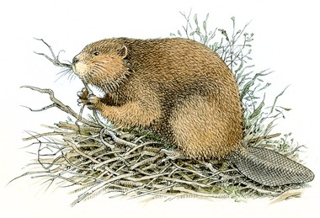
Activity 13: “Up the Food Chain”

Activity 13: Evaluation

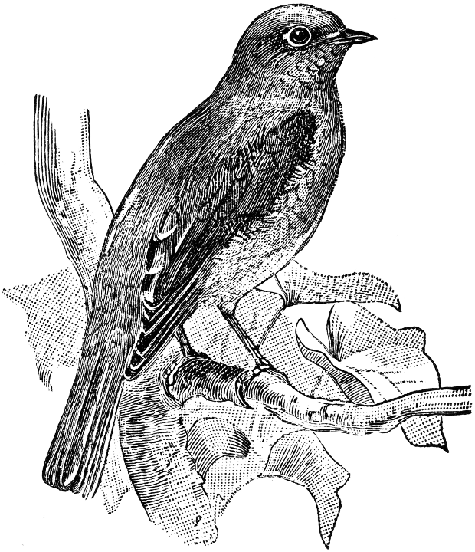
Bluebird Blues
When the first settlers arrived from England, bluebirds were very common. Most people were able to identify a bluebird.
The bluebird population greatly decreased from the 1920's to the 1970's. By the 1980's, many young people had never seen a bluebird. Even today, there are still many people who have not seen a bluebird. With the exception of weather, changes in the bluebird populations have been related to human activities.

Weather has played a role in the bluebird population decline.
Winter freezes in the South in 1895-96, 1939-40, 1950-51, and 1957-58, affected the birds. So did some severe winters in 1976-77 and 1977-78. Bluebirds that are caught in bad weather without shelter and liquid water may die. They may also starve to death if food sources are not available (i.e., covered by freezing rain/snow.)

The loss of natural nesting places is a problem.
The native bluebird is a timid, cavity-nesting bird. For shelter, it searches for large holes (cavities) in old wooden fence posts or dead trees. Bluebirds may also have nested or roosted in openings in log cabins and farm buildings. In the 1700’s farmers would clear areas in ways that created good food areas and nesting sites. Over the years, much more land has been cleared for roads, buildings and other developments. Nesting cavities in trees have disappeared. Metal posts have replaced wooden fence posts.

Competition with other birds is an issue.
The bluebird has to compete for shelter with native birds, such as the House Wren and Tree Sparrow. In the 1800s birds from Europe were brought into the U.S. They were the House Sparrow and the European Starling. Both the starling and sparrow are cavity nesters. These very aggressive birds compete with the passive bluebird for nesting sites. Sadly, starlings and sparrows often take over active bluebird nests. They will open eggs, kill nestlings and sometimes kill the parents.

The use of pesticides adds to the problem of Bluebird survival.
During the year, a large part of the bluebirds’ diet is insects. They are often seen swooping down from their perch to catch a grasshopper, beetle or other bugs. In the days before pesticides, farmers put up bluebird nest boxes around their fields. The bluebirds would help to control insects. Over time decisions were made to use pesticides to control insects. Pesticides were used to kill insects. Insects are the main item on the bluebird’s menu. The result was indirect poisoning of the bluebirds.

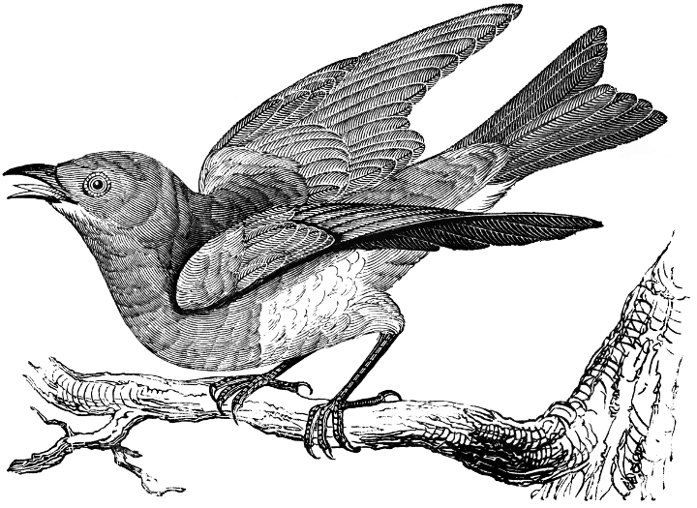
There is hope for the bluebird’s future.
The most important step for the population is to provide nesting sites. This is done by setting out bluebird houses. Starlings can be kept out of the houses by using a smaller entrance hole. Great places for houses include non-city property, golf courses, school yards, or any open area surrounded by woods. In areas where these houses have been correctly placed, bluebird populations are increasing. In addition, regulations have guided the use and proper disposal of pesticides. This has decreased the impact on the bluebird population.
Snowshoe Hare
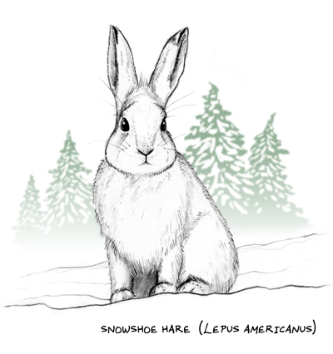
Rabbit or hare? That is often the question. A snowshoe hare looks
like a rabbit at first glance. In general hares have longer ears,
very large hind feet and longer legs made for jumping. Unlike the
rabbit, hares are born with their fur and with their eyes open.
Moveable ears helps the hare gather sounds from many directions.
This gives it a keen sense of hearing. Large hind feet help it stand
up and reach branches to feed on. It has a sensitive nose and
whiskers, which helps it smell or sense danger in the air.

Its teeth are very strong, made for gnawing on tree bark, woody twigs and tree buds from aspen, willow, birch, maple, sumac and alder in the winter. The hare will also eat the needles of conifers like fir, cedar, hemlock, spruce and white pine. In the summer, green vegetation like grasses, clover, dandelions, sweet raspberry and blackberry shoots makes up their diet.

The snowshoe hare changes its coat two times a year. It changes a thin brown summer coat to a heavy, white, fluffy winter coat. These different colored fur coats help the hare blend in with its surroundings. In the summer, the snowshoe hare is rusty brown with black on the top of the tail and ear tips; and grayish-white on its underside. This blends well with summer twigs and leaves. In fall, the new winter white coat comes in; starting with the ears and feet. This transformation takes about 10 weeks. The white blends in and hides the snowshoe hare in the snow covered woodlands. Some people call this animal the "varying hare" because of this seasonal color change.

Food for Thought: Making Tracks

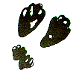
Snowshoes get their name from the shape of their back feet, which look like snowshoes and help the hare stay on top of the snow. You can't miss the large track prints from these unique feet with the dense fur pads. The fur pads keep their feet insulated and warm.

The snowshoe hare really likes wooded forests with coniferous trees in lowland areas and places with young aspen trees or spruce and cedar swamps. By day, they rest or hide in low vegetation, inside hollow logs or inside abandoned animal burrows. At night they travel along "runways" or worn down paths through low vegetation. Snowshoes are late eaters and really chow down around 11:00 pm.

Snowshoe hares are not alone in the woods. There are other plant eaters such as deer, voles, and various birds. These animals also dine on the shoots and leaves of plants and the fruits of forest shrubs. Along with the hare, they are stalked by many predators like coyotes, foxes, weasels, great horned owls and larger hawks. The bobcat's favorite meal is also the snowshoe hare. Beware snowshoe hare; there are lots of predators out there!

Snowshoe Hare Question Sheet Name _______________________________

After reading about the Snowshoe Hare, answer the following questions.

- List 3 parts of the Snowshoe hare’s body that help in its survival.
___________________ , ___________________ , _____________________

- How does the hare directly impact another living thing in its environment?
______________________________________________________________________

- List 3 things that make up a hare’s habitat.
___________________ , ___________________ , _____________________
- Why are the needles of the pine tree important to the tree?

______________________________________________________________________

- How does change in the atmosphere (weather) part of the environment impact the hare?
______________________________________________________________________
______________________________________________________________________

- How does the hare obtain its energy?
______________________________________________________________________

- Name two populations that are part of the hare’s community.
__________________________ , ____________________________

- a. Draw a simple food chain that includes the hare.
b. On your food chain label a herbivore, a carnivore and a producer.

- From your food chain draw an energy pyramid.
Label the parts.

- In the last paragraph of the reading, what does the word “predator” mean?
______________________________________________________________________

- From the reading, with what animal might the snowshoe hare compete?
________________________________

- From the reading, with what might the snowshoe hare have a harmful interaction?
________________________________

- From the reading, with what might the snowshoe hare have a beneficial interaction?
________________________________

- What would be the effect on another population if the number of snowshoe hare were to increase?
_____________________________________________________________________

- Think about it. From your own knowledge, what is one way that people might affect the Snowshoe hare?
_____________________________________________________________________

_____________________________________________________________________

