# Electrical Circuits

Kit # 11

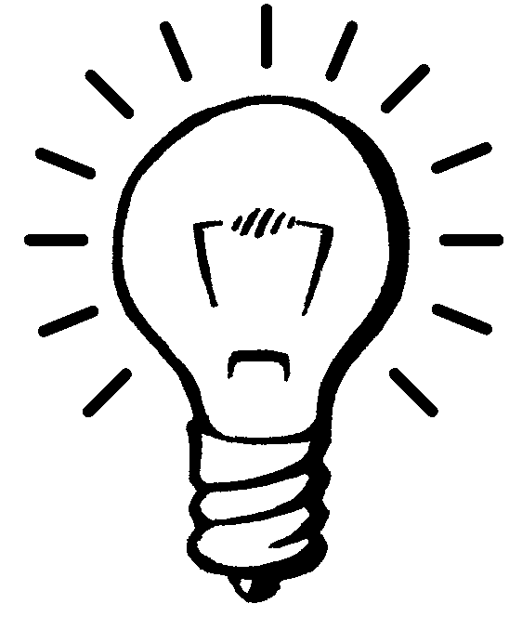

**Teacher Checkpoints**

**and**

**Assessments**

# **Revised August 2013** OCM BOCES Science Center

Updated diagrams

# **Checkpoint Activity 1 - 5**



1. Each of the pictures below show a battery and a light bulb.

Draw the wires on each picture so that the light bulb will light. Do this differently in each picture.

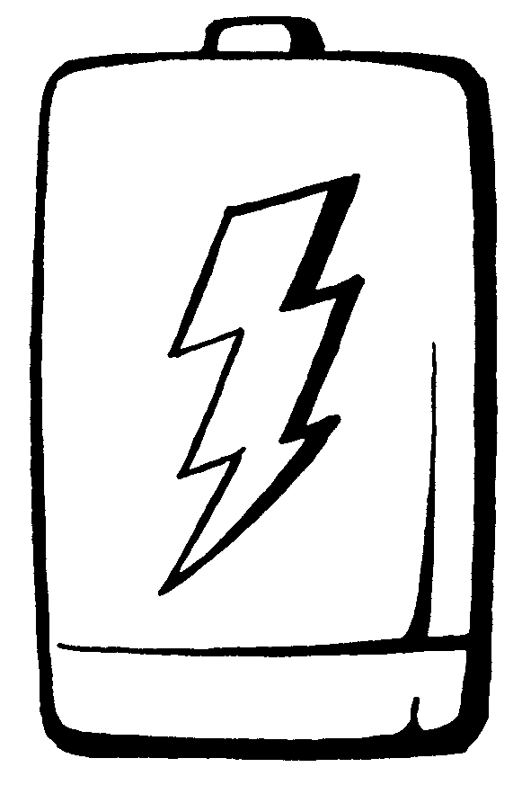

1. This is a diagram of a simple circuit. Answer the following questions using this diagram.

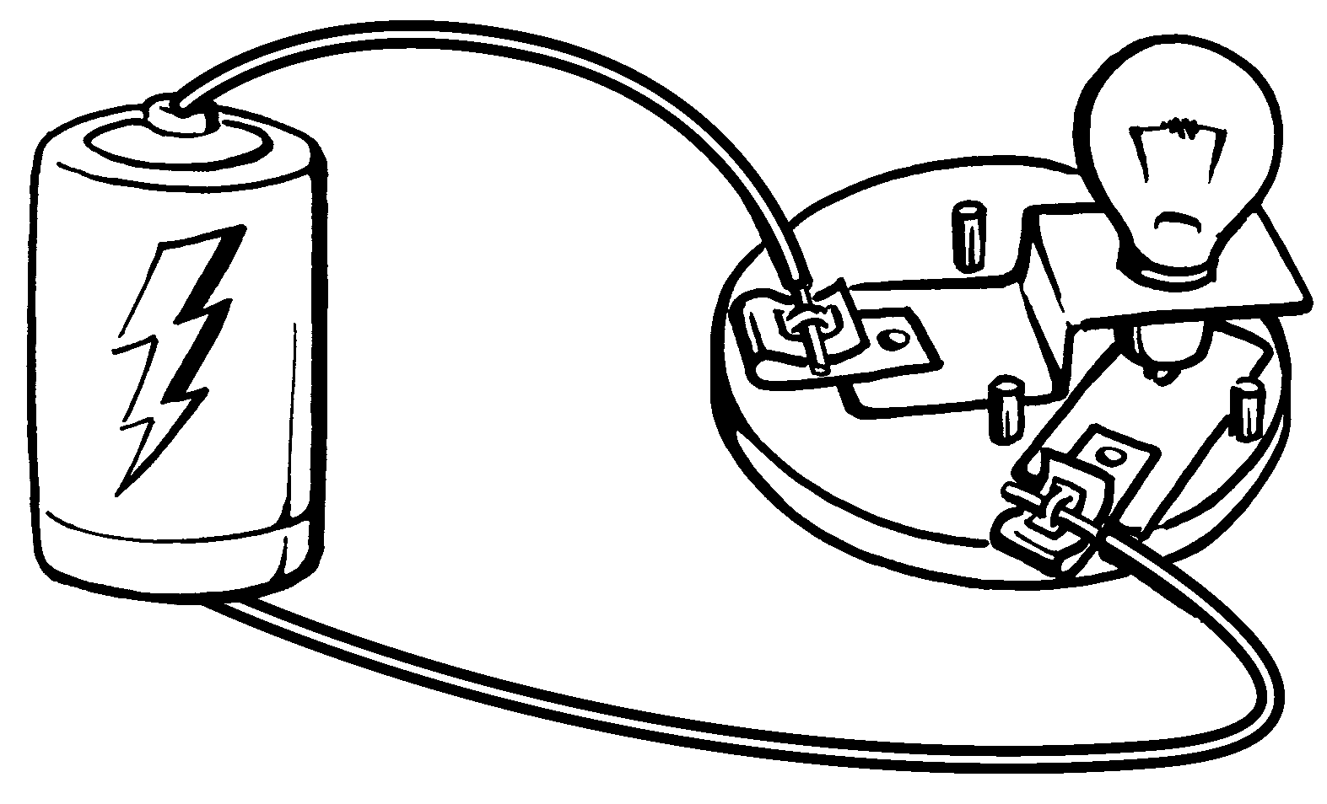

1. Show the source of electrical energy by drawing a box around it.

1. Show the source of light energy by drawing a circle around it.
2. The energy given off by the light bulb comes from the _____________________.
3. Is this an open or closed circuit? _________________________
4. Write the names of two pieces of matter that are part of the circuit.
5. What type of energy flows through all the parts of the circuit? _________________

# **Checkpoint Activity 1 – 5 (cont.)**

3. Draw a “secret language” diagram for the simple electrical circuit shown in the diagram.



4. Below is a list of words and a list of definitions. Match the word to the correct definition by writing the letter of the definition in front of the word that it matches.

|  |  |  |  |  |
| --- | --- | --- | --- | --- |
| **Answer** | **Word** |  | **Letter** | **Definition** |
|  | battery |  | **A** | move from one place to another |
|  | energy |  | **B** | the end of a battery |
|  | terminal |  | **C** | able to do work |
|  | electricity |  | **D** | flow of electrical energy |
|  | insulated wire |  | **E** | source of chemical energy |
|  | transfer |  | **F** | a battery having dry chemicals |
|  | dry cell |  | **G** | wire with a covering on it |

## **Checkpoint Activity 6 - 7**



Use diagram A and B to answering questions 1 through 5:

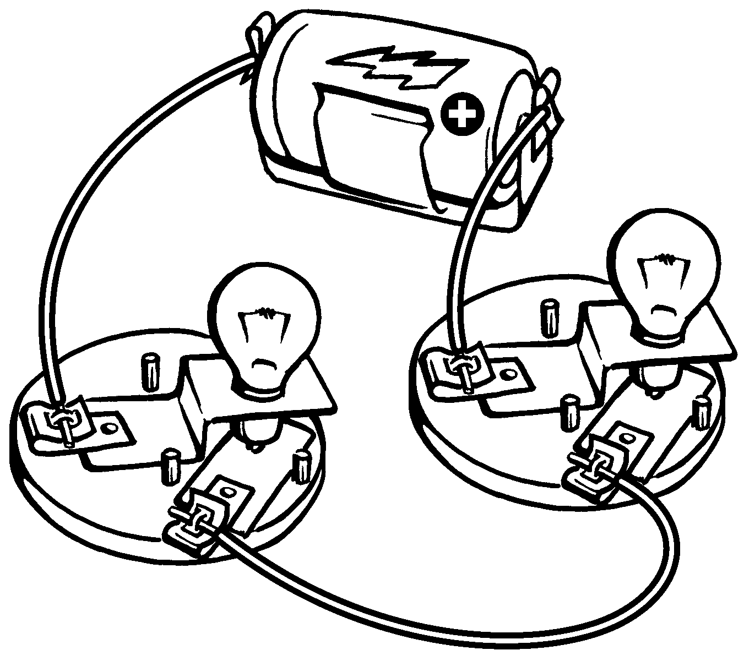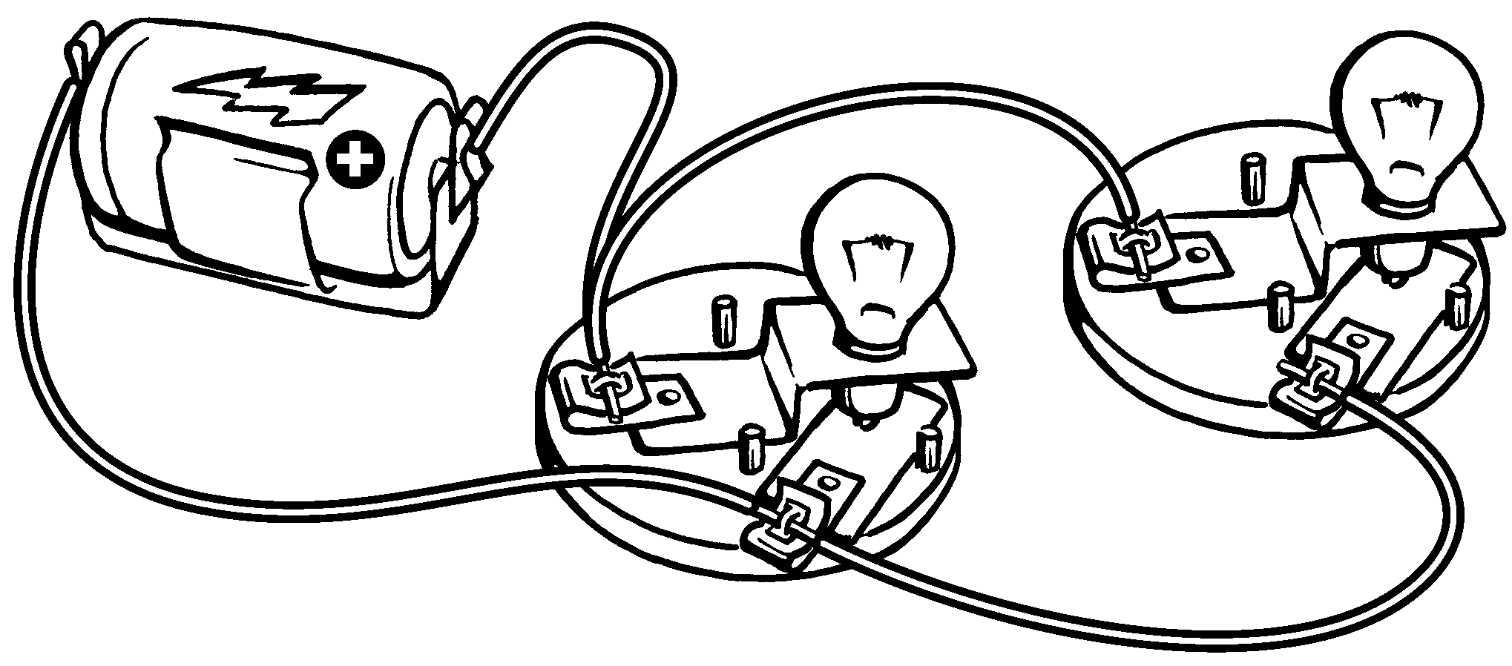

**B**

**A**

1. Which circuit is a series circuit? ________
2. In which circuit do both the light bulbs go out when one is unscrewed? ______
3. If a light bulb is able to light, is the circuit open or closed? ________
4. Which circuit has parts in two different paths? ________
5. In each diagram, circle one part that if removed would cause both the bulbs to go out.

Use the diagrams C and D to answer questions 6 through 9.

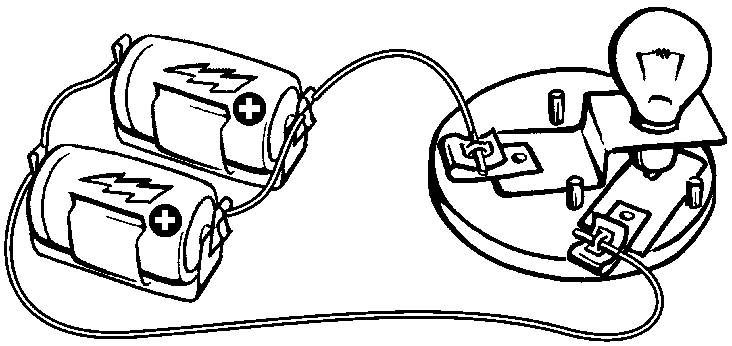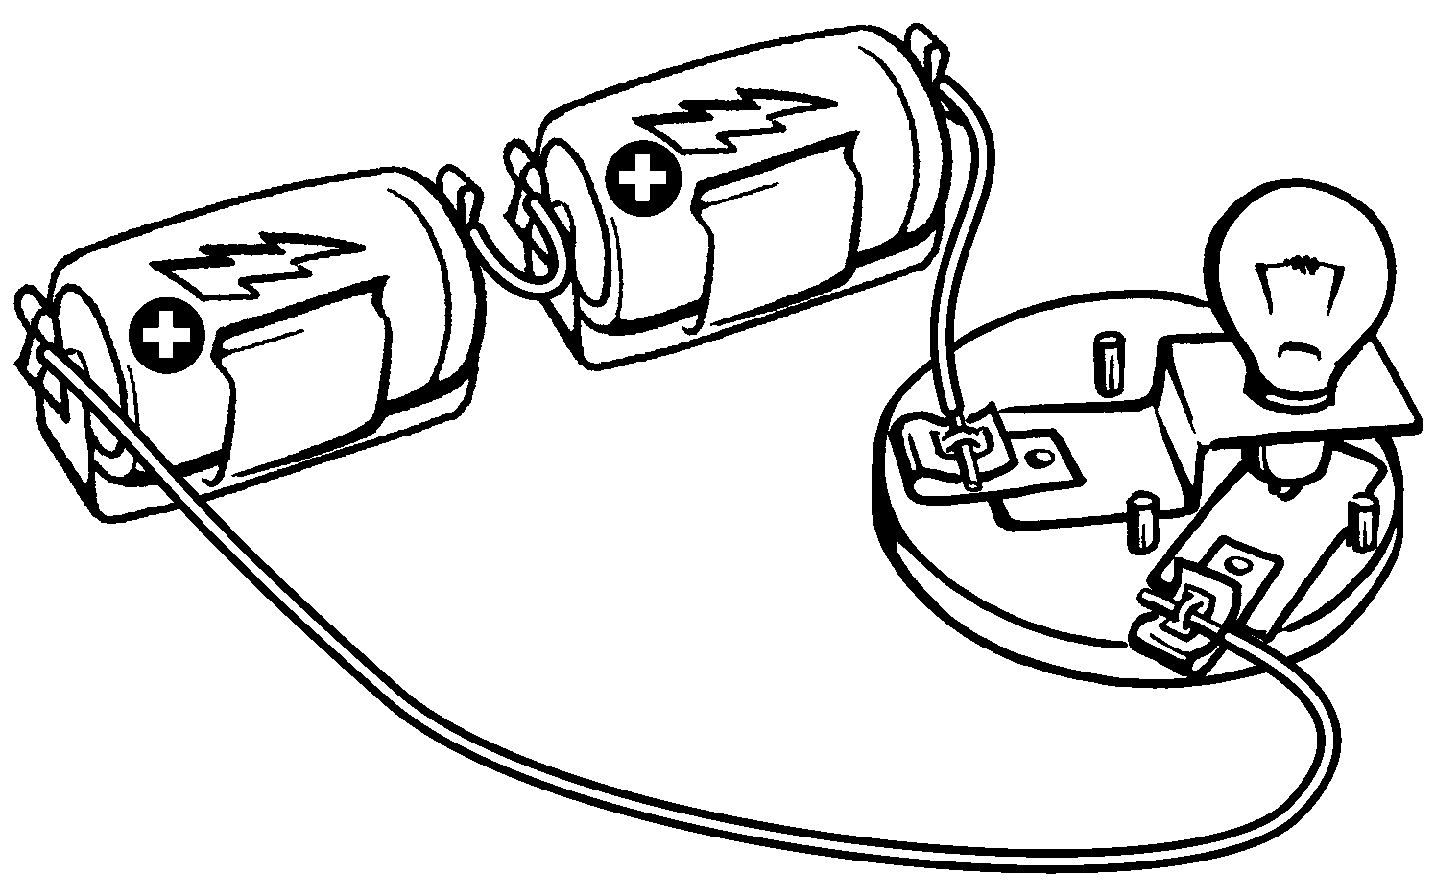

**C**

# **D**

1. Which circuit gives more energy and has a brighter light bulb? ________
2. Which circuit gives you energy for a longer time to light the bulb longer? _______
3. In each diagram, circle one part that if removed would cause the bulb to go out.
4. Which circuit is a parallel circuit? ________

## **CheckPoint Activity 6 – 7 (cont.)**



1. Which diagram has the batteries correctly connected together? _________

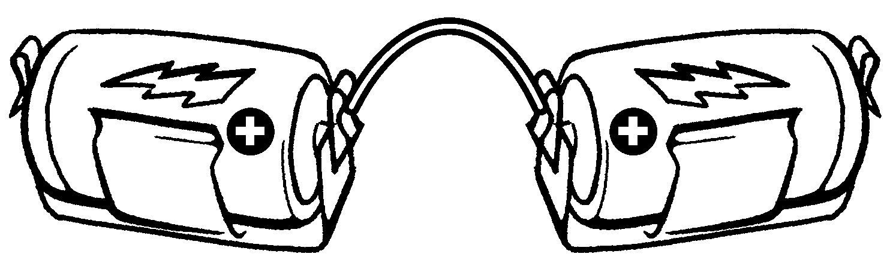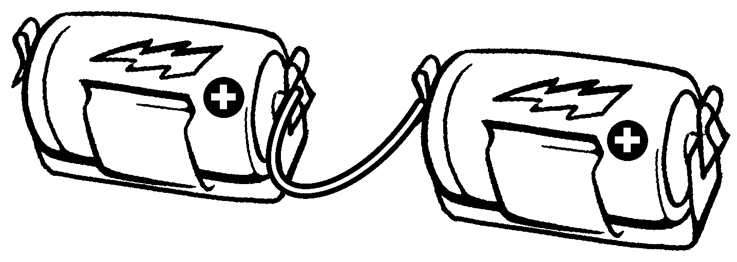

# **B**

**A**

The next few questions are about energy and systems. The questions refer to the diagram below. The light bulbs are lit.



1. What form of energy is stored in the battery? _________________________
2. What form of energy is flowing through the wire? ______________________
3. What form of energy enters the light bulbs? __________________________
4. What form of energy leaves (given off) by the light bulbs? _______________
5. The circuit can be described as being a system. Tell why the circuit is a system.



# **Checkpoint: Forms of Energy**

Energy can have different forms. Energy can change form. Energy can move from one place to another.

Some of the forms that energy can have are: heat, electrical, sound, chemical and light.

Using one battery and one light bulb, put together a simple series circuit. Observe your circuit. Energy changes form in your circuit. Energy moves through your circuit.

Using your observations, fill in the blanks on the diagram. Fill in the energy form each part of the circuit has or gives off.

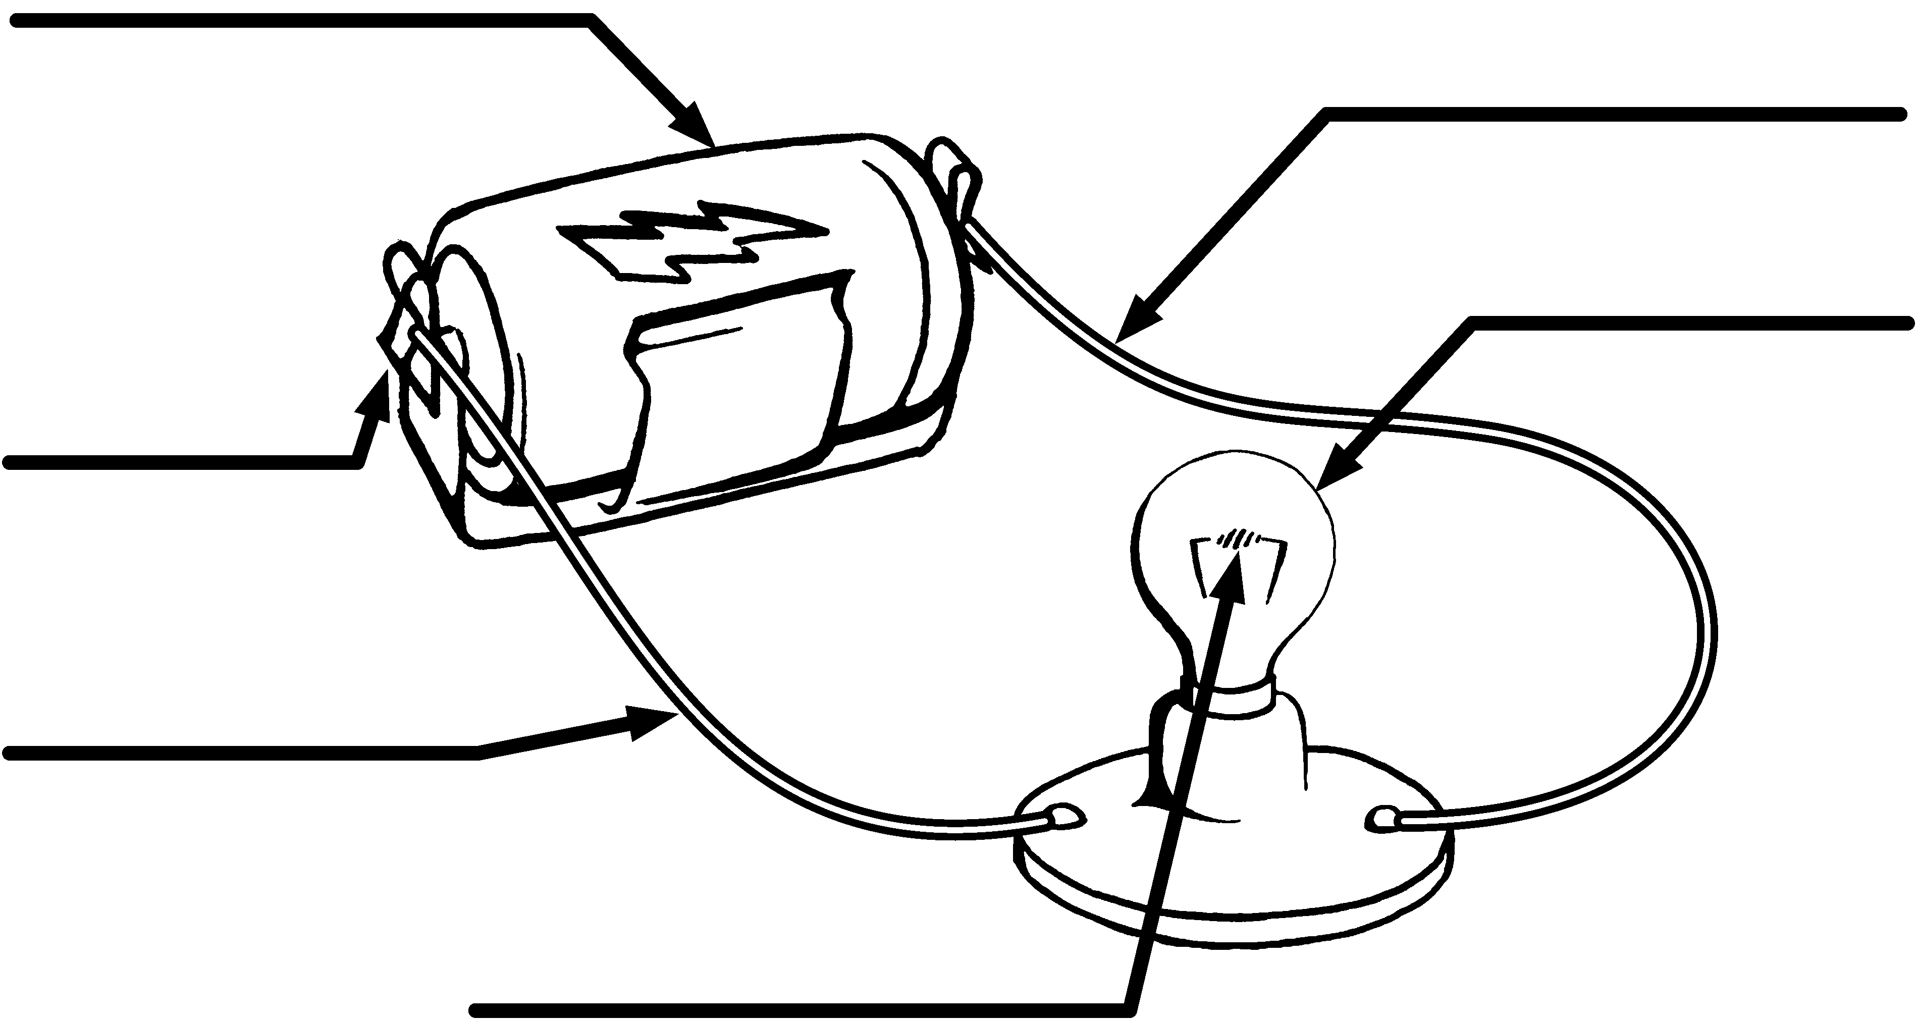

# **CheckPoint Activity 8 - 12**



The diagram on the left shows the circuit inside of a flashlight. The diagram on the right shows the circuit drawing of the flashlight circuit. Use these diagrams to answer the questions.

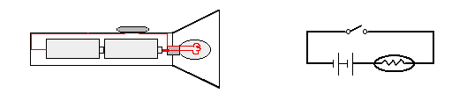

flashlight

circuit

1. There is a switch on the flashlight. There is a switch in the circuit diagram.

**Circle** the switch on each diagram.

1. What does the switch do as part of the circuit?
2. What job does the switch do as part of the flashlight system?
3. Give two examples of how you may use a switch in your everyday life.
4. The parts of the flashlight that are part of the circuit allow energy to flow through them. The batteries, light bulb, wires, and the metal strip in a flashlight will allow energy to flow through. Which term do we use for an object that allows energy to flow through it? Is it a conductor or an insulator?
5. This is a picture of a flashlight bulb. There is an arrow pointing to one part of the bulb. Is this part an insulator or a conductor of electricity?

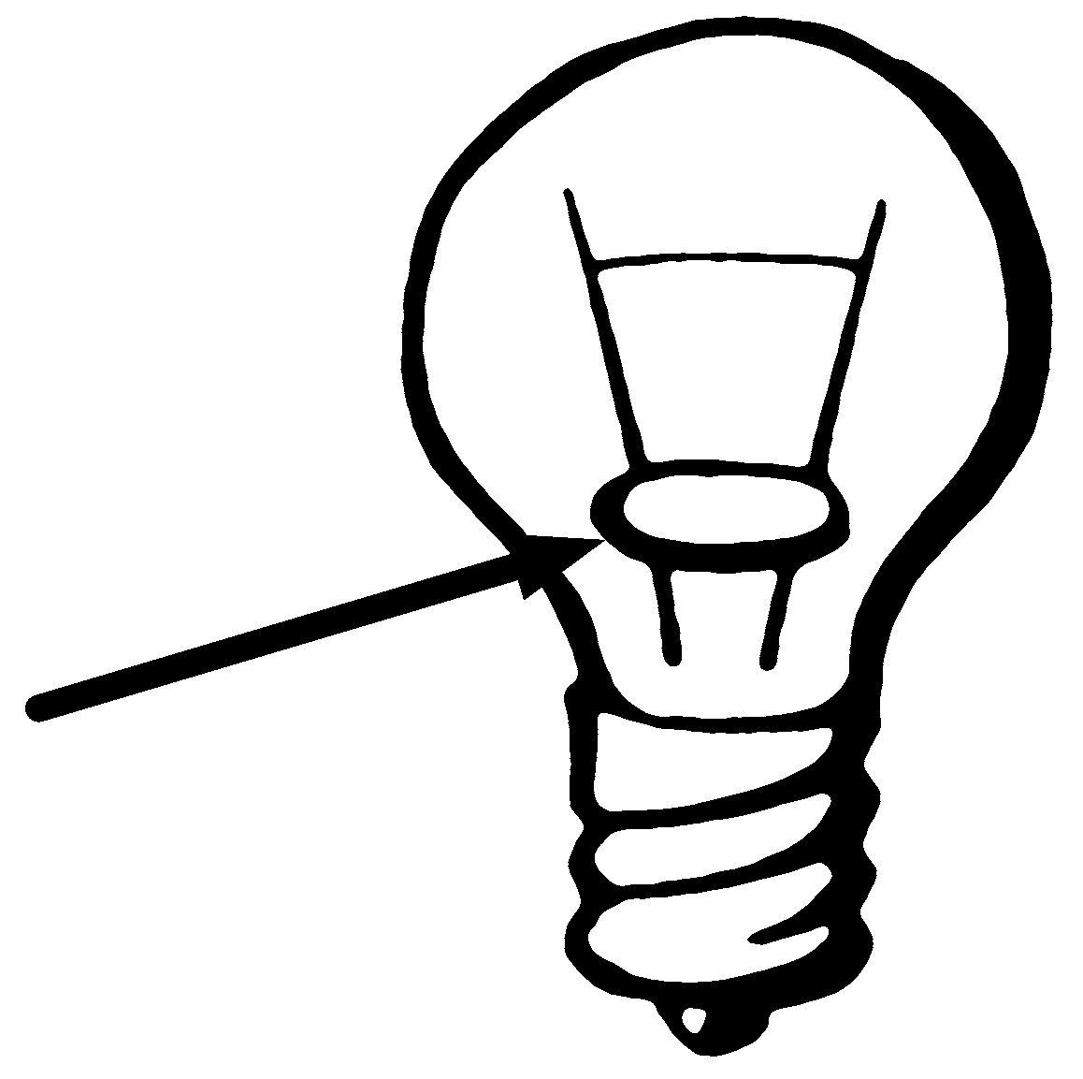

# **Checkpoint Activity 8 – 12 (cont.)**



1. This diagram shows an open circuit. The circuit needs a part added to it.   
   Which of the items listed would **NOT** close the circuit? (circle the item)

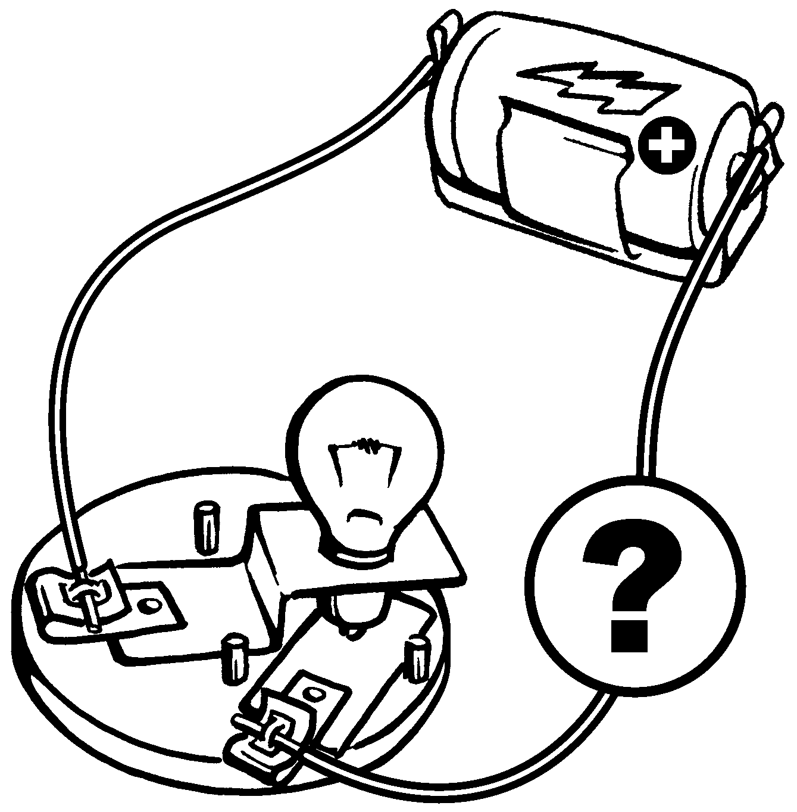

**A.** a paperclip

**B.** a battery

**C**. a wooden stick

**D**. a nail

1. As electricity flows through a light bulb, which of the following happens in the light bulb causing the light bulb to give off light energy.

**A.** the electricity opens the circuit **C.** the battery gives off energy

**B.** the wire gets so hot, it glows **D.** the wire in an insulator

1. George has to put a new bulb in his flashlight. He has found the bulb shown in the picture. Look at the bulb. Is this bulb a good one for George to use? Explain to George why he should or should not use this bulb.

|  |
| --- |
|  |
|  |
|  |
|  |
|  |
|  |

**CheckPoint Activity 13 - 16**



Read each of the following statements and decide if it describes a fuse or a short circuit. Write the word **fuse** or **short circuit** in the blank in front of the sentence.

**1**. It can cause a circuit to over heat.

**2**. It opens a circuit if it overloads.

**3**. It is an easier path that electricity can take to flow through.

**4**. It allows too much electricity to flow through a circuit.

**5**. It stops too much electricity from flowing through a circuit.

**6**. It is part of an electrical circuit system.

**7**. Since electricity can be harmful, this is a safety device.

**8.** Look at each circuit diagram.

Which diagram shows a fuse in the circuit? _____________

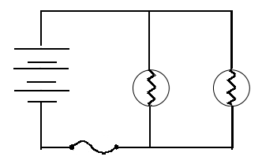

## **B**

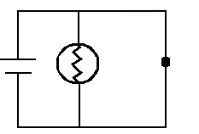

**A**

**9.** Alex takes his wool knit hat off of his head and finds that his hair wants to stand straight up. Sue walks across the rug in her socks and gets a shock when she touched the doorknob.

What is happening to Alex and Sue? Tell what you know about what is happening.

|  |
| --- |
|  |
|  |
|  |

#### Evaluation A: Flashlight

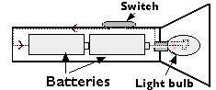

1) Draw a circuit diagram that shows the flashlight circuit.

2) Are the batteries in series or parallel?

3) What happens when the circuit is closed?

4) What happens when the circuit is opened?

5) How can you open the circuit if it is closed?

6) Name three forms of energy found in a flashlight system.

#### Challenging Evaluation: Car Electrical Diagram

This is a simple circuit diagram for a car. Use the diagram to answer the questions**.**

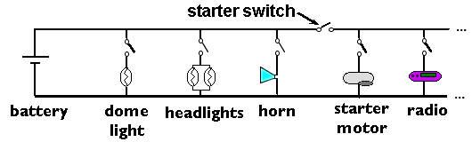

1) How many switches are there in the circuit?

2) What type of circuit is this, series or parallel?

3) What has to happen for the motor to start or the radio to play?

4) What happens to the radio if the headlight bulbs burn out?

5) What happens to the horn if the battery hasn’t any energy?

6)Name five forms of energy found in the car electrical system.

7) What is the source of energy for the car’s electrical system?

#### Electrical Circuits Basic Evaluation

**Part A**

Match the term with the statement.

|  |  |  |  |  |
| --- | --- | --- | --- | --- |
| **Letter** | **Word** |  |  | **Statement** |
|  | 1. battery |  | A. | a flow of electrons. |
|  | 2. parallel circuit |  | B. | material that resists the flow of electricity. |
|  | 3. conductor |  | C. | stores energy in chemicals. |
|  | 4. closed circuit |  | D. | a path for energy flow that is broken. |
|  | 5. electricity |  | E. | able to do work |
|  | 6. energy |  | F. | material that electricity can flow through. |
|  | 7. insulator |  | G. | a circuit with one path through it. |
|  | 8. open circuit |  | H. | working against, not allowing |
|  | 9. series circuit |  | I. | a path that is complete and allows energy to flow through. |
|  | 10. resistance |  | J. | a circuit with more than one path for electrical energy. |
|  | 11. system |  | K. | parts working together |

**Part B**

List 3 forms of energy that are found in a flashlight system.

Use the flashlight diagram as a guide.



12. 13. 14.

15. Is copper wire a good conductor or a good insulator? _______________

**Basic Evaluation p.2**



16. Write the letter of the circuit diagram that best shows the flashlight circuit.

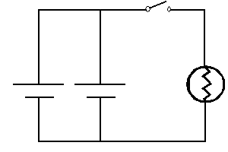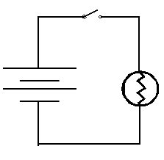

A. B.

17. What type of circuit is shown by diagram A, series or parallel?

18. What do we call a circuit that allows energy to flow and a light bulb to light?

Circle the best answer for each of questions 19 - 22

19. A switch is used in a circuit to

a. give resistance c. turn the battery on

b. open and close the circuit d. light the bulb

20. Which is an example of energy doing work?

a. a battery c. a toaster heating a piece of bread

b. a light bulb

21. Energy

a. keeps the same form c. moves from one place to another

b. is harmful

22. Resistance in a wire causes

a. heat to be given off b. a greater electricity flow

## **Electrical Circuits Evaluation: Constructed Response**

**WHAT IS ELECTRICITY?**

Electricity is a mystery to us. We can’t see it like we see the sun. We can’t hold it like we hold a rock or a plant. We know when it is working, but it is hard to know exactly what it is. Before we can understand electricity, we need to learn about atoms.

**WHAT ARE ATOMS?**

Everything is made of atoms—every star, every tree, every animal. Even you and I are made of atoms. The air and water are, too. Atoms are the building blocks of all matter in the universe. They are very, very tiny particles. Millions of atoms would fit on the head of a pin.

# **ATOMS ARE MADE OF EVEN SMALLER PARTICLES**

The picture shows a model of an atom. It has a center part. It has particles that spin around it.

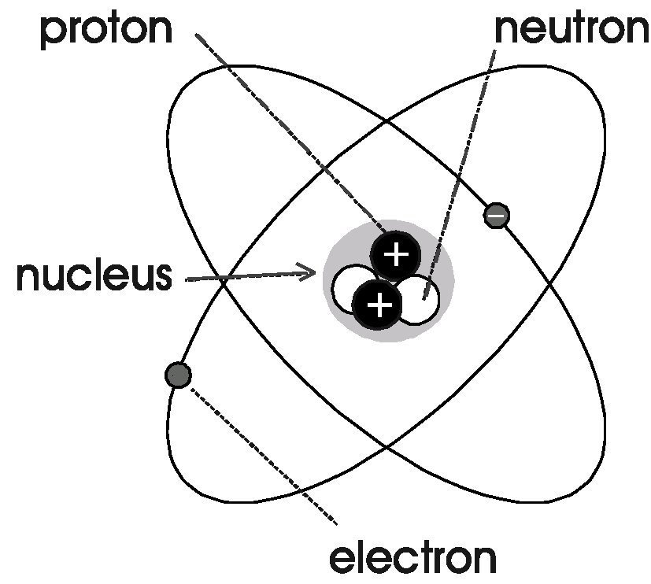

The center part is called the **nucleus**. The nucleus of an atom is made up of tiny particles. They are called **neutrons** and **protons**.

The tiny particles that travel around the nucleus are called **electrons**. The nucleus of the atom has an attraction for the electrons. This attraction keeps the electrons from traveling away from the atom.

This is the like a planet with moons. The moons travel around the planet. The planet has an attraction for the moons. This attraction keeps the moons from traveling away from the planet.

# **ELECTRICITY IS MOVING ELECTRONS**

Some of the electrons are held tight to the atom. Some are not. Sometimes these electrons can be pushed away from the atom. They can be moved. The energy released by moving electrons is called “electricity.”



## **Electrical Circuits Evaluation: Constructed Response**

# **ELECTRONS CAN TRAVEL THROUGH WIRES IN A CLOSED CIRCUIT**

Power plants use fuel to make electricity. This electricity flows into large wires called “power lines.” The electrons flow through the power lines to our homes. They flow through the wires in our homes. Next, they flow back to the power plant. Then they start their journey again. It is a closed circuit.

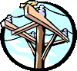

Electricity moves through the wires very fast. In just one second, electricity can travel around the world seven times.

We use this electricity to power our machines. We use it for heat and light. Electricity has made our lives very different. If you don’t believe this, try going for a day without it.

## **Electrical Circuits Evaluation: Constructed Response**

**NAME: DATE:**

Answer the questions about the reading selection. You may go back and reread parts of the selection.

1. What is made of atoms?

2. What are atoms made of?

3. Why do we need to know about atoms to study electricity?

4. Describe the closed circuit that allows electricity to flow to our homes.