Water Cycle

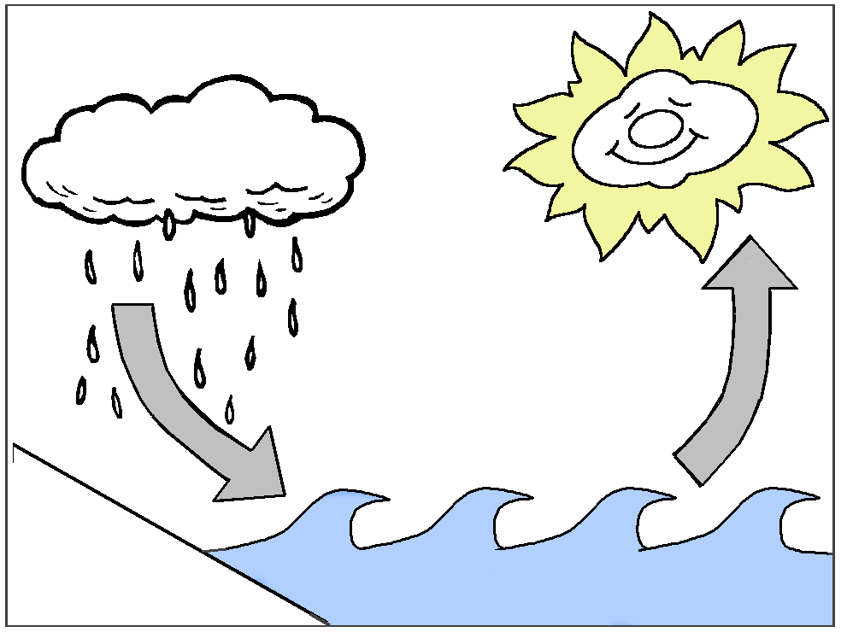

Student Notes

Student - ________________________________________

Based upon a Delta Science Module published by Delta Education
Activity 1: Where is water?
Vocabulary
freeze – to change to a solid state

glacier – a huge, slow-moving mass of ice and snow

melt – to change state from a solid to a liquid

Activity 2: Where Is the water on land?
Vocabulary
absorb – to take in

Activity 3: Where else is liquid water stored on Earth besides soil, lakes, rivers and oceans?
Vocabulary

Activity 4: Is there water stored as a gas as part of the air? How might it become a gas?
Vocabulary
evaporation – the process of changing from a liquid to a gas by heating (adding energy)

water vapor – water in the gas state
Activity 5: In the outside world, where does evaporation occur? What provides the heat energy for evaporation?
Vocabulary

Activity 6: Where else in the world does evaporation occur beside from standing water?
Vocabulary
transpiration – the evaporation of water from a plant’s surfaces, such as leaves, the process by which plants lose liquid water to the environment as a gas,

Note;
People perspire to transfer wastes through the skin and to evaporate water from our skin for cooling (transfer heat energy).
Latin per- through + spirare to breathe

Plants transpire to move water and wastes out through the stomas of the leaves. The movement of the water helps to draw water up from the roots of the plant (tree). It uses evaporation as a transport system.
Latin trans- through + spirare to breathe

Activity 7: How can I measure the amount of water there is as water vapor?
Vocabulary
humid – a condition to describe the amount of water as water vapor

humidity – a measure of the amount of water in the gas state at a given time

Activity 8: What do we call the process where a gas changes to a liquid? What causes a gas to change to a liquid?
Vocabulary
condensation – liquid that forms when matter in a gas state changes to a liquid state

dew – water in the liquid state that forms on surfaces when water vapor condenses (temperature gets cooler)

Activity 9: What process causes clouds to form?
Vocabulary
cloud – a large mass of tiny water droplets formed from water vapor condensing on tiny surfaces (dust, dirt, salt)

Activity 10: How are rainbows evidence of tiny water droplets floating in the air?
Vocabulary
rainbow – an arc of color in the sky formed when light waves change speed by passing through tiny water droplets

Activity 11: Where can water be found in a terrarium? How might water move within the terrarium?
How does this compare to the natural world?
Vocabulary
terrarium – a closed container in which living plants and animals are kept and observed

polluted – when a substance contains material that is unwanted

Activity 12: How does evaporating and condensing affect the movement of water?
Vocabulary
precipitation – rain, sleet, snow, hail and other forms of water that have condensed from water vapor and fallen to Earth

water cycle – the continuous evaporation and condensation of water from the Earth’s surface, into the atmosphere, and back to the Earth’s surface.

Activity 13: What happens to precipitation after it falls to Earth?
Vocabulary

