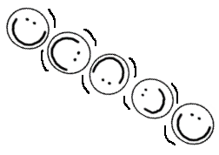

Motion

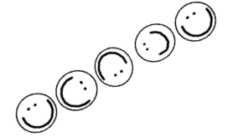

**Student**

**Name: \_\_\_\_\_\_\_\_\_\_\_\_\_\_\_\_\_\_\_\_\_\_\_\_\_\_**

#### **Teacher: \_\_\_\_\_\_\_\_\_\_\_\_\_\_\_\_\_\_\_\_\_\_\_**

#### Revised June 2008

#### Formatting changes, Reworded qu. #7, p. 17

|  |  |
| --- | --- |
|  | What is your favorite type of motion?  What affects your favorite motion? |
|  |
|  | What would be good to know about your motion? |
|  |
|  | What science facts did you learn about motion? |
|  |
|  | What are some new questions that you have about motion? |
|  |

Activity 1.1 How do we create motion?



Many of the games that you play involve using a ball. It may be a soccer ball, a football, a baseball, a bouncy ball, or one of many others. These balls are all different in some way. They are all the same in some way. They are all objects that are put in motion.

 You have a ball that your teacher has given you. Using this ball think about and write about the questions below.

1. Measure and describe the properties of your ball. Write a list of words that tell what your ball is like. Use all of your senses to do this.
2. What are some types of motion that your ball can have?

# Test and Sketch

Use the ball to show 3 different types of motion.

For each of these draw a sketch of the ball in motion.

Add arrows to show the direction of the motion.

Motion 1

Motion 2

Motion 3

1. Writeunder each sketch whether the force used to move the ball was a pushing or pulling force.
2. What type of motion do you think your ball would be “best” for? Why do you think that?

|  |
| --- |
|  |
|  |

1. What property of your ball is the most important for it to have this “best” motion? Why do you think that?

|  |
| --- |
|  |
|  |

1. Define the term “motion” using your own words. To help you do this, think about the effects of motion. Then draw a picture of something in motion.

|  |
| --- |
|  |
|  |

#### **Activity 1.2** “I wonder” questions about a group of balls.



**I wonder, how are these balls the same and different?**

Now, instead of one ball, you have a group of balls in front of you. You are going to compare the properties of the balls. Think about how the motion of these balls are the same and different.

1. Look at the set of balls that have been given to your group. Think about the properties of each of the balls. Make a data table to record 3 properties of each ball. Fill in your data table.
2. Sort the balls into two or three groups. Use a graphic organizer to compare the properties of the balls in the groups.





1. Place the balls back into one group. Write an “I wonder” question about the balls. The questions could be about the properties or use of the balls. For example, “I wonder which ball can be thrown the farthest?”

**I wonder**

This next part is about having an “I wonder” question that you would like to answer. Read the problem below. What is the “I wonder” question for the problem?

**The Problem:**

**You work at the OCM BOCES Science Center. There is a science activity that needs a group of balls that bounce at least 25 cm off the ground. Will this group of balls work for this activity?**

**Your job is to find a way to test how high each of these balls bounce. You will report how high each ball bounced. Then you will select the best balls from the group for the science activity.**

Now, re-read the problem statement. Underline the words that tell about what you need to find out. Circle any important numbers or measurements.

**Write the “I wonder” question for the problem:**

**I wonder**

###### marble_walkmarble_run

You are going to solve a problem. You will do this by doing a test to answer the problem question. This page gives you the steps in planning a test or experiment. You can write about these steps on pages 8-13.

**Create a test**.

Use pages 8-11 as a guide to plan your test.

Check your plan with your teacher before you try it out.

Make a prediction on page 12. What do you think will happen?

**Do your test**.

Be sure to run your test more than once.

Scientists say 3 is the magic number.

You should run the test 3 times.

This is done to check your measurements.

**Write your results and conclusions on page 13**.

The results are the statements about the measurements that you wrote down. It is what happened. You may write, for example, “The largest ball bounced the largest distance.”

The conclusion would be the answer to the “I wonder” question. A conclusion may tell why a result happened. A conclusion may tell if a prediction was correct.

***Motion Experiment Planning Form***

#### **STEP 1 Plan what you are going to do.**

**Plan: What do you want to find out?**

|  |
| --- |
| (This should be a question.)  j0078622 |

**Plan: Frame the problem by writing down your thoughts.**

|  |  |  |
| --- | --- | --- |
| Problem: FACTS | IDEAS | ACTIONS |
|  |  |  |

***Motion Experiment Planning Form:* STEP 1 Plan what you are going to do.**

**Plan: Planning the variable and controls.**

bd07017_ Think about your ideas for a plan. A test needs to focus on a **variable**. What you are testing is your variable. This is the only thing in a test that can be different. Your measurement tells about the variable. There should be only one variable in a test. For example, in a test of who runs the fastest, the variable is the speed of the runners.

What are you testing the motion of? This is your variable.

A **control** is a part of a test that is kept the same. This makes the test a fair one. For example, let’s say that you are testing who runs the fastest in your class. A control would be that everyone starts behind the same starting line. Everyone starting from different places would be a variable.

What are the parts of your test that will be the same for all the balls?

***Motion Experiment Planning Form:* STEP 1 Plan what you are going to do.**

#### **Plan:** What is your plan? Write in steps for your group to follow.

|  |  |
| --- | --- |
| What are you going to do? | |
| j00787321 |  |
|  |
|  |
| 2 |  |
|  |
|  |
| 3 |  |
|  |
|  |
| 4 |  |
|  |
|  |
| 5 |  |
|  |
|  |
| 6 |  |
|  |
|  |
| 7 |  |
|  |
|  |

Your plan is done! Make sure that you have checked it with your teacher. But wait a moment, what are you going to measure? Where are you going to write it down? This is the last part to the planning.

***Motion Experiment Planning Form:* STEP 1 Plan what you are going to do.**

**Plan: Plan your observations and measurements.**

#### Plan: Observing and measuring.

|  |
| --- |
| What are you going to measure or observe?    j0078753 |

#### Plan: For the record

|  |
| --- |
| How are you going to record your observations?  bd05012_ Are you going to use a data table? What are you going to measure and write down? If you are going to use a data table, draw it in the box below. You should do each test three times. Be sure that your data table has places for three measurements for each ball. |

|  |
| --- |
| HH02496_ |

***Motion Experiment Planning Form***

**Step 2 Making predictions about what will happen.**

|  |
| --- |
| Do you think the balls will all bounce the same or differently? If you think they will all bounce differently, try to put them in order from highest bouncing to lowest bouncing. |
| Why do you think the balls will bounce the same or differently?  Is there anything else that may affect how the balls will bounce? |

****

**Step 3 Doing the test.**

**Test:** Be sure to check your measuring plan with your teacher. Now you are ready to do your testing. Be careful chasing those bouncing balls. Don’t bump into anyone or anything!

***Motion Experiment Planning Form***

**Step 4 Writing about what happened.**

**Tell:**

Telling has two parts. One part, called the results, asks you to look at your data and write about it. For example a result may be, “The large ball did not bounce over 5 cm high.” This gets you ready for writing a conclusion. Write in 4 results on the form below. Remember to write complete sentences.



|  |
| --- |
| Results: Write what you observed about your measurements. |
|  |
|  |
|  |
|  |
|  |

|  |
| --- |
| Conclusion: Write about what you found out. |
|  |
|  |
|  |
|  |
|  |
|  |
|  |

Now it is time to tell about your results. Look back at your question or what you wanted to find out. How did the balls measure up? What should the Science Center do?

bd07213_

Activity 2.3 Marble-ous Shots

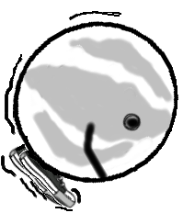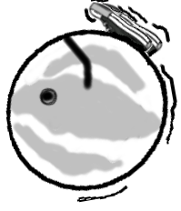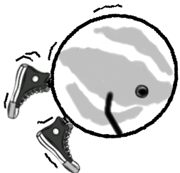

***Task:***

Use trial and error to solve a problem. The problem is about using some rules to shoot (roll) a marble. Think of a way to shoot a marble using one hand and following the rules.

***Rules:***

1. At least one knuckle of the shooting hand must be in contact with the floor.

2. The marble must roll at least 2 feet on a bare floor.

***Reporting:***

On the next page, describe the steps to shoot a marble. This should be a way that you think works and have tried out.

You should write about:

* what you did to shoot a marble
* how well it works
* different ways that you tried
* why you think this is the best way

Space for sketching :

|  |
| --- |
|  |
|  |
|  |
|  |
|  |
|  |
|  |
|  |
|  |
|  |
|  |
|  |
|  |
|  |
|  |
|  |
|  |
|  |

Marble-ous Shots Journal Sheet

Activity 2.5 Marble-ous Collisions

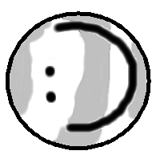

***Task:***

Use trial and error to solve this problem. The problem is to shoot (roll) a large marble so it will hit and move a smaller marble. You will need to control your shot.

***Rules:***

1. At least one knuckle of the shooting hand must be in contact with the floor.

2. It must hit a small marble 6 inches away and cause it to move.

(When you are able to do this, try longer distances such as 12 inches.)

Answer these questions after you do the task:

1. Write a sentence telling about the force that you use to shoot a marble and hit another marble.

2. What happens to the marble that is hit?

3. What 2 properties of the rolling marble caused the other marble to move?

4. How can you make the rolling marble move the hit marble farther?

**Activity 2.7 Reviewing Marble Collisions:**



1. What form of energy does a marble have as it rolls?

2. Does the small marble have energy of motion when it is sitting still?

3. What usually happens to the small marble when the large marble hits it?

1. If a rolling marble hits a marble, does it always move? \_\_\_\_\_\_



What are two properties of a rolling marble that cause it to move another marble?

1. What words are used to describe a moving marble passing on its energy of motion to another marble?
2. What type of force did you use to have the marbles change position (move)?
3. Fill in the blanks.

A bicycle will not move until you \_\_\_\_\_\_\_\_\_\_\_\_\_\_ it.

A fast moving bicycle has \_\_\_\_\_\_\_\_\_\_\_\_ force than a slow moving one.

If a bicycle hits a small box, which will have more force? \_\_\_\_\_\_\_\_\_\_\_\_\_\_

If a bicycle hits a car, which will have more force? \_\_\_\_\_\_\_\_\_\_\_\_\_\_\_\_\_\_

If a bicycle hits a truck, which will have more force? \_\_\_\_\_\_\_\_\_\_\_\_\_\_\_\_\_

**Activity 3.1 The Marble Game Called Ringer**

***Doing a Lag:***

taw = a large shooter marble

In the game of marbles you decide who goes first by tossing or shooting a **taw** (shooter marble) towards a line. The winner is the one

who gets the closest to the line. This is called doing a lag.

***Rules:***

1. To do a lag a player stands behind a starting line and tries to get their taw close to the ending line. The ending line is called the lag line.

Lag line

Starting line

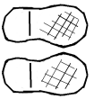

1. The player can toss or shoot his taw (shooting marble) toward the lag line.
2. The player’s hand should not cross the starting line.
3. To win the lag, a player’s taw must come closest to the lag line without going over.

**As a group decide on a shooting line and a lag line. First practice doing several lags. Next, lag against each other and see who wins the lag. Try this several times.**

What force did you use to lag a marble? Write your answer in a complete sentence.

###### Activity 3.1: How do we use motion to play a game?

A Marble Game Called Ringer

**Words to Know**: shooting marble is a “**taw**”

playing marble or regular glass marble is a “**duck**”

**Game Mat**: Our game is played in a 2-foot diameter marble ring.

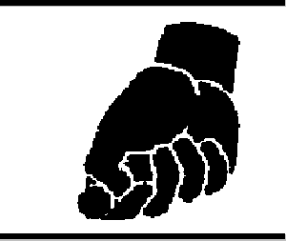

**Do you remember who starts first? It’s decided by a lag.**

Before you set up the ducks on the mat you need to decide who goes first. In the game of marbles you decide who goes first by tossing or shooting your taw towards a line to see who gets closest. This is called doing a lag. If you win the lag, you get to start the game.

**Starting Set-up**

In the center of the ring thirteen marbles are placed in the shape of an X.

One target marble is placed in the middle, with three on each leg spaced three inches apart.

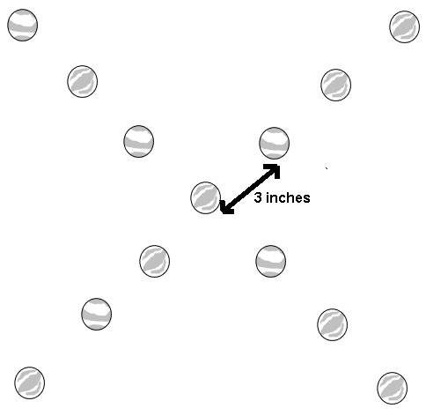

Activity 3.1: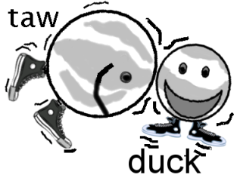 Playing the Game

(Target marbles are called “ducks”.)

1. The players will take turns knuckling down anywhere just outside the Ring Line.

2. If a player is able to knock one or more ducks out of the ring and keep the taw inside the ring, the player continues to shoot.

3. When a player's taw goes outside the ring, or fails to knock a duck out, the turn is over.

4. The player gets one point for each duck knocked out of the ring.

5. A turn or inning is complete when both players take a shot.

6. The game ends when one player knocks seven ducks from the ring or when seven innings are over. The player who has the most ducks out after seven innings is the winner of the game.

**Think about it:**

What do you think about the game of Ringer? How would you change it to play it differently?

|  |
| --- |
|  |
|  |
|  |
|  |
|  |

**Activity 3.5 Designing a Marble Game**

 Now you get the chance to design a game that uses marbles in motion. It can be a game like the game of Ringer or something very different. The important part is that the game must have:

* marbles in motion
* marbles at rest
* an energy transfer
* a force (push or a pull)
* a direction of motion

Use this page to describe your game and its rules. You may draw pictures as part of your description.

|  |
| --- |
|  |
|  |
|  |
|  |
|  |
|  |
|  |

Play your new game. How did it go? What worked? What needs to be changed to make it better?

\_\_\_\_\_\_\_\_\_\_\_\_\_\_\_\_\_\_\_\_\_\_\_\_\_\_\_\_\_\_\_\_\_\_\_\_\_\_\_\_\_\_\_\_\_\_\_\_\_\_\_\_\_\_\_\_\_\_\_\_\_\_\_\_\_\_\_\_

\_\_\_\_\_\_\_\_\_\_\_\_\_\_\_\_\_\_\_\_\_\_\_\_\_\_\_\_\_\_\_\_\_\_\_\_\_\_\_\_\_\_\_\_\_\_\_\_\_\_\_\_\_\_\_\_\_\_\_\_\_\_\_\_\_\_\_\_

\_\_\_\_\_\_\_\_\_\_\_\_\_\_\_\_\_\_\_\_\_\_\_\_\_\_\_\_\_\_\_\_\_\_\_\_\_\_\_\_\_\_\_\_\_\_\_\_\_\_\_\_\_\_\_\_\_\_\_\_\_\_\_\_\_\_\_\_

**Activity 4.4 Marble Roll, a Contest of Slow-pokes**

Contest:

Your job is to create a ramp causes a marble to roll the

shortest distance.

Your ramp must be 10 - 12 inches long.

The starting point of the marble will be 10 inches up the ramp.

You will place your marble on the ramp and let go. It cannot pushed or thrown.

The ramp can be any shape. It can be up to 8 inches wide. It can be made of any material.

The ramp can be covered with any material.

The distance the marble travels is measured from the bottom of the ramp to where the marble stops. (The judge can declare when the marble stops.)

The marble must make it down the ramp to qualify.

On **Marble Roll Day**, each group may have only one try (roll the marble once).

A good way to start is to observe a marble just rolling down a ramp. You may use the basic ramp for the Slow-Poke Contest. Think about what can make the marble roll the least. Think about what can slow the marble down. Do some tests. Make some changes. Test again.

Be careful not to accidentally share your ideas with the other teams. ☺

**Activity 4.4 Marble Roll, a Contest of Rollers**

Contest:

Your job is to create a ramp that allows a marble to roll fast.

The marble will have to roll a distance of 6 feet the fastest to win.

Your ramp can be up to 12 inches long.

You decide the height of the raised end of the ramp.

You decide the starting point of the marble on the ramp.

The marble will be placed on the ramp and let go. It cannot be pushed or thrown.

The ramp can be any shape or width and be made of any material.

The ramp can be covered with any material.

The time the marble rolls is measured from when the marble is released to when it crosses the line. The line will be 6 feet away from the ramp.

The marble must make it down the ramp to qualify.

On Marble Roll Day, each group may have only one try (roll the marble once).

A good way to start is to observe a marble just rolling down a ramp. You can use the basic ramp for this. Think about what can make the marble roll fastest. Do some tests. Make some changes. Test again.

Be careful not to accidentally share your ideas with the other teams. ☺

**Marble Roll Contest Worksheet**: \_\_\_\_\_\_\_\_\_\_\_\_\_\_\_\_\_\_\_\_\_\_\_\_\_\_\_\_\_\_\_\_

This is what I think is important to plan the contest:

|  |
| --- |
|  |
|  |

This is what my group thinks is important for the design:

|  |
| --- |
|  |
|  |
|  |

What materials we are going to use in our ramp? How we are going to use the materials?

Materials:

|  |
| --- |
|  |
|  |
|  |

Plan:

|  |
| --- |
|  |
|  |
|  |
|  |
|  |

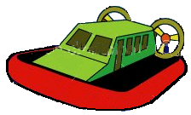Acme Racer Inc.

Air Power, How can we go the distance?

**Problem:**

Each year Hands-On School has a derby racer competition. Children buy a race car to put together. The car is raced down a long ramp out in the parking lot. The car that has the fastest time wins. Hands-On School has a problem this year. Over the summer, when the school was under construction, the ramp was destroyed. In addition, there is not room to store a new ramp. So Hands-On School has to have a different race this year. They need a racer that is powered by another force other than gravity.

Our company needs to design a new car for the children at Hands-On School called the R2. A balloon will power it. Your team needs to design an air-powered racer that will move on the floor. The winning team is the team whose racer goes the longest distance.

You will be able to design, construct and test your racer. On “test day” your racer will get 2 tries to go the longest distance. In the case of a tie, the racer that went the straightest will win.

**Progress Report:**

Use some lined paper for your reporting. Write about what you did each time you have a work session. You can use words and drawings to tell about what you tried to do and how it worked. Number or date each report.

* Keep a record of what you try and how it works.
* Write down what was successful and what was a problem.
* Do this after each building session.

When you are all done fill in the “Air Powered Racer Design and Results Final Report Sheet”

Acme Racer Inc.

Air Power, How high can we go?

**Problem:**

Our company has decided to offer a new product to our customers. We would like to sell kites. In order to do this we must decide on the best designs for our kite. We have a basic design. Now we would like to find out if changing the design makes the kite better. What would be important in designing a kite? It is important to have the kite fly straight and stay in the air. We would like to also sell some different shaped kites. So we need to find out what shapes are good for flying. Our basic design has a diamond shape. Can it be a circle or a rectangle? Can it be a butterfly or a bird shape? We would like your class to help us to find this out.

STEP 1: Make a kite using the basic design.

STEP 2: Fly the kite.

STEP 3: Pick one thing about the design to change. The change can be one that you think will make the kite fly differently. For example, you could change the length of the tail or the shape of the kite.

STEP 4: Make the changes to the kite.

STEP 5: Fly the new kite.

Use the “Air Powered Kite Design and Results Report Sheet” to report on your project.

###### mazeGravity Powered Maze Game

Your job is to plan and construct a maze. A maze is a set of paths for an object to move on. One of the paths must have a starting point and a finish. The other pathways are ones that do not go to the finish. Your maze will be made by gluing objects onto a sheet of cardboard. There should be a path on the cardboard that a marble could travel to get from the start to finish. The marble will be given motion by tilting the cardboard. You can time people to see how long it takes them to get the marble through the maze.

STEP 1: Plan out your maze on a piece of paper. Save your plan so that you can hand it in with your “Maze Report”.

STEP 2: Think about what you could use for the walls of the paths on your maze.

Some suggestions are: toothpicks, straws, craft sticks, clay, and Styrofoam strips.

The walls of the paths must be high enough to keep the marble on the path.

STEP 3: Construct your maze on a piece of cardboard.

STEP 4: Have some classmates try your maze.

Use the “Maze Game Report Sheet” to report on your project.

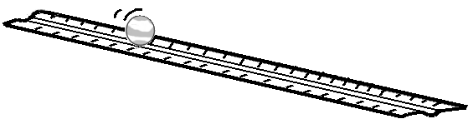**Marble Derby**

**Materials:** 24 dominos, 4 marbles, 4 rulers

**Task:** Your group’s job is to plan a Marble Derby using rulers, marbles and dominos.

The derby will have a starting point. (This is the place where energy comes in.)

Objects need to cause other objects to move. (This is called energy transfer.)

Energy will move through the system using forces (pushes and pulls). The energy will leave the system at the finish.

**Your job is to plan and build a Marble Derby. It needs to have as many energy transfers as possible. How long can you make it last? You want it to move slowly to take a long time to finish.**

**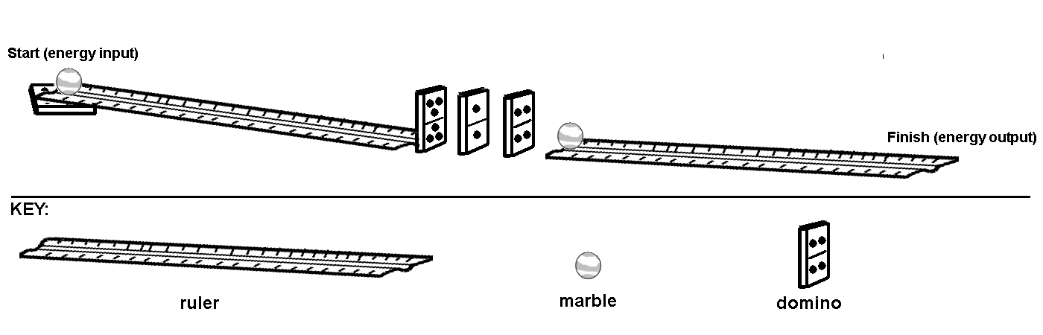STEP 1:** Your group should first build a system using the design below. Once you have set it up, add energy to start the derby going by tapping the marble. Observe the energy transfer when it hits the dominos. Experiment with the parts to get the right spacing and marble speed. Use a stopwatch to time the final run.

**STEP 2:** Now you are ready to plan your own derby design. Start by sketching out your plan on a piece of paper. You can do this on your own or with a partner. Use the number of materials listed on the previous page.

**STEP 3:** Share your plan with your whole group. Listen to other student’s plans. Decide as a group on a plan. Sketch it out and then build your derby. Test it and make changes. Get ready for your official timed derby run!

Use the “**Marble Derby Report**” sheet to report about your derby.