### Water Play

### Kit #2



#### Student Activity Packet

Revised May 2003

LOGO- revision June 2008

**Activity 1:** What are some properties of water?

Circle the best words for each property.

Draw a line from the property to the sense used (picture).

**Senses**

|  |  |
| --- | --- |
| eye**Property Words for Water** | Sense used |
| A. smell or no smell | A• |
| earB. hard or soft | B• |
| C. smooth or rough | C• |
| noseD. warm or cold | D• |
| handE. blue or clear | E• |
| F. move or does not move | F• |
| G. (class words?) | G• |

**Activity 2:** WHAT ARE SOME BASIC RULES TO FOLLOW WHILE PLAYING WITH WATER?

Circle the pictures that show water safety in the class:

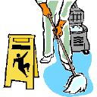



**Activity 3**: HOW CAN YOU TELL THAT WATER HAS WEIGHT?

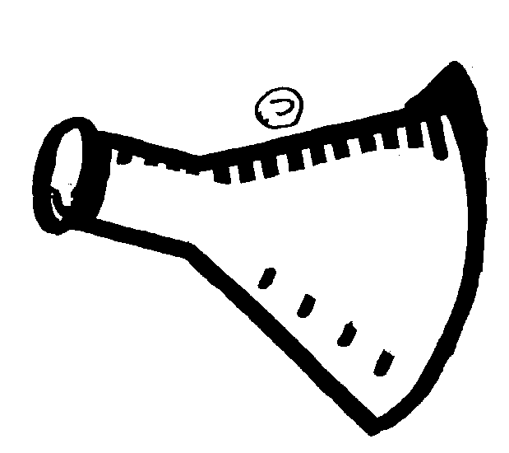

What would the pan do if you poured water in it?

Circle the arrow that shows what the pan will do.**Activity 3**: HOW CAN YOU TELL THAT WATER HAS WEIGHT?

Both buckets are filled with water. Color the buckets to show them full of water. Circle the one that would weigh less.

**Activity 4**: WATER CAN BE POURED



A.



Circle the items you would use to put water into the glass.



B. Circle the items that can be poured.



**Activity 5**: How can you tell that water takes up space.

Color the glass to show how much water you would put in the glass for “all of the space” in the glass to be taken up by water.

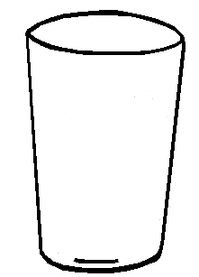

Draw a picture of a balloon that has the space inside of it half-filled with water.

**Activity 6**: What shape is water?

Circle the pictures that show shapes that water can be.



**Activity 7**: What happens to things when you put them in water?



Draw a RED circle around the pictures of objects that sink.

Draw a BLUE circle around the objects that float.



Shark is a good discussion topic for: Does everything either float to the top or sink to the bottom?

**Activity 8**: Does air help things float?

Circle the bottle that has air in it.



Which is heavier? From the picture, circle the bottle that is heavier.



**Activity 9**: How can you make a boat move using air and water?

Circle the things that are easier to move by pushing.

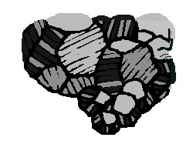



Draw a picture of something you could use to help you to move in or on water.

Could you use this easily on land? YES or NO

**Activity 10:** Are Water and Soapy Water the Same or Different?

Draw a RED circle around the pictures that show how water and soapy water are the SAME.

Draw a BLUE circle around the pictures that show how water and soapy water are DIFFERENT.

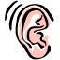

SOUNDS

LOOKS

SMELLS



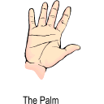

FEELS

WEIGH

MAKES BUBBLES



THINGS FLOAT IN

POURS

THINGS SINK IN

**Activity 12:** What happens when food coloring is added to water?

(Liquids are always moving, in motion.)

Color the picture to show where the food coloring is when it is first dropped in, then after a little while (next) and where it is later (last).



# FIRST



# NEXT

# LAST

**Activity 13:** What materials absorb water?



Draw a picture of something that “absorbs” water.

I absorb water!!



Draw a picture of something that “repels” water.

I repel water!!

**Activity 14:** What is ice?

Color YELLOW the picture parts that show a **water as a SOLID.**

Color BLUE the picture parts that showa **water as a LIQUID**.

NA00826_



**Activity 15: Have You Ever Seen Water Disappear**

Circle the pictures where water is evaporating.

