NYSED Continuum of Services

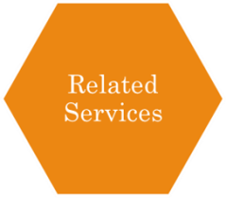

Provision of a variety of services such as speech therapy, occupational therapy, physical therapy as per student’s IEP



Specially designed instruction provided to an individual student with a disability or to a group of students with disabilities in his or her general education class. The purpose is to adapt, as appropriate to the needs of the student, the content, methodology, or delivery of instruction to support the student to successfully participate and progress in the general curriculum during regular instruction.  The focus of services provided by the CT is to an individual student with a disability.

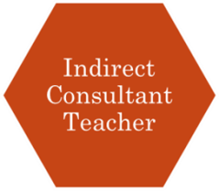

Consultation provided by a certified special education teacher to a general education teacher to assist the general education teacher in adjusting the learning environment and/or modifying his/her instructional methods to meet the individual needs of a student with a disability who attends the general education class.

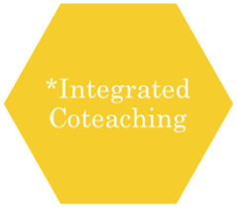

Students intentionally grouped together based on similarity of need for the purpose of receiving specially designed instruction in a general education class, usually daily for the identified class. The general education teacher and a special education teacher share responsibility for the delivery of primary instruction, planning and evaluation for all students. \*\*Not a mandated service.

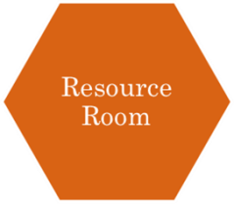

Small group supplementary instruction that cannot otherwise be provided during the student's regular instructional time. Resource room students must also have access to instruction in all required general education content area learning standards in addition to their resource room supplemental instruction. Instruction is not provided in place of the student's regular academic instruction.

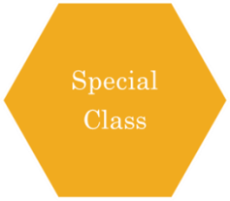

Class consisting of students with disabilities who have been grouped together because of similarity of individual needs for the purpose of receiving specially designed instruction in a self-contained setting, meaning that such students are receiving their primary instruction separate from their non-disabled peers. Configurations include; 15:1 Specialized instruction-12:1:1 Management needs interfere with Instructional process-8:1:1 Intensive management needs-6:1:1Highly intensive management needs-12:1 (3:1) Severe, multiple disabilities in Special Class