How to Modify/Delete an Employee’s Leave Request Approved by the Supervisor

Go to: www.wincapweb.com

Go to: “Employee Self-Service”, “Admin Menu”, ”Leave Requests”

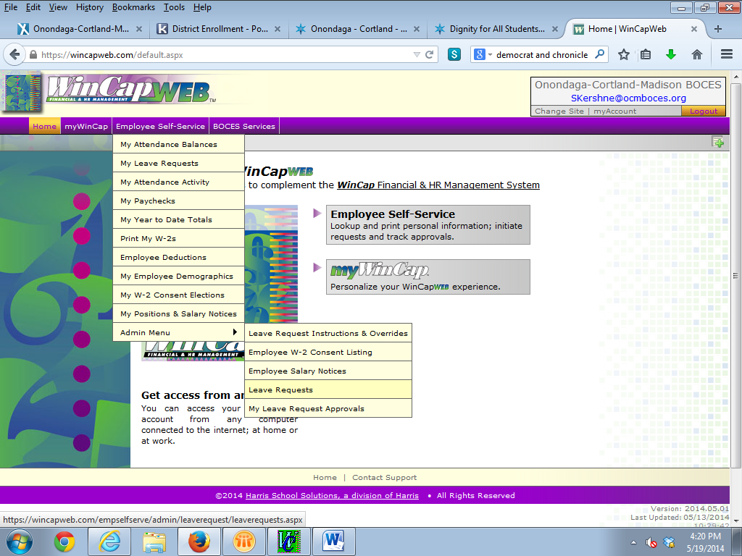

To the right of the purple button that says “Add Leave Request”, click on the “Filter” icon (looks like funnel). Enter date(s) and/or employee name and click “Filter”.

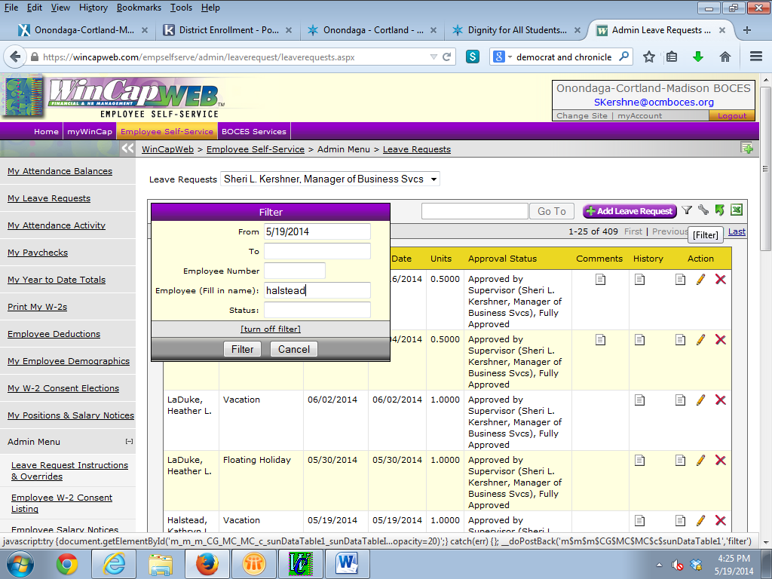

To edit the request, click on the “Pencil” icon under the “Action” column on the far right hand side of the grid.
This will take you into the leave transaction. Please note that you can only change the date and or the units. You cannot change the type of leave day (Attendance Code).
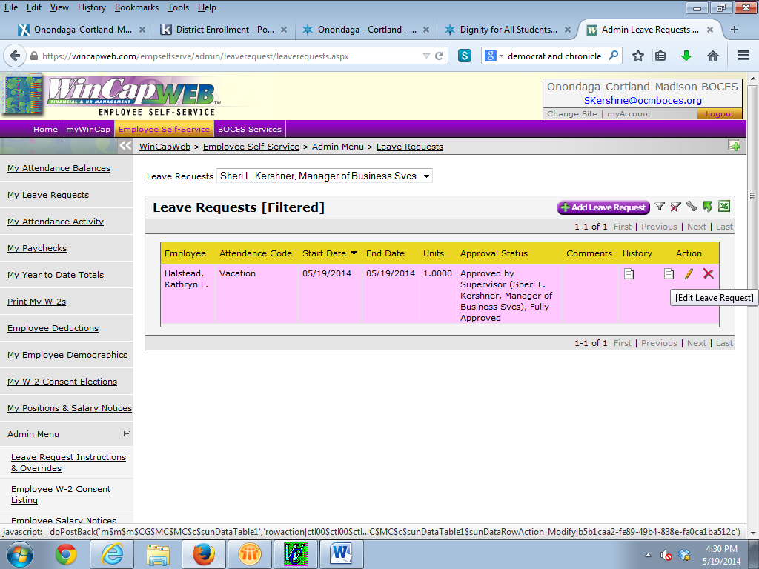

After changing the date or units, enter in a reason in the “Employee Comment” area, then this “Submit”.

To delete a request, click on the red “X” icon under the “Action” column on the far right hand side of the grid.
This will take you into the leave transaction. On the bottom of the form, enter a “Remove Reason” and hit “Remove”. Please note that you will need to delete the request if the employee wants to change anything other than a date or unit. Also if you want the employee to enter the request over again to prove that they did request the change, you could delete the request and ask them to enter it again with the change.

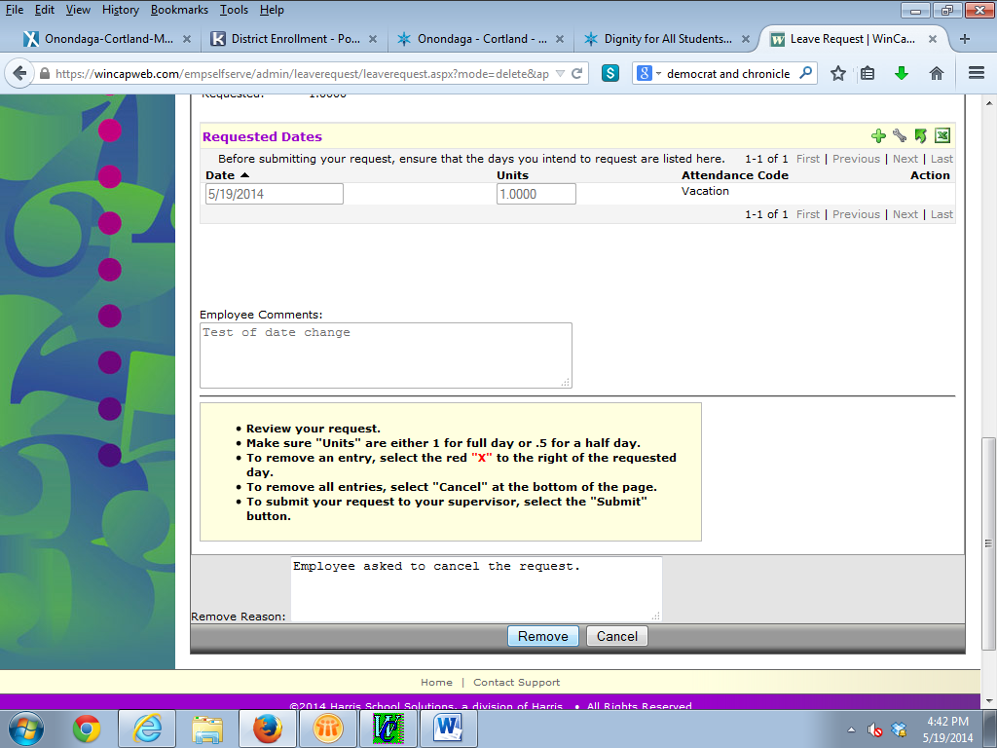

Call or email Sheri Kershner at (315) 433-2613 or skershne@ocmboces.org, with any questions.

