WinCap WEB Timesheets- Employee Training Document

Section 1: Logging into WinCapWEB Timesheets

Section 2: Accessing the Timecard

Section 3: Adding New Time Worked

Section 4: Changing Existing Time Worked

Section 5: Adding a Note to Time

Section 6: Approving Time

Section 7: Printing your Timecard

Section 1: Logging into WinCapWEB Timesheets

- Open Internet Browser and navigate to www.wincapweb.com
- Input your email as your username and the password that was chosen during account activation
- Once complete select “Login”

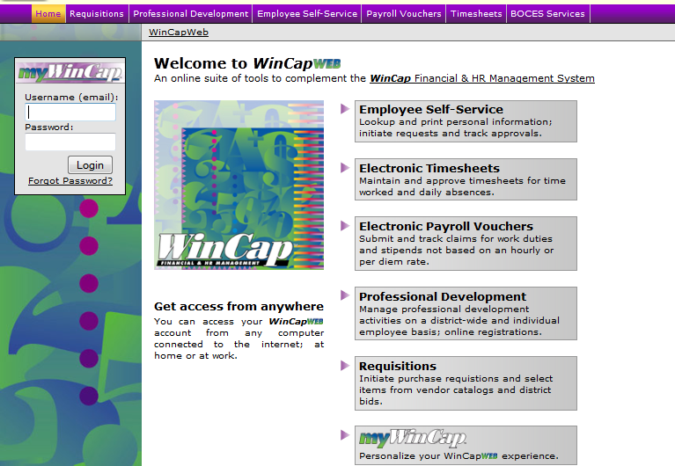

Section 2: Accessing the Timecard

- Once you have successfully logged into WinCapWEB, by selecting “timesheets” on the purple toolbar you may access the Timesheets Web Module. You will need to do one left mouse click on the word “Timesheets” in the purple toolbar to log in.

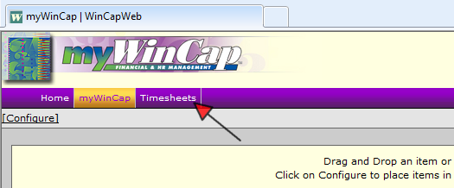

- Once “Timesheets” is selected, you will enter the Timesheets home page where you will see a “Welcome” greeting. On the home page, you will also see any messages that have been posted by Admin staff. On the left hand side of your screen the Timesheets Menu will display. In order to access your timecard you must select “Time Card” from the menu.

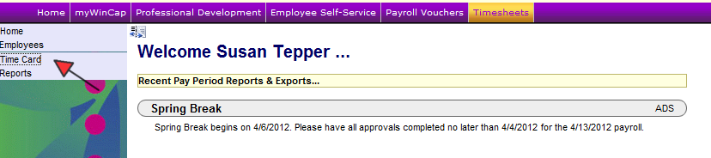

- By selecting “Time Card” from the timesheets menu your timecard will appear for a current date range based on today’s date. The date range appears in the upper right hand corner. In order to change the date range you can manually type in the dates you wish to display or you can click in the date cell and a calendar will appear where you can chose the date. Select “Refresh” to update the timecard.

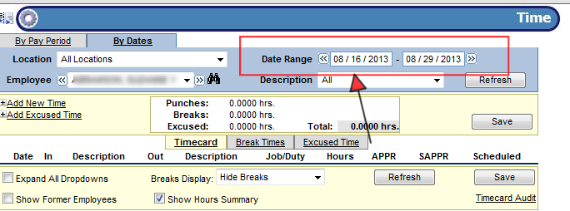

Section 3: Adding New Time Worked

- If you are required to manually enter the in and out times for each work day, you will need to select “add new time.”

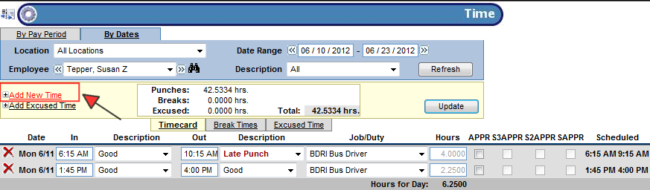

- When “add new time” is selected a new entry row will appear at the top of timecard where the date may be adjusted to the date that you must add time for. The date range may be adjusted by selecting the down arrow and selecting the appropriate date from the list. Only the date range that is selected for the timecard will display in the drop down. If you need to add time for a date outside of the range, you must first adjust your timecard date range, select “Refresh” and then select “Add New Time.”

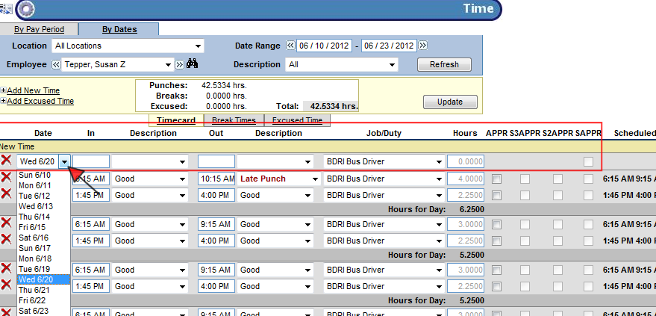

- Once you have selected the appropriate date from the drop down list, you will need to type in the in and out times into the empty section for each applicable field. In the example below the employee worked a midday shift from 11:00am to 1:00pm. The Description field may be left blank. Once you save the new time entry, the system will generate the description “Extra Punch”. This description does not mean anything so please ignore. Note: If you type in 11a, then tab and 1p and tab, the 11:00am and 1:00pm will automatically fill in. If you do not put a letter (a or p) after the numeric time, the system will default in as “am” and it may mess up your total hours calculated.

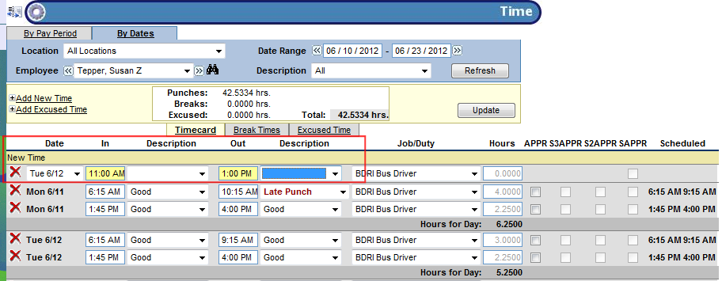

- Once you have entered your time, hit the “Save” button.

Section 4: Changing Existing Time Worked

- If you need to change time worked for a day that you have previously added, you will need to change the in or out punch to reflect the correct time. In order to change the time you can select the existing time in the cell (whether in or out) and select “backspace” or “delete” on your keyboard.

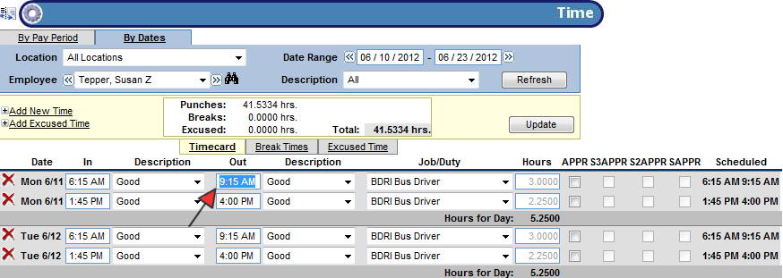

- Once you have selected “backspace” or “delete”, the time will be cleared out of the cell you wish to change. You may now type in the true time into the cell. In the example below we have removed the out punch of 9:15am because the employee worked an additional hour and stayed until 10:15am. By typing 1015a then pressing “Save” the system will automatically format the time to 10:15am and save the change to the timecard.

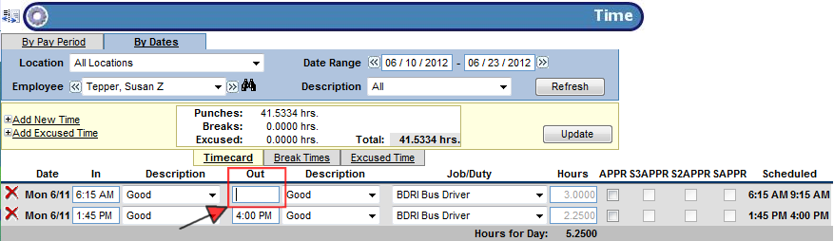

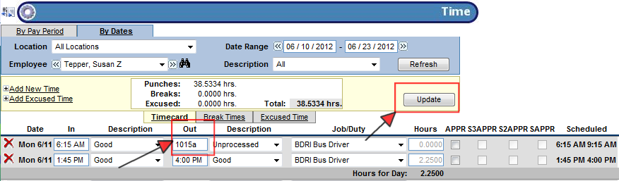

- Once “Save” is selected, the correct out time for the day will display, the total hours for the shift will be adjusted from 3 hours to 4 hours.

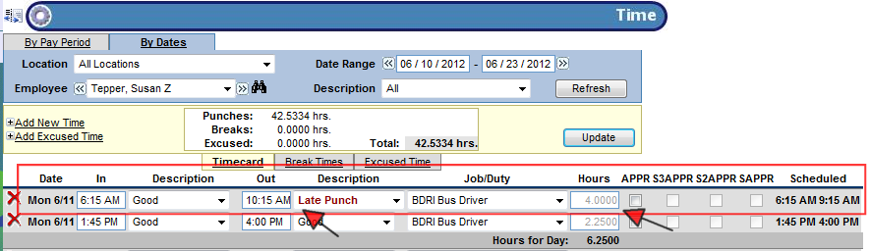

Section 5: Adding a Note to Time

- You may add a note to your time worked to let your supervisor know what task you were performing or any other information you would like to denote on time worked. In order to open up the note section for a day, you will need to select the “> “character which is located to the right of the scheduled time column for the day.

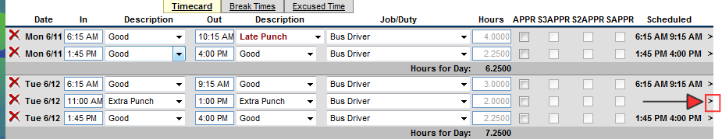

- Once the “>” character is selected, the note section will be opened up for the day/time worked chosen.

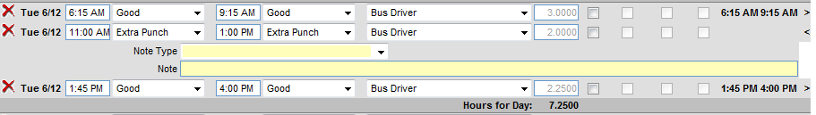

- Use the Note section to type in your notes. Save the note section by selecting “Save”. The note fields will be saved and displayed for you as well as your supervisor to view.

Section 6: Approving Time

- In order to approve your timecard there is an employee approval section listed for each day. The approval columns are broken out by supervisor and employee. The APPR column is for all employee approvals. The S3APPR through SAPPR is the supervisor section for approving. Once time has been approved by an employee or a supervisor a check mark will appear on the day. If a supervisor has approved a day, you will no longer be able to make any adjustments to the time.

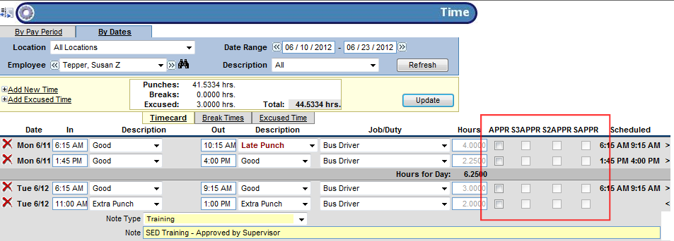

- In order to approve your own timecard you will need to select the box for the applicable day in the APPR column. By selecting the box a check mark will appear. In order to save your approval once all applicable times have been approved you should select “Save”.

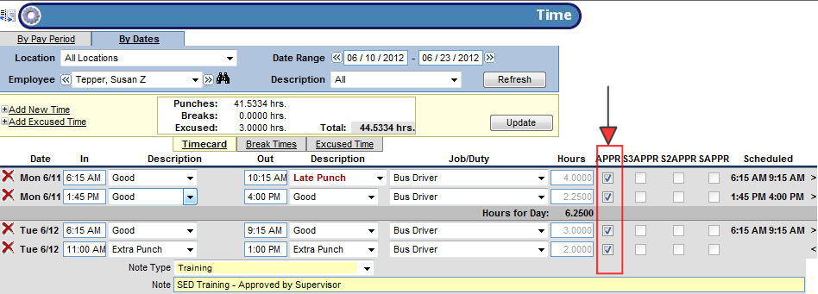

Section 7: Printing your Timecard

- Timecard data is saved from the day you have started with timesheets and does not get removed once approved and exported through payroll. If you wish to see your timecard for three months prior you can navigate to your timecard and change the date range. The data will still be displayed for you to view. If you prefer to have a print off of your timecard you may access the timecard report under the main “timesheets menu” under the “Reports” section. By selecting “Reports” the time reports section will appear. By selecting “Time” all applicable reports that you have access to will appear. Select “Timecard” in order to open up the Timecard Report.

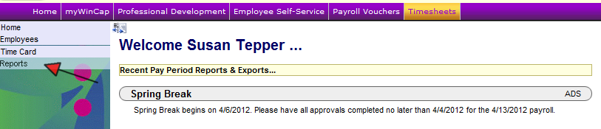

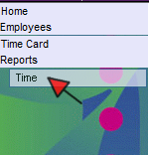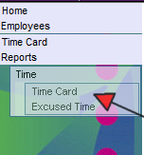

- The Timecard Report form will open up on your screen where you have the ability to change the date range and also include optional data within the report.

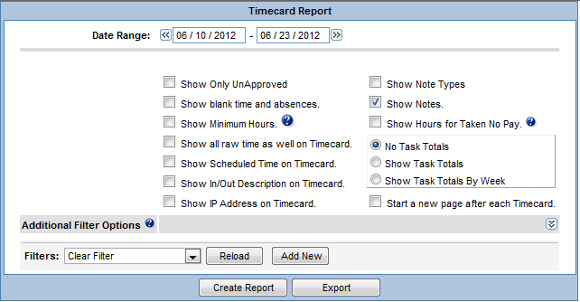

- In order to change the date range you can manually type in the effective date or you may select the effective date’s section and a calendar will appear. You can then select the date from the calendar and it will default into the field.

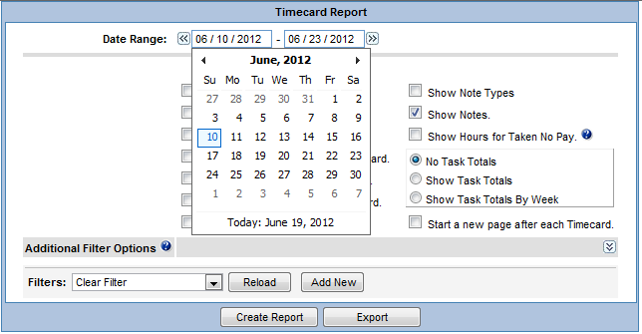

- Once you have the applicable date range chosen and the options you would like to display selected you may receive a “PDF” of the report by selecting “Create Report.” A pop up of the PDF report will appear. You may select the “print” icon on your report to print out the report.

